SPCV25-00195

IN THE SUPERIOR COURT OF CHATHAM COUNTY S ATE OF GEORGIA
e-Filed in Office Tammie Mosley
Clerk of Superior Court Chatham County
Date: 2/7/2025 1:51 PM
Reviewer: KW

Clara Greig and Tana Fileccia-Flagg, )
)
Petitioners, )
)
V. )
)
City of Savannah, Seacrest Seven, LLC, ) 1015 Whitaker, LLC and Portfolio )
Holdings, LLC )
)
Defendants. )
)
)
)

SPCV25-00195
Case No.

PETITION FOR JUDICIAL REVIEW

COME NOW, Petitioners Clara Greig and Tana Fileccia-Flagg ("Petitioners") and file this Petitioner against Defendants City of Savannah City (the "City"); Seacrest Seven, LLC; 1015 Whitaker, LLC; and Portfolio Holdings, LLC and file this petition for judicial review pursuant to the Court's original jurisdiction over declaratory judgments and equity.
1.

This Petition seeks final review of the final decision of the City of Savannah on January 9, 2025, to amend the City of Savannah Zoning Ordinance and the Future Land Use Map pursuant to File Nos. 24-005815-ZA and 24-005816-ZA, respectively (the "Zoning Amendment" and the "FLUM Amendment").
2.

This Petition is filed within 30 days of the final decision of the City.

PARTIES, JURISDICTION AND VENUE

3.

Petitioners are persons who reside in and own principal residences in Chatham County, Georgia. Petitioners are aggrieved by the above final decision and have exhausted their remedies.
4.

The City of Savannah is a municipal entity in Chatham County. It can be served through the City Attorney, Bates Lovett, at 2 East Bay Street, Savannah, GA 31401.
5.
Seacrest Seven, LLC is a Georgia limited liability corporation with its principal place of business in Savannah, Georgia and can be served with process via its Registered Agent, David Paddison, at 1001 Whitaker Street, Savannah, Georgia 31401, who acts on its behalf.
6.

1015 Whitaker, LLC is a Georgia limited liability corporation with its principal place of business in Savannah, Georgia and can be served with process via its Registered Agent, Key D. Compton, at 18 East 35th Street, Ste 300 Savannah, Georgia 31401, who acts on its behalf.
7.

Portfolio Holdings, LLC is a Georgia limited liability corporation with its principal place of business in Savannah, Georgia and can be served via its Registered Agent, Brad Baugh, at 213 West Bolton Street, Savannah, GA 31401, who acts on its behalf. Together, the three defendant LLCs are referred to as the "LLCs" and their Registered Agents as the LLCs' "Registered Agents."

8.

Jeff Jepson of Evans General Contractors is the authorized agent who acts on behalf of the

LLCs

9.

Jeff Jepson, as authorized agent, has retained Hunter Maclean Exley & Dunn P.C. ("Hunter Maclean") as counsel. (Exhibit A, December 19, 2025, City Council Minutes, pp. 7-8). Hunter Maclean acts on behalf of the LLCs and Jeff Jepson together. Harold Yellin is the Hunter Maclean partner working on this matter.
10.

The cause of action arises from the rezoning by the City of Savannah of properties located in Chatham County, Georgia.
11.

This Court has jurisdiction over the parties and allegations complained of herein, and venue is proper in this Court as to the City and LLCs, pursuant to O.C.G.A. § 36-66-5.1 and pursuant to the Court's original jurisdiction over declaratory judgments and equity.
FACTS

12.

On January 9, 2025, the City of Savannah's City Council held a second reading and voted to rezone four properties in the City of Savannah. (Exhibit B, Zoning Amendment).

13.

On January 9, 2025, the City of Savannah's City Council also voted to amend its Future Land Use Map ("FLUM") to reflect the rezoning of the four properties. (Exhibit C, FLUM Amendment).
14.

The members of the City Council include Mayor Van Johnson and the Aldermen, who are Carol Bell, Bernadetta Lanier, Detric Leggett, Alicia Miller Blakely, Nick Palumbo, Kurtis Purtee, Estella Shabazz, and Linda Wilder-Bryant. All of the foregoing persons are local government officials who consider rezoning requests.
15.

The first property is located at 1001 Whitaker Street in Savannah, Georgia and has a property identification number ("PIN") of 20044-25001.
16.

1001 Whitaker Street in Savannah is owned by Defendant Seacrest Seven, LLC.

17.

The second property is located at 1015 Whitaker Street in Savannah, Georgia and has a property identification number ("PIN") of 20044-25002.
18.

1015 Whitaker Street is owned by Defendant 1015 Whitaker, LLC.

19.

The third property is located at 120 West Park Avenue in Savannah, Georgia and has a property identification number ("PIN") of 20044-24002.

20.

120 West Park Avenue is owned by Defendant Portfolio Holdings, LLC.

21.

The fourth property is located at 124 West Park Avenue in Savannah, Georgia and has a property identification number ("PIN") of 200044-24003. Together, the four properties are hereinafter referred to as the "Properties."
22.

124 West Park Avenue is owned by Defendant Portfolio Holdings, LLC.

23.

The City rezoned only the Properties and not any other properties in the same zoning area. (Exhibit D, Council Report of the Chatham County Metropolitan Planning Commission (Zoning), p.3).
24.

Nearly all other properties surrounding the Properties still maintain the TN-1 Zoning. (Exhibit E Council Report of the Chatham County Metropolitan Planning Commission (FLUM),
p. 4).

25.

The City rezoned the Properties from TN-1 to TC-2 conditioned upon TN-1 uses. (Exhibit B, Zoning Amendment).
26.

The rezoning does not affect the use. The current TN-1 zoning district permits the use of general office and retail as well as a parking facility.

27.

However, TN-1 zoning limits building footprint, lot coverage and height in a manner that is compatible in use and compatible visually with the residential buildings in the neighborhood, which is part of the Victorian Historic District.
28.

The proposed zoning of TC-2 allows for larger building footprints, lot coverage and height.

29.

The purpose of the Rezoning and FLUM Amendment Application was to permit the Defendant LLCs to construct 118,000 SF of office and retail, which would not have been permitted under the TN-1 zoning, above a three-story underground parking deck (the "Development") on the four Properties.
30.
The Zoning Amendment and FLUM Amendment are arbitrary and unreasonable acts that serve primarily the interests of private parties and are insubstantially related to public health, safety, morality, or general welfare. The primary tenant for the Development will be Hunter Maclean, a law firm operating in Savannah Georgia. The firm will have its principal offices in the building, and a majority of the parking places, approximately 300 of approximately 450 spaces, will be reserved for the tenants during working hours (Exhibit F, Agreement between City and Forsyth Park Commons LLC).
31.

The Zoning Amendment and FLUM Amendment pose significant detriment to the general welfare. Unlike the TN-1 zoning, the TC-2 zoning would allow the LLCs to build the

Development's proposed 118,000 square feet of commercial and retail space. Such a development would be incompatible with the surrounding structures, especially the smaller residences, and historic character of the neighborhood.
32.

The Properties are in the Victorian Historic district, an area primarily characterized by historic homes. The district is protected under the Victorian District Overlay in the City of Savannah Ordinance. The district would benefit by retaining the TN-1 zoning in order to prevent the construction of buildings that would violate the Ordinance's requirement that new building be visually compatible with the historic buildings. Allowing large buildings under TC-2 zoning would pose a threat to the historic integrity of the district. The value of homes carries a premium because of the historic character of the neighborhood. The change in zoning will adversely affect the desirability of the adjacent lots for homeowners.
33.

Prior to the rezoning, the Properties were in a TN-1 Zoning District. The TN-1 zoning is suitable for the Properties, which are adjacent to many small homes, such as those of the Petitioners. TN-1 zoning allows for development of the Properties for high-value residential and commercial, including office space. There is no hardship imposed on the LLCs under current zoning law. The TN-1 zoning does not lower the value of the properties from the value of nearby comparable properties. The current buildings on the Properties are small commercial buildings that still are or have been occupied until the recent past. The T-N zoning does not pose a threat to public health, safety, or morality.

34.

The City Council also amended the FLUM to reflect the new zoning and did so only for the Properties. The prior FLUM did not provide for the rezoning of the four Properties. (Exhibit C, FLUM Amendment).
35.
The application to rezone the Properties and amend the FLUM was filed by the LLCs on or around October 28, 2024. (Exhibit G, Rezoning and FLUM Amendment Application). The LLCs are the applicants, and the Registered Agents of the LLCs act on their behalf. The Registered Agents of the LLCs, acting on behalf of the LLCs, appointed Jeff Jepson as authorized agent. The LLCs applied for the rezoning and FLUM amendment through Jeff Jepson, authorized agent, who was the "Petitioner" on the application. Together with the Registered Agents, Jeff Jepson acts on behalf of the LLCs in the application process. The application form included a campaign disclosure form for complying with O.C.G.A. § 36-67A-1 et seq., which was submitted by the Registered Agent of each LLC.
36.

Michael Garcia of LS3P Associates, LTD is an agent of the LLCs but was not named as an authorized agent in the notarized authorization forms in the Rezoning and FLUM Amendment Application. The application form required that the Agent, if different from the Petitioner, had to submit an authorized agent form.
37.

The election for the Savannah City Council was held in November 2023.

38.

Hunter Maclean, through Hunter Maclean Georgia PAC, made campaign contributions to the City Council candidates. These included $500 to Carol Bell on August 11, 2023; $500 to Detric Leggett on July 19, 2023; $500 to Nick Palumbo on April 6, 2023; $500 to Estella Shabazz on August 17, 2023; $500 to Linda Wilder-Bryant on June 20, 2023. (Exhibits H-1, H-2, H-3, H-4 and H-5, Hunter Maclean Contributions).
39.

Jeff Jepson, an authorized agent for the LLCs, made campaign contributions to the City Council candidates. These included $2500 to Van Johnson on April 11, 2023; $1500 to Detric Leggett on July 12, 2023; $1000 to Nick Palumbo on April 6, 2023; $1800 to Kurtis Purtee on August 8, 2023; and $3000 to Estella Shabazz on May 16, 2023. In addition, Donna Jepson also donated $2500 to Van Johnson on April 11, 2023. (Exhibits 1-1, 1-2, 1-3, 1-4 and 1-5, Jepson Campaign Contributions).
40.

David Paddison, registered agent and managing member for Seacrest Seven, LLC, made campaign contributions to the City Council candidates. These included $1500 to Detric Leggett on August 2, 2023; $1000 to Nick Palumbo on April 4, 2023; and $1000 to Kurtis Purtee on June 30, 2023. In addition, David and Jeanne Paddison gave $2500 to Carol Bell on October 4, 2023, and Jeanne Paddison gave $2500 to Van Johnson on April 11, 2023. (Exhibits J-1, J-2, J-3, J-4 and J- 5, Paddison Campaign Contributions).

41.

The Rezoning and Flum Amendment Application did not include disclosure of campaign contributions by agent Jeff Jepson or Hunter Maclean.
42.

The Rezoning and Flum Amendment Application included disclosure forms for Seacrest Seven LLC, for which David Paddison indicated that no contributions were made during the two years preceding the application. David Paddison did not disclose campaign contributions made by himself.
43.

Certain members of the City Council cited above knew they had received campaign contributions from persons acting on behalf of the LLCs and knew the application was missing proper disclosures. Despite this knowledge, the City failed to require such persons to make the disclosures. Further, the City Council concealed the insufficient disclosures from the public and voted on the application in an act of fraudulent concealment, corruption, and manifest abuse of power to the oppression of the Petitioners.
44.

The application included an authorization form for agent Jeff Jepson as authorized agent for the LLCs. They did not include authorization forms for Michael Garcia as agent for the LLCs or Jeff Jepson.

45.

Michael Garcia signed a certification for the Rezoning and FLUM Amendment Application, despite not being the authorized agent in the application's authorization form authorizing him to do so.
46.

The Zoning Amendment and FLUM Amendment pose significant detriment to Petitioners' property rights, and are detrimental to public health, safety, and general welfare.
47.

Petitioner Tana Fileccia-Flagg has a substantial interest in the Zoning Amendment and FLUM Amendment. Her property interest will suffer special damages and injury not common to all property owners in the vicinity. She lives at 115 West Park Avenue, which she owns with her husband. The front of her home is located across the street from the south side of the Properties and is directly across from the intersection of Howard Street and West Park Avenue, which is an intersection through which traffic to the underground parking garage will flow. The increased traffic in and out of the underground parking of approximately 450 parking places adds as much as 1000 additional passing vehicles per day. Increased traffic flowing past her home will increase the noise level and air and nighttime light pollution, will create noise and visual intrusions on her peace and privacy, and will greatly lessen the historic and aesthetic appeal of her home. Traffic will be inordinately concentrated immediately across from her property, being twice as much as the traffic to either side of her home. Traffic leading from the parking garage into Park will enter a two-way street that is extremely narrow - there is parking on both sides making it often impassable by two vehicles going in opposite directions. This project will cause a surge in traffic

jams and an increase in density severely compromising her ability to enjoy her property and lowering its value by 20% or more.
48.

The massive scale of the new structures, which is only possible with the rezoning, will negatively affect the aesthetic and historic appeal of the Park Avenue street frontage of Petitioner Tana Fileccia-Flagg's property, resulting in a decline in value. Even if the Development does not occur, the rezoning now allows a massive building that would not have been permissible under the prior zoning, which was in place when Petitioner purchased her property. The massiveness of the structures will exacerbate the nighttime pollution emanating from the proposed commercial structures.
49.

Petitioner Clara Greig has a substantial interest in the Zoning Amendment and Flum Amendment. Her property interest will suffer special damages and injury not common to all property owners in the vicinity. She owns and lives at 202 West Park Avenue, Savannah, Georgia, the side of which is across the street from the west side of the Properties.
50.

The development will uniquely hurt Ms. Greig's property rights by reducing her enjoyment of her property and lowering its value by at least 20%.
51.
Ms. Greig's property is uniquely affected by the manner in which the rezoning will cause the side of her property to face a much larger building than permitted under prior zoning. Ms. Greig's home is across the street from 124 West Park Avenue, which currently has two, two-story Victorian era dwellings (later converted to a single funeral home), which are consistent with the

historic character of the neighborhood. These buildings will be demolished for the Development. This destruction of historic fabric, which would not be necessary under the TN-1 zoning, diminishes the historic appeal and value of Ms. Greig's home by at least 20%.
52.

For Petitioner Greig, the new four-story office buildings will affect the privacy and safety of her home. Occupants of the new buildings, with little to no setbacks from the streets, will look directly into Petitioner's bedrooms and private outdoor spaces, creating a visual intrusion on her peace and privacy, while also lowering the value of her property.
53.

Petitioners have exhausted their remedies by speaking at hearings related to this matter. During the hearing for the first reading for the rezoning and FLUM application on December 19, 2024, Petitioner Clara Greig's agent Jim Hundsrucker read her statement objecting to the changes in the two minutes allotted to her. (Exhibit A, December 19, 2025, City Council Minutes, pp. 7- 8). Through her agent, she set forth constitutional objections, showing that the proposed zoning change was arbitrary and unreasonable and was not related to the general welfare, stating that the proposed rezoning would have detrimental effects on the character, culture, and the overall quality of life in our historic district. She further explained that the proposed rezoning prioritizes non­ public commercial interests that do not align with the needs and desires of the residents. She stated that the TN-1 zoning not only preserves the integrity of our rich heritage but also promotes a balanced, pedestrian-friendly environment that encourages local businesses and fosters community interactions.

54.

Both Petitioners submitted statements opposmg Rezoning Amendment and Flum Amendment on constitutional grounds to the November 19, 2024, hearing by the Metropolitan Planning Commission, which reviewed the application and recommended approval to City Council. (Exhibits Kand L, Public Comments for the MPC November 19, 2024, hearing). Each made arguments that illustrated that the amendments were arbitrary and unreasonable and not in the interest of public welfare.
55.

Although the City was on notice that certain residents opposed the rezoning Amendment and FLUM amendment on constitutional grounds, showing that it was arbitrary, unreasonable, and not related to public welfare, the majority of City Council expressed no interest in remedying the situation. The majority of members had already accepted campaign contributions and were beholden to the LLCs and their agents to vote to amend the City's FLUM and rezone the Properties. Had those members recused themselves, there would have been no quorum.
56.

Petitioners reasonably relied on the City to have properly enforced campaign contribution disclosure requirements. The public reasonably relied as well on such enforcement and assumed the absence of corruption and fraudulent concealment.
57.
In an earlier City Council hearing on September 14, 2023, regarding whether the buildings on the Properties would be protected from demolition, one City Council member alluded to the fact that the Mayor and certain other City Council members had accepted campaign contributions from persons acting on behalf of the LLCs. Nick Palumbo, who had received contributions from

Hunter Maclean, Jeff Jepson and David Paddison, together with Linda Wilder-Bryant, who had received a contribution from Hunter Maclean, opposed the disclosure by calling a point of order, after which the Mayor refused to allow any testimony on that matter at the hearing. (Exhibit M, September 14, 2023, City Council Minutes, pp. 5-6).
58.
The September 14, 2023 hearing illustrated the intention of City Council to fraudulently conceal campaign contributions not properly disclosed in the application, and to prohibit any discussion thereof in public hearings, thereby leading Petitioners to believe that they were prohibited from raising such issues on December 19, 2024, at the first reading of the Rezoning and FLUM Amendment Application at City Council.
59.

No testimony was permitted at the City Council's second reading on January 9, 2025.

COUNT I - CONSTITUTIONAL CHALLENGE
60.
Petitioners re-allege, as if fully set forth herein, every allegation contained in the preceding paragraphs of this Petition.
61.

The Zoning Amendment and FLUM Amendment are unconstitutional under O.C.G.A. § 36-66-5.1 because the preponderance of the evidence shows they pose significant detriment to Petitioners' property rights, serve primarily the interests of private parties and the members of City Council, and are insubstantially related to public health, safety, morality, and general welfare.

62.

The Zoning Amendment and FLUM Amendment permit the construction of overscale buildings that will be significantly detrimental to Petitioners' property rights whether or not the Development proceeds.
63.
If the Development takes place as a result of the rezoning, the rezoning and FLUM amendment will be detrimental to Petitioners' property rights as explained in the facts set forth earlier herein.
64.

The rezoning and FLUM amendment bear an insubstantial relationship to public welfare.

65.
The primary purpose of the rezoning and FLUM amendment is to benefit private parties, including the three LLCs, certain agents thereof, and Hunter Maclean.
66.

The rezoning will allow for the construction of office space to be rented to Hunter Maclean, a private law firm, which is a purpose insubstantially related to public health, safety, morality, or general welfare. Because the majority of the parking spaces will be reserved for Hunter Maclean, the parking garage also is primarily for private use.
67.
The individual members of City Council benefit personally from the rezonmg. As candidates, members of the City Council accepted substantial contributions from persons acting on behalf of the LLCs. These persons included Jeff Jepson, David Paddison of Seacrest Seven

LLC, Hunter Maclean and others. Hunter Maclean donated through Hunter Maclean Georgia PAC, which acts is an instrumentality of the former.
68.

The Zoning Amendment and FLUM Amendment were insubstantially related to morality and general welfare because they were the result of an unlawful failure to disclose campaign contributions under O.C.G.A. § 36-67A-3(a), an act which is contradictory to public welfare and morality.
69.

The Zoning Amendment and Flum Amendment are harmful to the public welfare in another way. The Properties are in the Victorian Historic district, an area primarily characterized by historic homes. The district is protected under the Victorian District Overlay in the City of Savannah Ordinance. The district would benefit by retaining the TN-1 zoning in order to prevent the construction of buildings that would violate the Ordinance's requirement that new building be visually compatible with the historic buildings. Allowing large buildings under TC-2 zoning would pose a threat to the historic integrity of the district. The value of homes carries a premium because of the historic character of the neighborhood. The change in zoning will adversely affect the desirability of the adjacent lots for homeowners.
70.

Other factors are relevant In determining that that the Zoning Amendment and FLUM Amendment are insubstantially related to the public health, safety, morality or general welfare Prior to the rezoning, the Properties lay in a TN-1 Zoning District. The TN-1 zoning is suitable for the Properties, which are adjacent to many small homes, such as those of the Petitioners. TMN-1 zoning allows for development of this property for high-value residential and limited commercial,

including office space. There is no hardship imposed on the LLCs under current zoning law. The TN-1 zoning does not lower the value of the properties from the value of nearby comparable properties, also zoned TN-1. The current buildings on the Properties are small commercial buildings that have been occupied until the recent past. The TN-1 zoning does not pose a threat to public health, safety, or morality.
71.
All of the foregoing factors, including the detriment to Petitioners as described herein, necessitates that the Zoning Amendment and FLUM Amendment be set aside and declared void.
COUNT II - VIOLATION OF THE ZONING PROCEDURES LAW
72.

Petitioners re-allege, as if fully set forth herein, every allegation contained in the preceding paragraphs of this Petition.
73.

The City and Defendant LLCs and their agents violated the Zoning Procedures Law, including O.C.G.A. § 36-67A-3(a), and as a result, the rezoning amendment is void.
74.
The applicants and their agents, acting against the interests of general welfare and morality, violated O.C.G.A. § 36-67A-3(a), which requires an applicant for rezoning action to file disclosure of campaign contributions aggregating $250.00 or more to a local government official who will consider the application if such contribution was made within two years immediately preceding the filing of that applicant's application. O.C.G.A. § 36-67A-1(1) defines "applicant" as "any person who applies for a rezoning action and any attorney or other person representing or acting on behalf of a person who applies for a rezoning action." O.C.G.A. § 36-67A-1(6.3) defines "person" as "an individual, partnership, committee, association, corporation, labor organization,

or any other organization or group of persons." O.C.G.A. § 36-67A-1(5) "Local government official" means any member of the governing authority of a local government or any member of a planning or zoning commission."
75.

Jeff Jepson, who acted on behalf of all three LLCs, violated O.C.G.A. § 36-67A-3(a) because he failed to provide disclosures of his campaign contributions to City Council members, who are the government officials who considered the application, in the two-year period prior to the filing of the Rezoning and FLUM Amendment Application.
76.

Hunter Maclean, acting on behalf of the LLCs and their agents, also violated O.C.G.A. § 36-67A-3(a) because it failed to provide disclosures of its campaign contributions to City Council members, who are the government officials who considered the application, in the two-year period prior to the filing of the Rezoning and FLUM Amendment Application.
77.

David Paddison, who acted on behalf of Seacrest Seven LLC, also violated O.C.G.A. § 36- 67A-3(a) because he did not individually file a disclosure form of his campaign contributions to members of City Council, and because the forms provided by David Paddison, registered agent for Seacrest Seven LLC, stated that the total contributions were zero, despite Mr. Paddison, who acts on behalf of Seacrest Seven LLC, having made campaign contributions to members of City Council in the two-year period prior to the application.
78.

Defendant City of Savannah, including certain members of City Council, knew the details of each campaign contribution, but unlawfully failed to properly require the LLCs and persons

acting on their behalf to fully disclose campaign contributions made to City Council members in accordance with O.C.G.A. § 36-67A-3(a) or to require that such disclosures become part of the record for the Rezoning and FLUM Amendment Application.
79.

The City also failed to require that Jeff Jepson, the authorized agent, sign the certification to the Rezoning and FLUM Amendment Application. The City nonetheless processed the application and approved it.
80.

The failure of the City to follow the Zoning Procedures Act necessitates that the Zoning Amendment and FLUM Amendment be set aside and declared void.
COUNT III - MANIFEST ABUSE OF POWER
81.

Petitioners re-allege, as if fully set forth herein, every allegation contained in the preceding paragraphs of this Petition.
82.

Defendant City of Savannah manifestly abused its power to the oppression of Petitioners by rewarding private parties who made campaign contributions to City Council members, giving the appearance of a corrupt pay-to-play scheme.
83.
As a result of the applicants' and their agents' failure to provide all the disclosures required by O.C.G.A. § 36-67A-3(a) and by their failure to disclose the actual amount of campaign contributions, the rezoning application and rezoning decisions are contrary to Georgia law and void.

84.

In approving the rezoning request, certain members of City Council knew that the LLCs and their agents had made the campaign contributions and that the LLCs and their agents were not fully disclosing such contributions.
85.
In order to hide these campaign contributions from the public, the City failed to require that the disclosures by Jeff Jepson, agent for the LLCs, required by O.C.G.A. § 36-67A-3(a), be filed and made part of the record of the proceedings, constituting a manifest abuse of power. Nor did the City require David Paddison or Hunter Maclean to make the required disclosure. Such concealment by the City constitutes corruption and fraud against the public. The City set forth its intention to hide campaign contributions an such lack of disclosure thereof from the public as early as the September 14, 2023, City Council hearing.
86.

Defendant City of Savannah failed to require the Rezoning and FLUM Amendment Application to have a proper certification.
87.

The certification was signed by Michael Garcia, a person who did not provide an authorized agent form.
88.
Additionally, the application's certification was not accurate because David Paddison, agent for applicant Seacrest Seven LLC, failed to disclose campaign contributions he made.

89.

Had the City required Jeff Jepson, the authorized agent, to sign the certification, he could not have signed because the application did not include disclosure of his own campaign contributions.
90.
Because the City failed to ensure that the application was certified by an authorized signer, the City abused its power by allowing the LLCs and their agents to fraudulently conceal campaign contributions from the application and approval process.
91.

Such a "pay-to-play" scheme, together with concealment thereof, undermine the confidence of the public in the City's legislative process.
92.

The manifest abuse of power by the City to the detriment to Petitioners as described herein necessitates that the Zoning Amendment and FLUM Amendment be set aside and declared void.
COUNT IV - SPOT ZONING

93.

Petitioners re-allege, as if fully set forth herein, every allegation contained in the preceding paragraphs of this Petition.
94.

By rezoning only the Properties, but not the surrounding area, Defendant City of Savannah engaged in unlawful spot zoning to the detriment of Petitioners. The Zoning Amendment and

FLUM Amendment are arbitrary and unreasonable acts that serve primarily the interests of the LLCs to the oppression of the Petitioners.
95.

The City rezoned only the Properties of the LLCs because those were the only properties that the LLCs and agents, including donors to certain City Council members, requested to be rezoned.
96.

Further, the City engaged in spot zoning primarily to specifically benefit the LLCs at the expense of the Petitioners, whose properties have been harmed as described herein. Without the proposed Development, there is no evidence that the rezoning would have occurred.
97.

The rezoning occurred without a comprehensive development plan supporting it. Instead, the zoning plan or FLUM, required modification in order for the rezoning to take place.
98.

The unlawful use of spot zoning by the City to the detriment to Petitioners as described herein necessitates that the Zoning Amendment and FLUM Amendment be set aside and declared void.
COUNT V - ATTORNEY'S FEES
99.

Petitioners re-allege, as if fully set forth herein, every allegation contained in the preceding paragraphs of this Petitioner.
100.
Defendants have acted in bad faith and have caused the Petitioners unnecessary trouble and expense.

101.

Petitioners is entitled to a judgment for reasonable attorney's fees and costs as a result of Defendants' actions as found in O.C.G.A. § 13-6-11.
WHEREFORE, Petitioners respectfully pray that this Court set aside and declare the Zoning Amendment and Flum Amendment to be void.
This 7th day of February, 2025.

Respectfully submitted,

3505 Pelham Road Suite C
Greenville, SC 29615 mthomerson@tjelaw.net ajones@tjelaw.net
THOMERSON, JONES & EDWARDS P.C.
Isl Michael J Thomerson
Michael J Thomerson (GA Bar No. 706999) Isl Andrew B. Jones
Andrew B. Jones (GA Bar No. 802033) Isl Michael L. Edwards
Michael L. Edwards (GA Bar No.240112) Attorneys for Petitioners Clara Greig and Tana Fileccia-Flagg


■

DECEMBER 19, 2024 - 2:00 p.m. - CITY COUNCIL REGULAR MEETING CITY GOVERNMENT
OFFICIAL PROCEEDINGS OF THE MAYOR AND ALDERMEN SAVANNAH, GEORGIA
The regular meeting of the City Council was held at 2:02 p.m., in the SCCPSS Board of Education Room located at the Eli Whitney Administrative Complex, 2 Laura Avenue, Building G. Mayor Pro Tern Dr. Estella Edwards Shabazz called the meeting to order, then introduced Alderwoman Bernetta Lanier to offer the invocation. The Pledge of Allegiance was recited in unison.

PRESENT:
Mayor Van R. Johnson, II
Alderwoman Carolyn H. Bell, At-Large, Post 1 Alderwoman Alicia Miller Blakely, At-Large, Post 2 Alderwoman Bernetta B. Lanier, District 1 Alderman Detric Leggett, District 2
Alderwoman Linda Wilder-Bryan, District 3 - Vice Chair Alderman Nick Palumbo, District 4 - Chairman
Alderwoman Dr. Estella Edwards Shabazz, District 5 - Mayor Pro Tern Alderman Kurtis Purtee, District 6
ALSO, PRESENT:
City Manager Jay Melder
Chief of Staff Daphanie Williams City Attorney Bates Lovett
Clerk of Council Mark Massey
Assistant to Clerk of Council Renee Osborne

Exhibit 1: MPC Recommendation Packet for a Speci Use Permit (FIie No. 24-005474-ZA).pdf

See related agenda items #10, #11, #16, and #17.
- Aid. Leggett moved to close the zoning hearings for agenda items #10, #11, and #12, seconded by Aid. Wilder-Bryan and Aid. Miller Blakely. The motion passed unanimously, 9-0-0.
- Aid. Leggett moved to approve the Special Use Permit for agenda item #12, seconded by Aid. Wilder-Bryan. The motion passed, 7-2-0. Aid. Palumbo and Aid. Purtee voted no.

13. Petition of Jeff Jepson, on Behalf of Seacrest Seven, LLC, 1015 Whitaker Street, LLC, and Portfolio H dings, LLC, with agent Micha Garcia, for a Future Land Use Map (FLUM) Amendment for 0.97 acres ocated at 1001 Whitaker Street, 1015 Whitaker Street, 120 West Park Avenue, and 124 West Park Avenue (P Ns 20044 25001, 20044 25002, 20044 24002, and 20044 24003) to Change the FLUM designation from Tradition Neighborhood to Tradition Commerci in Aldermanic District 2 (File No. 24- 005816-ZA).
Exhibit 1: MPC Recommendation Packet for FLUM (File No. 24-005816-ZA).pdf Exhibit 2: Zoning Maps (File No. 24-005815-ZA and 24-005816-ZA) .pdf
Mayor Johnson declared the zoning hearings open for agenda items #13 and #14. See related agenda items #18 and #19.
Speaker(s):
. Edward Morrow, representing the MPC
  - Howard Yellin on behalf of Jeff Jepson, representing the petitioner
. Elaine Picard - OPPOSED
. Elaine Pullen - OPPOSED
. Dylan Wiliam - OPPOSED
  - Monica Vernon - IN SUPPORT
. James Hundsrucker - OPPOSED
  - Clara Greig - OPPOSED
. Garth Vernon - IN SUPPORT
. Ryan Madson on behalf of Nancy Maia - IN SUPPORT Written comment(s):
. Katie Glusica - OPPOSED
  - Nancy Maia - IN SUPPORT
. Elaine Pullen - OPPOSED
  - Andree Patterson - OPPOSED
  - James Fredericks - OPPOSED
  - Clara Greig - OPPOSED
. Matt Williams - OPPOSED
. Mary E. Adams - OPPOSED
Aid. Palumbo moved to close the zoning hearing for agenda items #13 and #14, seconded by Aid. Wilder-Bryan and Aid. Leggett. The motion passed unanimously, 9-0-0.
Mayor Johnson stated for clarification the ownership of the garage determines the hours of operation for the garage. The City Manager stated yes, the City will operate the garage.
Aid. Leggett asked for the ordinances be heard for first reading only, seconded by Aid. Wilder-Bryan. Aid. Leggett asked if there is an opportunity for the neighborhood to have a conversation and develop a good neighbor agreement in the interim with Mr. Yellin, the petitioner, and surrounding neighborhoods. The City Manager agreed. Aid. Leggett stated that he doesn't want this opportunity to pass.
Mayor Johnson advised we were required to have a public hearing and we have done that. To take care of the first and second readings in one meeting, we all have to agree. Since Aid. Leggett

opposes having both, today reverts to a first reading and we hold a second reading on January 9, 2025.
Aid. Bell asked who is the neighborhood (Victorian, Forsyth Park, and brand new neighbors who live around Howard Street). She asked to make it clear about what is expected to occur between now and the next reading. She has lived there for over 40 years and does not remember the area being anything but commercial. Aid. Bell said she thinks that was stated in the Victorian Neighborhood president's letter.
Aid. Leggett said it will be a lot work, and an opportunity for the At-Large Council members to work with him and the community to find out what works and get to the finish line. He plans to have conversations with the residents and report back what they come up with. He wants to give all parties the opportunity to speak with the elected officials.
Aid. Miller Blakely stated she does not agree with this particular project because of the way it is going to affect the community. She does not believe in the underground parking. Once it starts it is going to affect some of the homes in the area, and mess up the foundations. Several residents have spoke in disagreement with what is being done.
Aid. Lanier stated when the residents came up, she heard some things, like the 24-hour parking, bars and restaurants, parking concerns, preservation, history, and the character of the area as they work with the developers. She said a gentleman also spoke of a community benefit agreement, which makes sense to her. But we do not have community benefits ordinance (CBO) that will dictate what happens. An ordinance is not needed in order to work directly with a developer to create a legally binding agreement with the community. Good neighbor agreements are not legally binding (no teeth), but it shows our good intentions.

14. Petition of Jeff Jepson, on Behalf of Seacrest Seven, LLC, 1015 Whitaker Street, LLC, and Portfolio Holdings, LLC, with agent Michael Garcia, for Zoning Map
Amendment for 0.97 acres ocated at 1001 Whitaker Street, 1015 Whitaker Street, 120 West Park Avenue, and 124 West Park Avenue ( Ns 20044 25001, 20044 25002, 20044 24002, and 20044 24003) to Change the Tradition Neighborhood-1 (TN-1) to Tradition Commercial-2 (TC-2) in Aldermanic District 2 (File No. 24-005815-ZA).

Exhibit 1: MPC Recommendation Packet for Rezoning (File No. 24-005815-ZA).pdf Exhibit 2: Zoning Maps (File No. 24-005815-ZA and 24-005816-ZA).pdf
Mayor Johnson declared the zoning hearings open for agenda items #13 and #14. See related agenda items #18 and #19.
Aid. Palumbo moved to close the zoning hearing for agenda items #13 and #14, seconded by Aid. Wilder-Bryan and Aid. Leggett. The motion passed unanimously, 9-0-0.
See related agenda items #13, #18, and #19.
15. Petition of Robert Mccorkle on Behalf of Speir Property, LLC to Zone -677 Acres Located on 420 Bush Road and 302 Bush Road ( Ns 11026 01002C and 11026 01017) from R-A (Residenti Agriculture) and PDR-SM (Planned Development Reclamation Surface Mining) to PD (Planned Development) (File No. 24-006311-ZA).
Exhibit 1: Staff Report for 302 and 420 Bush Rd (File No. 24-006311-ZA) .pdf Exhibit 2: Fin GA for the Little Neck Road Annexation.pd!
Exhibit 3: Zoning Maps (File No. 24-006311-ZA) .pdf

Mayor Johnson declared the zoning hearing open for agenda item #15. See related agenda items #21 and #22.
Speaker(s):
. Bridget Lidy, representing the City of Savannah
  - Robert Mccorkle, representing the petitioner
. Kerrie Bieber - OPPOSED
. Bennie Warshaw - OPPOSED
  - Michael Love - OPPOSED

AN ORDINANCE
To Be Entitled
AN ORDINANCE TO AMEND AN ORDINANCE TO AMEND THE CITY OF SAVANNAH ZONING MAP FROM TN-1 (TRADITIONAL NEIGHBORHOOD - 1) TO TC-2 (TRADITIONAL COMMERCIAL - 2) FOR 1001 WHITAKER STREET, 1015 WHITAKER STREET, 120 WEST PARK
AVENUE, AND 124 WEST PARK AVENUE (PINS 20044 25001, 20044
25002, 20044 24002, AND 20044 24003); TO REPEAL ALL OTHER ORDINANCES IN CONFLICT HEREWITH; AND FOR OTHER PURPOSES.

BE IT ORDAINED by the Mayor and Aldermen of the City of Savannah, Georgia, in a regular meeting of Council assembled and pursuant to lawful authority thereof:

SECTION IA: Amend the Zoning Map from TN-1 to TC-2 for the properties located at 1001 Whitaker Street (PIN 20044 25001), 1015 Whitaker Street (PIN 20044 25002), 120 West
Park Avenue (PIN 20044 24002), and 124 West Park Avenue (PIN 20044 24003) and described as:

(Approximate Representation)

Beginning from a point located at the approximate intersection of the centerlines of Whitaker Street & West Park Avenue, said point being, THE POINT OF BEGINNING

Thence proceeding in a NW direction along the approximate centerline of West Park Avenue for an estimated distance of 358.9 ft. to a point, said point being located along the approximate intersection of the center line of West Park Avenue & Barnard Street,

Thence proceeding in a NE direction along the approximate centerline of Barnard Street for an estimated distance of 152.2 ft. to a point,

Thence proceeding in a SE direction [S 73-17-26 E] along a line for an estimated distance of 184.0 ft. to a point, said point being located along the approximate centerline of Howard Street,

Thence proceeding in a NE direction along the approximate centerline of Howard Street for an estimated distance of 151.8 ft. to a point, said point being located along the approximate intersection of the center line of Howard Street & West Waldburg Street,

Thence proceeding in a SE direction along the approximate centerline of West Waldburg Street for an estimated distance of 172.5 ft. to a point, said point being located along the approximate intersection of the center line of West Waldburg Street & Whitaker Street,

Thence proceeding in a SW direction along the approximate centerline of Whitaker Street for an estimated distance of 300.7 ft. to a point, said point being, THE POINT OF BEGINNING.

SECTION lB: The condition that permissible uses shall be limited to those allowed within the lN-1 zoning district and shall comply with all applicable supplemental use standards.

SECTION 2: That the requirements of Section 3.2 of the Zoning Ordinance adopted on the 181.h of July 2019 and the law in such cases made and provided has been satisfied. An opportunity for a public hearing was afforded anyone having an interest or property right which may have been affected by this zoning amendment, said notice being published in the Savannah
Morning News, on the 4th day of December 2024, a copy of said notice being attached hereto and
made a part hereof.

SECTION 3: All ordinances or parts of ordinances in conflict herewith are hereby repealed.

EFFECTIVE DATE: This ordinance shall be effective as of the date hereof.

ADOPTED AND APPROVED: 9_t_h_ day of Ja_n_ua_r y 2025.

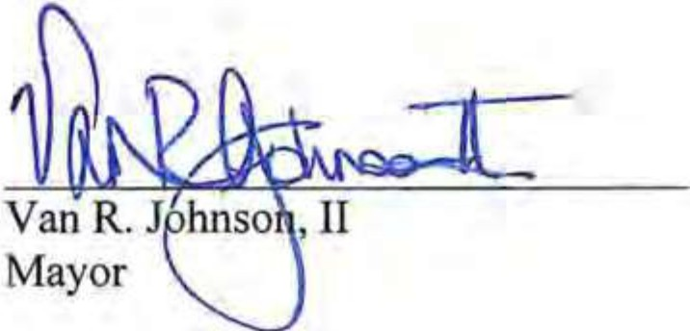

ATTEST:


File No. 24-005815-ZA 2

LO ALQ
The Augusta Chronicle Athens Banner-Herald Savannah Morning News
PO Box 631697 Cincinnati, OH 45263-1697

AFFIDAVIT OF PUBLICATION
Zarina Davis
ATIN: BIANCA B1SSE1TE
City Of Savannah Po Box l027

Savannah GA31402-1027

STATE OF GEORGIA, COUNTY OF CHATHAM

The Savannah Morning News, a dally newspaper published and of general circulation in Chatham County; and personal knowledge of lhe facts herein state and that the notice hereto annexed was Published in said newspapers in the issues dated or by publication on the newspaper's website, lf authorized, on:
12/04/2024
and that the fees charged are legal.
Sworn to and subscribed before on 12/04/2024

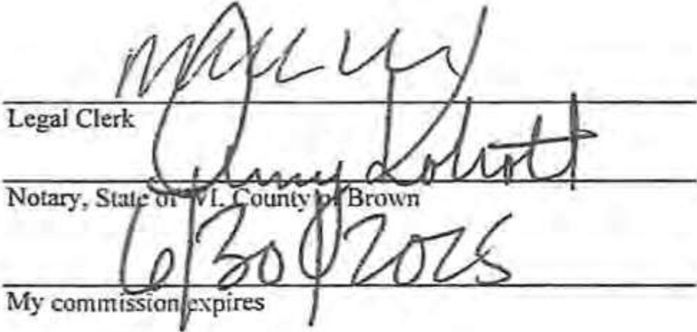

Publication Cost | S80.00
Tax Amount | S0.00
Paymeat Cost | S80.00
Order No: | 10808614 | # of Copies:
Customer No: | 758801 | 1
PO#:
nns I '-oT . - INVOICE!
Pl asr do ,u:,t i= chis form forJXIJ'1ffPnt nmittanCI!.
AMY KOKOTT
Notary Public
State of Wisconsin

Page 1 of 3

P.1ge I of2

- "PUBLIC NOTICE•,.
NoHce rs hereby <;JIVen lhol Tho Moyor arid Aldermen of lhe CilY of Savannah, Gear• la, 111 regular meeting of Council, wiII convene a pubflchcning hearing regard­ Ing leitt amendments to the Zoning Ordinance, Zoning Map (rezoning or zoning). arid Future Land Use Map or Speclol Use Permlls of prop­ erty described below on Thursday, December 19, 2024, ot 2:00 p.m. In Ell Whit­ ney Administrative Complex (Boord of Education Meelfng Chambers), 2 Louro Avenue,
Boord Room Savannah, GA.
A Petition or Jeff Jepson, on behalf of Seacrest Seven, LLC, 1015 Whitaker Street, LLC, and Portfolio Holdings, LLC, \vlth agent Michael Garcia, for a Future Land Use Map (FLUM) Amend­ men tar 0.97 acres localed al 1001 Whiloker Street, 1015 Whitaker Srreel, 120 West Pork Avenue, and 12; West Park Avenue (PINs 20044 2500I. 20044 25002, 20044
2<002, and 200,1; 24003) to
Change lhe FLUM designa­ tion from Traditional Neigh­ borhood 1D Trodll'onol Commercial (File No. 24• 005816-ZA I,
A l"elltion of Jeff Jepson, on behalf of Seacrest Seven, LLC, 1015 Whllol<l.'r Street, LLC, and Podfallo Holdlngs, LLC. wllh c,gent Michoet Gorclo, for Zanlt19 Map Amendment for 0.97 acres locoled ot 1001 Whiloker Street, 1015 WhiloKer Street,
120 West Pork Allenue, and n◄ West Pork Avenue CPINs 200◄◄25001, 2004◄25002. 200.C4
2d002, ond 2004d 24003) lo
Change the Trodillonol Ne ghborhood-1 (TN-1) ro Troditlonol Cammerciol•2 CTC·2) ( Flle No. 2◄-005815- ZA1.
PcTilion al Robert Mccorkle, on behalf al Speir ProPertv, LLC, lo zone -6TT acres locoled on J20 Bush Recd and jQ2 Bush Raad (PINs 11026 01002c and 11026 01017)
from R·A (Residential Allri- cullurel ond PDR-sSM (Planned Development Reclamalfon Surtace Mining) lo PO (Planned Devetopmentl (Fite Na. 24· 0063ll•ZAJ.
Pubnc Comment Allowed; Anyone whose interest of Proportv rights may be
affected bv the propased changes rJ'IOY OPl>eOr al lhol ime. may be heard. and may submit evidence, includ• ing wrillen comments.
Meeting confJrmgtJon: The octitioner mov withdraw or
re<iuest o conliouafian of lhe pctrtfon after this notice hos been moiled. II is suggested that vou confirm whelher the petrlian will be an lh agenda before deporting tor the scheduled City Council meet• ing. The scheduled meeting dole and time ore oravided In rhe Orsi oorogroph of this notice.
If Yau Connet Attend the Qfv council Mtttin9; Anvone who cannot attend the meeting end whose inter­ est of property righls mov oe
affec1ed bY lhe P(cn>OSCU changes moy submfl evidence including written comments to :ili!!l:: lJ!o arby c.olllng 912-651-JIOB. Please reference the me number loccted on his notice. Wrir­ ren comments become public record ond ore .sJ1arl!d With

EXHIBITB

Page 2of2

the Movor and Aldermen
prior 10 !he Council meelln_si.
Materials Avoiloble roe Public 101ormoljon: 1ntor­ molion oboul these Item end related moler!ols moy be r-evielrled on the Cltv's website of b.11v:/{90-sayon­
noh2.cJvjcPlus.com/4sziA9.-m: do,;-Mfnutes Prior to lhe meeting. If you hove onv questions, please conloct 912- 525-3097 or
t1io9 sav0nnohqQ.,9,llv.
Envfe un correo e/ectronico a plann/ngCsavannohga.gov para solicitor esto f/Olifi­ coci6n en E?spofio/.
SAVANNAH MORNING NEWS-
SPECIAL NOTICE COLUMN
Please inserl lhe above notice ln the Si:>eciol Notice Column of the Sovonnoh Morning News:
Wecnesdo,i:. December 4,
llli-

AN ORDINANCE
To Be Entitled
AN ORDINANCE TO AMEND THE FUTURE LAND USE MAP OF THE CO.tv!PREHENSIVE PLAN 2040 FOR 1001 WHITAKER STREET, 1015 WHITAKER STREET, 120 WEST PARK AVENUE, AND 124 WEST PARK AVENUE (PINS 20044 25001, 20044 25002, 20044 24002, AND 20044 24003) FROM TRADITIONAL NEIGHBORHOOD TO TRADITIONAL COMMERCIAL; TO REPEAL ALL OTHER ORDINANCES IN CONFLICT HEREWITH; AND FOR OTHER PURPOSES.

BE IT ORDAINED by the Mayor and Aldermen of the City of Savannah, Georgia, in a regular meeting of Council assembled and pursuant to lawful authority thereof:

SECTION 1: Amend the Future Land Use Map from Traditional Neighborhood to Traditional Commercial for the properties located at 1001 Whitaker Street (PIN 20044 25001), 1015 Whitaker Street (PIN 20044 25002), 120 West Park Avenue (PIN 20044 24002), and 124 West Park Avenue (PIN 20044 24003) and described as:

(Approximate Representation)

Beginning from a point located at the approximate intersection of the centerlines of Whitaker Street & West Park Avenue, said point being, THE POINT OF BEGINNING

Thence proceeding in a NW direction along the approximate centerline of West Park Avenue for an estimated distance of 358.9 ft. to a point, said point being located along the approximate intersection of the center line of West Park Avenue & Barnard Street,

Thence proceeding in a NE direction along the approximate centerline of Barnard Street for an estimated distance of 152.2 ft. to a point,

Thence proceeding in a SE direction [S 73-17-26 E] along a line for an estimated distance of 184.0 ft. to a point, said point being located along the approximate centerline of Howard Street,

Thence proceeding in a NE direction along the approximate centerline of Howard Street for an estimated distance of 151.8 ft. to a point, said point being located along the approximate intersection of the center line of Howard Street & West Waldburg Street,

Thence proceeding in a SE direction along the approximate centerline of West Waldburg Street for an estimated distance of 172.5 ft. to a point, said point being located along the approximate intersection of the center line of West Waldburg Street & Whitaker Street,

Thence proceeding in a SW direction along the approximate centerline of Whitaker Street for an estimated distance of 300.7 ft. to a point, said point being, THE POINT OF BEGINNING.

SECTION 2: That the requirements of Section 3.2 of the Zoning Ordinance adopted on the 18th of July 2019 and the law in such cases made and provided has been satisfied. An opportunity for a public hearing was afforded anyone having an interest or property right which may have been affected by this zoning amendment, said notice being published in the Savannah Morning News, on the 4th day of December 2024, a copy of said notice being attached hereto and made a part hereof.

SECTION 3: All ordinances or parts of ordinances in conflict herewith are hereby repealed.

EFFECTIVE DATE: This ordinance shall be effective as of the date hereof. ADOPTED AND APPROVED: 9_t_h_ day of January 2025.
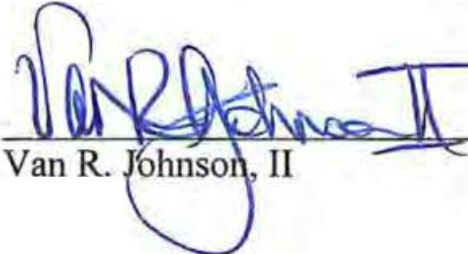

Mayor


ATTEST:

File No. 24-005816-ZA 2

AFFIDAVIT OF PUBLICATION
Zarina Davis
ATTN: BIANCA BISSElTE
City Of Savannah
Po Box 1027

Savannah GA 31402-1027
CAL1Q

The Augusta Chronicle Athens Banner-Herald Savannah Morning News

PO Box 631697 Cincinnati, OH 45263-1697

STATE OF GEORGIA, COUNTY OF CHATHAM

The Savannah Morning News, a dally newspaper published and of general circulation in Chatham County; and personal knowledge of the facts herein slate and that the notice hereto annexed was Published in said newspapers in the issues dated or by publication on the newspaper's website, if authorized, on:

12/04/2024

and that the fees charged are legal.
Sworn to and subscribed before on 12/04/2024

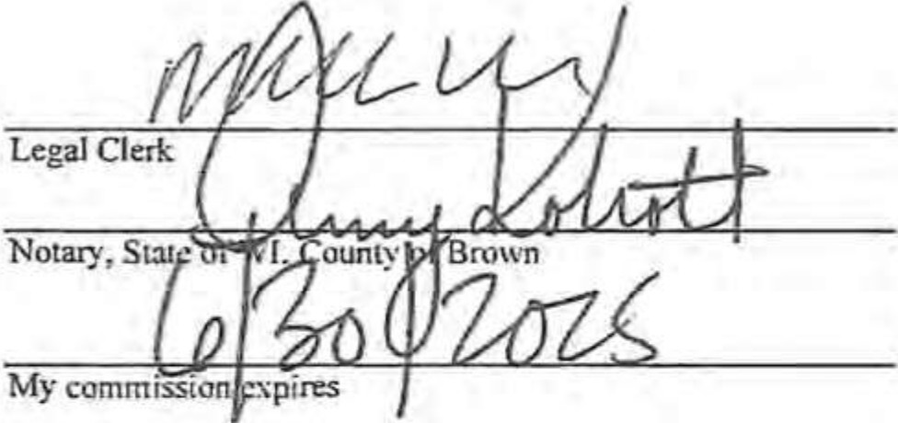

PubITcation Cost Tax Amount Payment Cost Order No:
Customer No:
PO#:
S80.00
$0.00
S80.00 10808614
758801

# of Copies:. 1

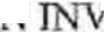
THl I -or A 7
·01CE!

Pl an do not ure this form/or paym nr r miuonu.
AMY KOKOTT
Notary Public State of Wisconsin

Page 1 of 3

P:ige l of2

··•PUBLIC NOTICE••· Notice is hereby given 1h01
The Movor ond Aldermen of the City of Savannah, Geor- 1110, 111 regular meeting of Council, will convene a publich:aning hearing regard­ Ing text amendments 1o the Zoning Ordinance, -Zoning Map (reroning or ?Oning), and Future Land Use Mop or Soeclol Use Permits of prop­ erty described below on Thursdoy, December 19, 202d, ol 2:00 o.m. In Ell Whit­ ney Admfnisfrotlve Comnlex (Boord of Educollon Meellng Chombers), 2 Louro Avenue, Boord Room S011onnoh, GA.
A Pe!Ttlon of Jeff Jepson, on behalf at Seocresl Seven, LLC, 1015 Whitoker Sfreet, LLC, ond Portrolio Holdfn9s, LLC, With ogenl Michael Gorclo, for a Future Land Use Mop (FLUM) Amend­ ment ror 0.97 acres locoted at 1001 Whilok r Sfreet, 101.S Whflolte-r Street, 120 West Pork Avenue, and 12, West Pork Avenue (PINS 20044 25001, 20044 25002, 20044
2ioo2, ond 200,M 24003) to Change the FLUM designa­ tion from Tradltlonol Neigh­ borhood lo Trodit•onol Commercial (File No. 24- 005816-ZAl.
A l"'e!ltion at Jeff Jepson, on behalf of Seo rest Seven, LLC, TOH Whitaker Street, LLC, and Porlfolio Holdings. LLC, with agent Michael
Gordo, for Zoning Moo Amendmenf far o.97 acres localed al 1001 Whifaker
Street, 1015 Whlloker Streel,
120 V est Pork Avenue, and 12< West Park Avenue CPINs 20044 25001, 20044 25002. 20044
24002, and 20044 2'1003) lo
Chon!le lhe Trodftional Neighborhood-! (TN-1) to Traditional Commercicl-2 (TC-2) (Fite No. l◄·OOS81S­ ZA).
Petition of Roberf Mccorkle on beholf of Speir Property, LLC, lo zone -6n acres located an 420 Bush Rood and 302 Bush Rood (PINs 11026 Ol002C and 11026 01017)
from R-A (Residential Agri- culture) and PDR·SM (Planned Development Reclamation Surface Mining) to PO (Planned Development) (File No. 24· 006311-ZA).
Publlc Comment Allowed·
AriYone whose interest of property rights moy be affected by lhe proposed changes may appear al that time, may be heard, and may ubrnil evidence, includ­ ing wriflen comments.
Meeting ConQrmgtlon: The aelitioner mov withdraw or rl!<luesl o continuation of the pelilian after this notice hos been moiled. II is suggested
that you confirm whether the oetilion will be on the agenda before deporting for the scheduled City Council meet­ ing. The scheduled meeting dote and time ore ar011ided in rhe first oorogroph of this nolice.
If You Cannot Al1end the Cttv Council Meelina:, Anvone who cannot attend the m lins and.,hose infer­ est of property rights mov ae afh,cled by the proposed changes may submil
evidence induding written commen1s fo P.li1!l::
ni09Ssqyam101::t<;n..Q.lll! or by calling 912 St•JI08. Please reference fhe file numl:er localed on his notice. Writ­ ten comments become Public reaird ond ore shoretf with

EXHIBIT C

Page 2of2

the Mayor ond Aldermc,n prior to the Council meeting,
Materials AyoiJgbfe for PVbflc lolocmotioo· In/or•
matron about lhese llems
and related molerlols may be reviewed on the City's website ol h.11,;:,'fffl·7'°YPO·
noh2.cjyicP!us.coJ<i!W:.
dos-MJnu,:,,s prior to lhe meetlrig. If you hove anv questions, please conloct 912- 52.S-3097 or Pl!!n:
s 1iovonnoh110.,g.ov.
nv,e un corrro electr6nico o p/onn/ngllsovonnohgo.go para sollcllor esla notffi­ coci6n en /:spoffol,
SAVANNAH MORNING NEWS-
SPECIAL NOTICE COLUMN
Please Insert the above nolice In the Spec[ol Notice Column of lhe Savannah Morning News:
Wedne;;dov. December :f,
znll.


CHATHAM COUNTY-SAVANNAH

METROPOLITAN PLANNING COMMISSION
"Planning the Future - Respecting the Past"
M E M O R A N D U M

DATE: TO: FROM: SUBJECT:
November 19, 2024

THE MAYOR AND ALDERMEN OF THE CITY OF SAVANNAH METROPOLITAN PLANNING COMMISSION
Zoning Map Amendment

PETITION REFERENCED:

Petitioner: Jeff Jepson

Agent: Michael Garcia

Address: 1001 and 1015 Whitaker Street, and 120 and 124 West Park Street
Alderman: District -2- Detric Leggett

County Commission: District- 2- Malinda Scott Hodge

Property Identification Numher: 20044- 25001, 25002, 24003, 24002

Petition File No.: 24-005815-ZA

MPCACTION:

In the absence of a zoning district that adequately captures the characteristics and nuance of the increasingly commercial-dominant mixed-use nature of development along higher volume corridors in the Victorian District, the Planning Commission recommends approval of the request to rezone to Traditional Commercial-2 (TC-2) with the following condition:

1) Permissible uses shall consist only of those permitted in the lN-1 zoning district and only in accordance with all applicable supplemental use standards.

MPC STAFF RECOMMENDATION:

In the absence of a zoning district that adequately captures the characteristics and nuance of the increasingly commercial-dominant mixed-use nature of development along higher volume corridors in the Victorian District, MPC Staff recommends approval of the request to rezone to Traditional Commercial-2 (TC-2) with the following condition:
1) Permissible uses shall consist only of those permitted in the lN-1 zoning district and only in accordance with all applicable supplemental use standards.

Zoning Map Amendment File No. 24-005815-ZA
MPC Page 2 of 2
November 19, 2024 Page2

MEMBERS PRESENT: 8

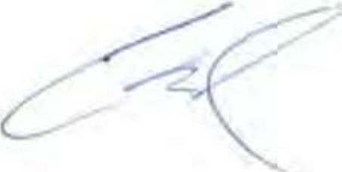
Michael Kaigler Dwayne Stephens Coren Ross
Tom Woiwode Laureen Boles Amanda Wil on
Karen Jarrett- Chairwoman Joseph Ervin

PLANNING COMMISSION VOTE: Approve Staff Recommendation. (7-0)

APPROVAL  Votes: 7 | DENIAL  Votes: | ABSENT | Abstain | Recused | Online
Jarrett |  | Welch Notrica Amick Coles  Ros Plunk |  |  | Stephens
Boles
Woiwod
Ervin
Wilson
Kaigler
Melder
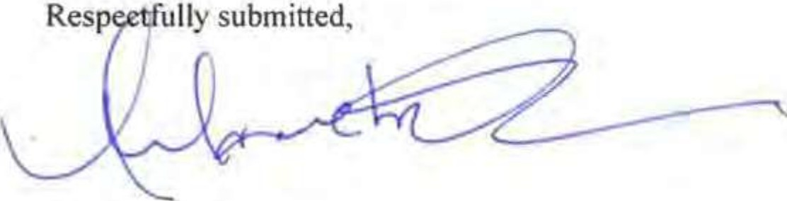
Melanie Wilson
Executive Director and CEO

MW/sh Enclosure
cc Mark Massey Clerk of Council
Lester B. Johnson Assistant City Attorney Jennifer Herman, Assistant City Attorney Bridget Lidy. Department of Inspections


CHATHAM COUNTY-SAVANNAH METROPOLITAN PLANNING COMMISSION

"Planning the Future, Respecting the Past"
Council Report

To: From: Date: Subject:
City Council
Planning Commission November 19, 2024 Zoning Map Amendment
Applicant/Agent: Jeff Jepson, Evans General Contractors
Michael Garcia, LS3P Associates, Ltd.
Address: 1001 and 1015 Whitaker Street, and 120, 124 West Park Street
PIN: 20044-25001, 20044-25002, 20044-240031 and 20044-24002
Alderman District: 2 - Alderman Detric Leggett
Chatham County Commission District: 2 - Malinda Scott Hodge
Request: Rezone from TN-1 (Traditional Neighborhood-1) to TC-2 (Traditional Commercial-2)
File Number: 24-005815-ZA

Request
The Petitioner requests amendment of the Zoning Map from Traditional Neighborhood-1 (TN-1) to Traditional Commercial-2 (TC-2) in association with a proposed office building and retail use with accessory underground parking facility. The request is contingent upon approval of a concurrent request to amend the FLUM for 'Traditional Commercial' use (24-005816-ZA-FLUM). Only the rezoning of the subject parcels is under consideration at present. Variances to development standards of the requested zoning district cannot be considered until a decision is made for the rezoning by City Council.
The amendment is requested to enable utilization of four existing parcels to construct 3 office buildings with an underground parking facility that is intended to serve both the proposed structures and the general public for off-street parking needs in the vicinity of Historic Forsyth Park.

On March 28. 2024 Savannah's City Council endorsed a development agreement with Forsyth Park Commons, LLC for an underground public parking garage. Per the agreement, the partnership would result in the construction of a 2-story underground parking garage with 450 spaces to support the estimated 115,000 square foot office use. One hundred of the spaces are to be made available to the public during business hours and all spaces made available to the public after business hours and on the weekend.
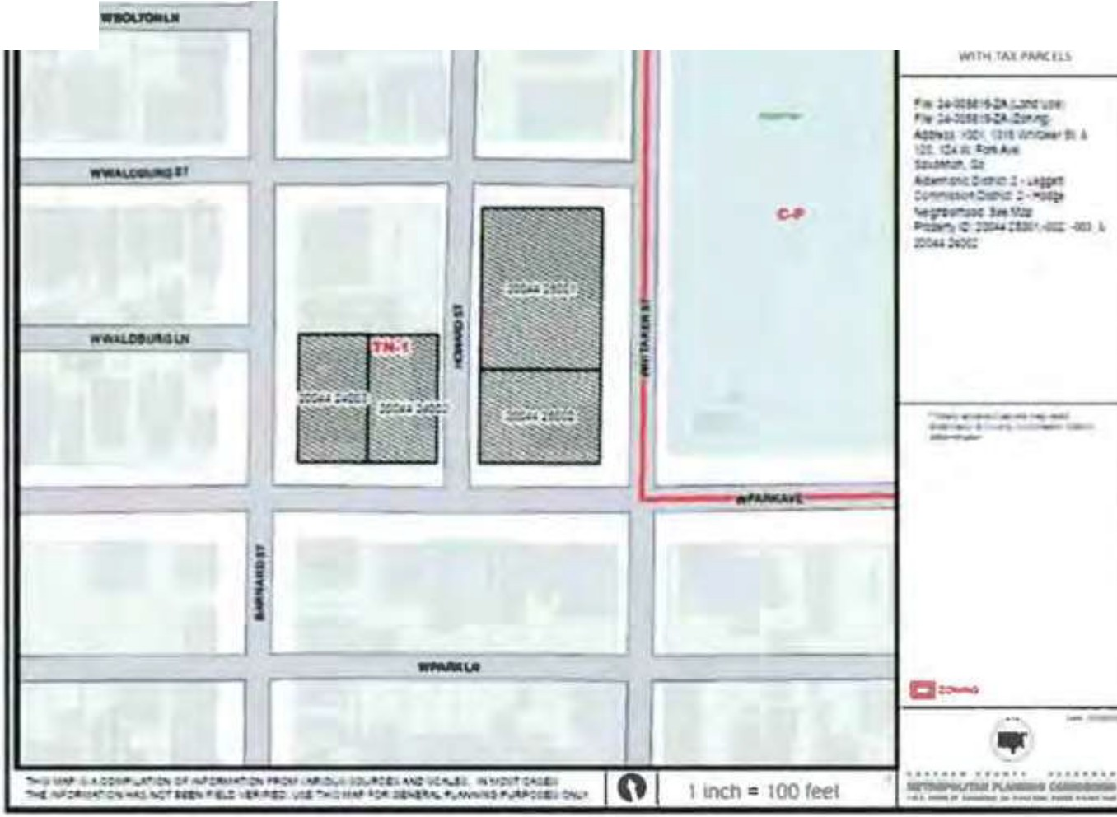
ZONING
MAP
Current Zoning Map
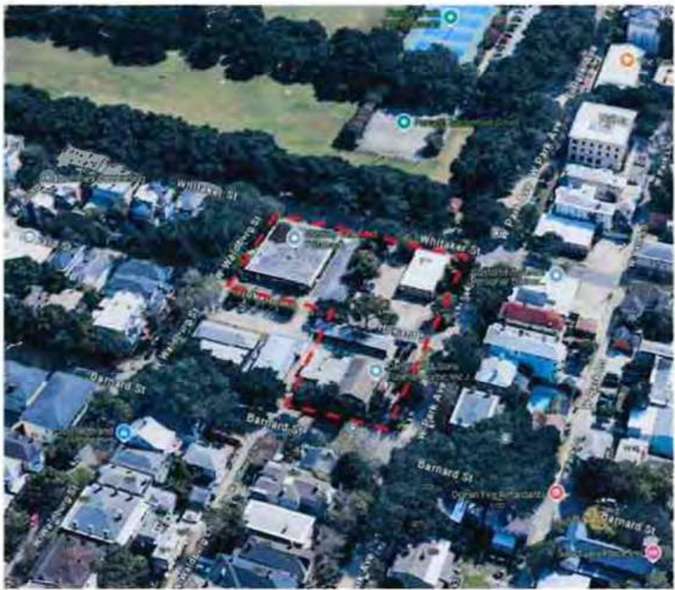
Subject Parcels

Facts and Findings Site
The four subject parcels consist of approximately 0.966 acres (42,114 square feet) in total across two
blocks. The development will effectuate the recombination of two parcels fronting Whitaker Street, which will result in parcel 1 having 236 feet of frontage with 113 feet in depth (26,668 square feet). The remaining two parcels fronting West Park Avenue will be recombined (parcel 2) resulting in a parcel 118 feet wide by 130.9 feet deep (15,446 square feet).

Existing Zoning and Development Pattern

The subject parcel is currently zoned TN-1 (Traditional Neighborhood-1). This zoning district permits the development of the full spectrum of residential uses up to office and neighborhood-scale commercial uses.

Location | Land Use | Existing Zoning
North | Dwellings | TN-1
South | Dwellings, Commercial (Office, Fitness Studio) | TN-1
East | Parks and Recreation (Forsyth Park} | C-P
West | Dwellings | TN-1

Each of the subject parcels presently contains principal use nonresidential structures: two mid-century office buildings and a mortuary formed from the merging of two historic residences. According to the District Resource Map, none of the structures in question were designated as 'contributing' to the character of the District. Demolition of all three structures is proposed contingent upon approval of a COA for the proposed office building. The structures to be demolished are not characteristic of the District's period of significance, neither are they conforming with regard to the current development standards of the District, which were adopted well after their construction.

Public Notice

Mailed notice of the Planning Commission meeting was sent to all property owners within 300-feet of the subject property, signs were posted on site and required newspaper advertisements were run at least 15 days prior to the meeting. The mailed notice included instructions on how to access the public meeting via the internet.

Neighborhood Meetings

The Petitioner has presented the concept both at a general meeting of the Victorian Neighborhood Association (VNA) and with its leadership at critical intervals in the project's development. Several meetings were held with leadership of the Historic Savannah Foundation, the Downtown Neighborhood Association, and other concerned residents and neighborhood groups.

Impact and Suitability Public Servies and Facilities
The proposed developments would be served by City water, sewer and stormwater systems. Preliminary discussions have taken place with all plan reviewing departments to discuss potential on and off-site infrastructure improvements. The Plan must ultimately receive site plan approval of all departments following any zoning-related approvals by City Council and the MPC.

Comprehensive Land Use Plan Element

The rezoning request was filed concurrently with a request to amend the Future Land Use Map to reflect Traditional Commercial use on the subject parcel. At the time of the request, the parcel was designated for Traditional Neighborhood Character. As the name suggests, this Character Area would permit rezoning only to a Traditional Neighborhood (TN) zoning district. Traditional Commercial is described as 'Business areas in close proximity to Downtown Savannah or in outlying historically settled areas. This category includes commercial uses that should be compatible with the character and scale of adjacent neighborhoods, most often found along collectors and arterials. Characteristics include walkability, limited or on street parking, and multi­ tenant retail.' Staff supports the FLUM amendment as the parcel is on a major thoroughfare, and in proximity of other parcels already functioning in a principally commercial capacity.
The proposal would not introduce new or inconsistent principal uses but would introduce structures larger in scale and increased in intensity. The requested amendment is arguably more akin to a correction of the future land use map to reflect uses already in place for several decades than introduction of something wholly new. The requested FLUM designation more closely represents the Plan 2040 Character Area designation of existing and proposed uses of the arterial-fronting site.

Existing Zoning District

- Intent of the TN Zoning District: The Traditional Neighborhood ("TN-") districts are established to allow residential-oriented mixed-use development in areas that were established in the 19th and early 20th centuries. Residential uses are the foundation of the TN- districts, but each TN- district also allows a mix of non-residential uses. It is this mix of residential, commercial, and institutional uses that distinguishes TN- districts from Residential Single Family (RSF) and Traditional Residential (TR) districts. The TN- districts are listed below.

- Allowed Uses: The uses allowed in the zoning district appear in the attached chart.

- Development Standards: The development standards of the TN-1 zoning district appear in the attached chart.

4

5.12.5 Development Standards for Permitted Uses
De op en n elopme" .a da'Cfs s ; 'o h bel

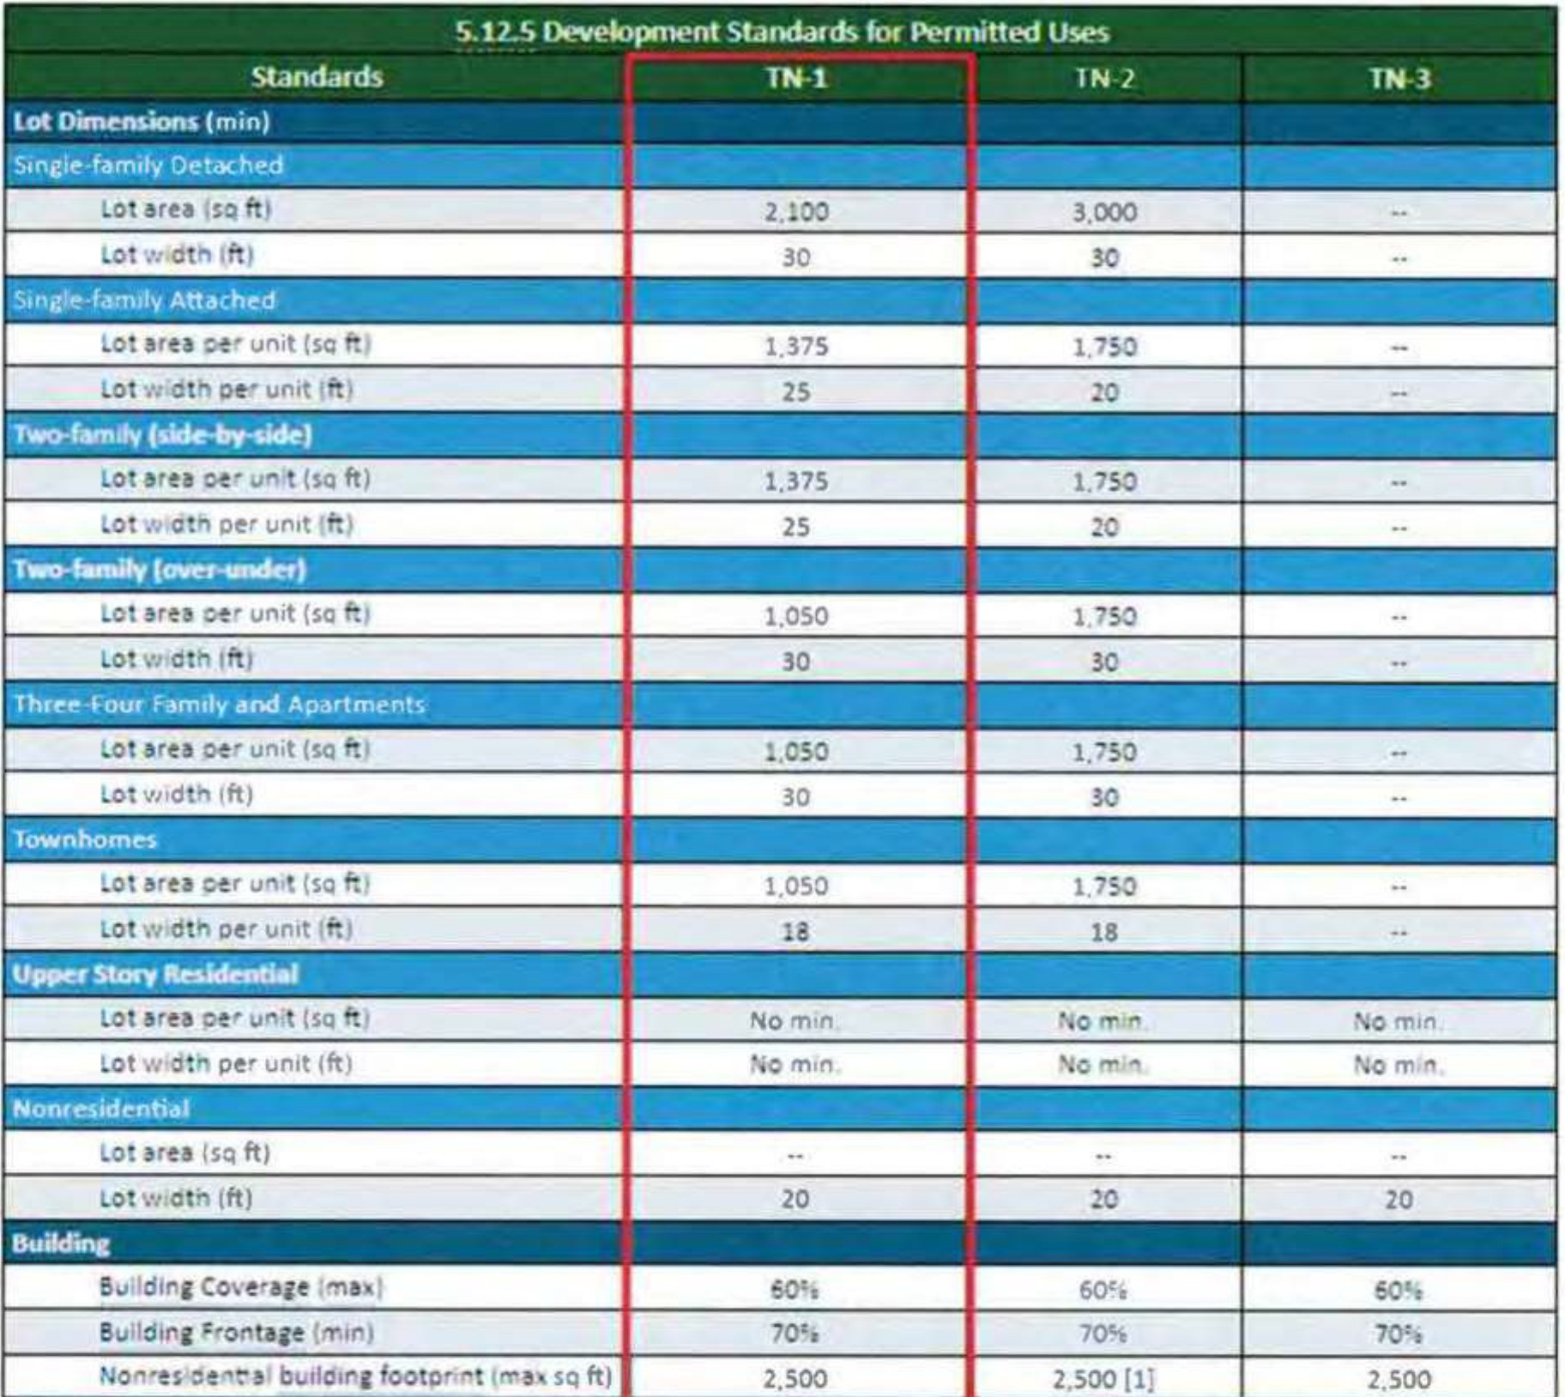

Bulcfinc Setbecb (ft}
s,x;: tsliill . _ -_- - rvc_t .r • -;-_ - , _ - '.: - .

_. ;

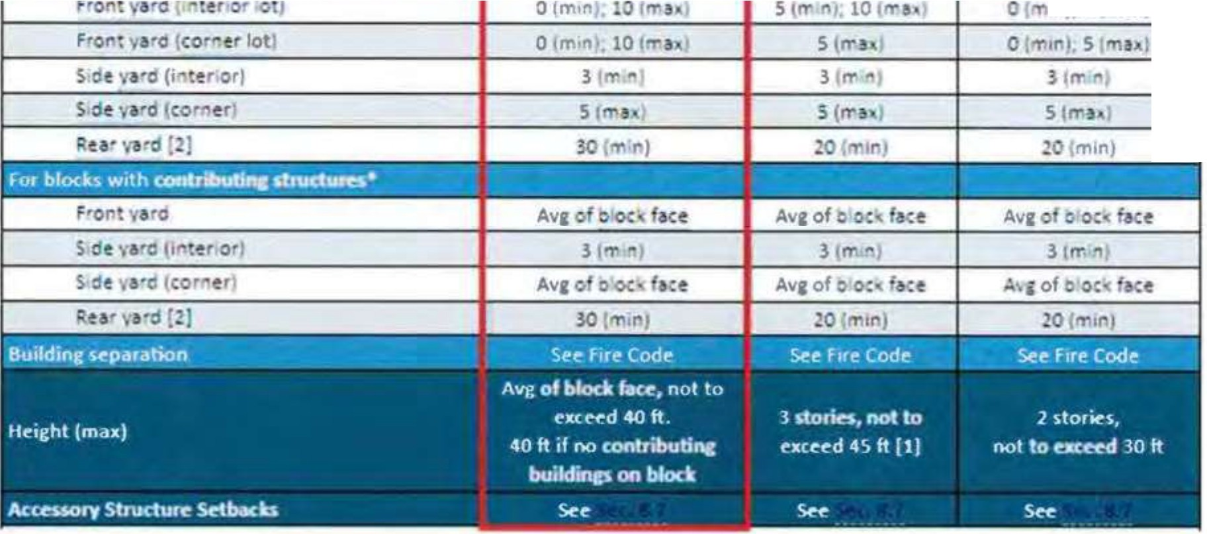
1r1 S mt
s

Proposed Zoning District

- Intent of the TC-2 Zoning District: The Traditional Commercial (TC) districts support mixed-use, commercially oriented development in areas dating from the 19th and early 20th centuries, emphasizing a "Main Street" character with pedestrian-friendly design and historic continuity. These districts, often adjacent to Traditional Neighborhood (TN) and Traditional Residential (TR) zones, foster sustainable neighborhoods with convenient local commercial access. The TC districts vary in intensity, with TC-1 being the least intense and TC-2 the most, aimed at supporting vibrant, historically patterned commercial corridors in historic neighborhoods, especially those from Savannah's streetcar and early automobile periods.

- Allowed Uses: The uses allowed in the TC-2 zoning district appear in the attached chart.

- Development Standards: The development standards of the TC-2 zoning district appear in the attached chart.
5.lS.5 Dewlopmenl S-1.1ndard1 for l'erm ed u-
0. 't "' ft '" TC dlnt,CI lhall mHt Ille • ,op,,, I l:)1'Cll!$ u set forth bflo .,_

"> 11 \ O.•wlnprrwnl \l.1nd.1111\ IO,f m.llrd IIW"I
nd,11d, I< I ll 1
l<ll 1.-J
libi - ., - .... ' ·-.· - -' ,, -=-- - --· - :
Lo,1ru oe,. unit ,s..: ft,
'"
lOl w dth p.e- 1.tn t ,fU
,,.
I
I
I
.IC
I
.IC
l •SO
11
12.00
11
-
..
... .
LO\\."Jd\nlftl
..
lOtltUM""un•tll<I tt,
Lat ·11 4th 1ft1
I
I
I
I
1.500
JO
- SOC>
lO
=
l.olWdl"lltJ
-Lot a.rH oe,. un,t (so ftl
\.Ot ltH Ot wn,t [1,Q ftl
1,.0twolns:ie.'unitift:)

L.ol tt • CM'"' wn,t {JC f:I
unw dtn oc,u,,,\ .ft,
I I
I
I
!.'SO
1•
uoo
\I
·"
"'"
om,n
I
,1
I 450
)0
1100
)0
I I
I
I
I I
•J
lO
lk, ldm1C<wenoct 1"1.. 1
a.,,,c1,.,. "onQl'f jnun)
-
20
-
I I
I
I
I I
•JS
30
-
20
-
700,,
I I
...,'",.
NO,nl"!
!'! .,
l0flttlot:'Uft•t¹k:'ft:I
LOl'itOt '"'

Lot 1rt•1so "'
LOtwd1h(ftt

,.,,.;m. .--..-..--
a.-. -lftl
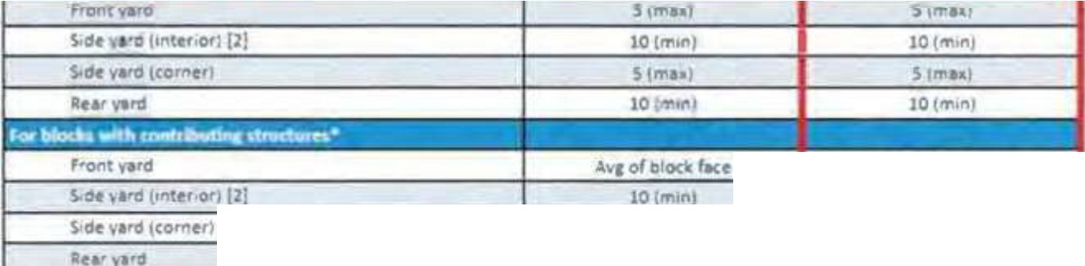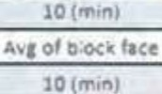
A."1' of o oc face
Ayt of b occ f1<t
10(•,unj
lkulcfonc ..,,.; ,_, 5ttfi,• Cod .s.,'.iil. - • _•
H•IIWl-1111 111°""...,1o4\ft ,.,.,,1n..,.1ot II
A&,_tt90l"fS&.IWdwf'

Zoning Ordinance Review

The following review criteria for rezoning are prescribed in the Savannah Zoning Ordinance Sec. 3.5.8:
Suitability and Community Need
- Whether the range of uses permitted by the proposed zoning district is more suitable than the range of uses that are permitted by the current zoning district.
MPC Comment: The anticipated use intensity at this location is more consistent with the requested zoning district than the present. The "traditional" character areas (and associated zoning districts) are closely related by design and cumulative in nature, with each higher classification representing a slight increase in density and/or use intensity. Regardless of the use the intent of the District is that development be compact and walkable in its form, contributing to the relatively dense, historic urban context in which it is situated.
As the intended use of the site is known, restriction of uses permissible in the requested district deemed inappropriate as well as restrictions on issuance of permits for redevelopment may be reasonable considerations in conditioning approval of the requested rezoning.

- Whether the proposed zoning district addresses a specific need in the county or city.
MPC Comment: While dated, the Parking Matters study conducted in 2016 offers valuable recommendations related to the strategic development of public parking assets in key redevelopment areas. The Victorian and Mid-City districts contain several parcels that are 1) already approved for new development, 2) presently developed as noncontributing structures, or 3) vacant, which will introduce significant new developments requiring off-street parking for which provision has not yet been made. The location of the proposed asset within this general area could be seen as consistent with the findings of this study.
Serious consideration should be given to implementation of other associated Study recommendations such as the adjustment of parking pricing policies and strategic expansion of mobility options. Extension of fixed-route circulator services, in particular, along with thoughtful planning for accessibility of key neighborhood activity centers could encourage parking garage use among visitors, stabilizing circulation through the City's growing urbanized neighborhoods.

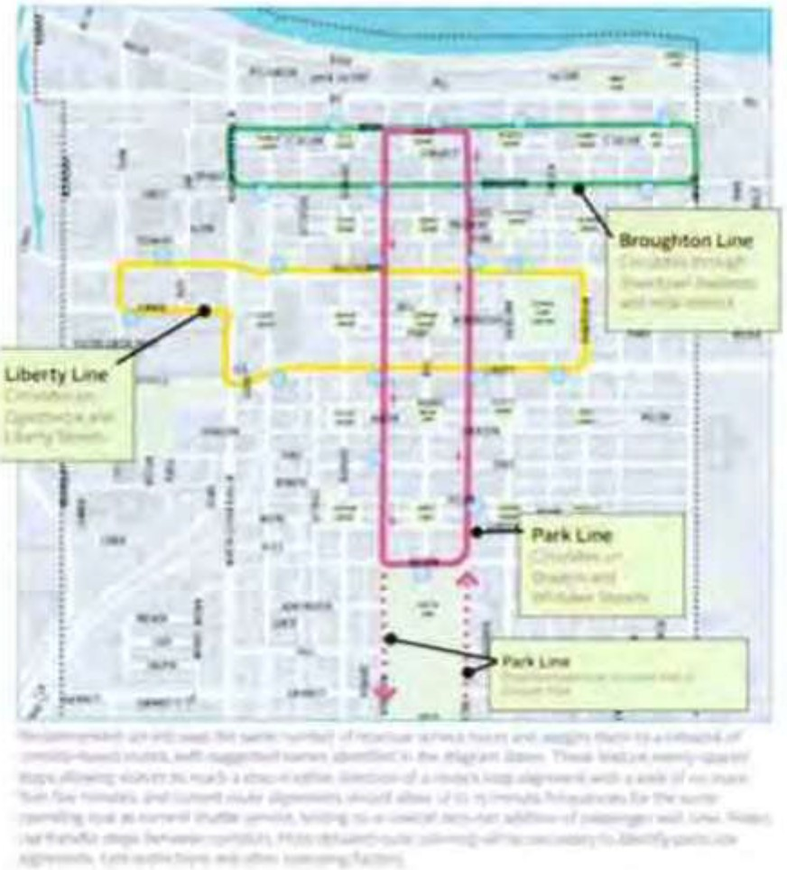
3-1 Pl n for u ur p rkmg ga s nd expansion
o supply through coordination with d v lopm n and I nd u e planning

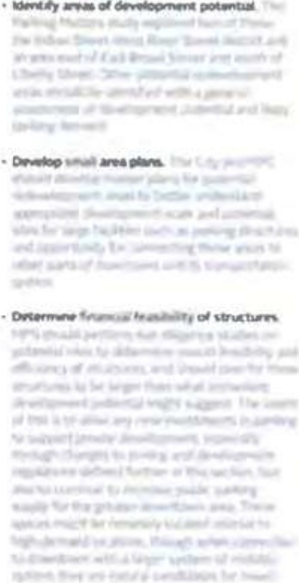
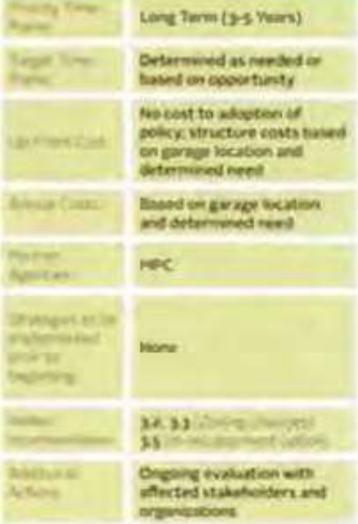
. &otl:MAfll)t,fCUCJr,,a.t,11(1


Excerpts from 2016 Parking Matters study

- Whether the zoning proposal will adversely affect the existing use or usability of adjacent or nearby property.
MPC Comment: The request is not likely to adversely affect existing use or usability of adjacent properties. Given that the site is arterial fronting on a comer, use intensification at this particular location is consistent with the intent of the existing and proposed zoning districts and the intent of the policies of the Comprehensive Plan.

5.12.8 Additional Requirements Applicable to the Tr1dltfon1I Neighborhood Districts
- All TN- Districts
  - Del" ies shall be rem,cted to the hours of 8:00 a m. to 8:00 p.m., any day of the wee .
  - Hours of o ration for commercial uses shall be limit4!'d to:
    - 6:00 a.m. until 10:00 p.m., Sunday through Thursday; and
    - 6:00 a.m. unnl 11:00 p.m., F11day and Sa urday.
  - Drive• hru service is not permi ed.
  - Accessory s ructures with a roof must be located in the rear yard.
  - Pnncipal use dwellings shall be a minimum of 450 square feet.
v1. On intenor lots, perm, ed nonres dential uses are allowed only on the ground floor
- TN·l District
  - Nonresiden '111uses shall be located on a corner lot and abut a street that is clauih_d as a collector or greater.
ii lots of record existing as of the Effective Date of his Ordinance. shall be utilized to d ermine he extent to which the comer lot prOV1sion of this S4!'cnon shall be allowed. The recombination of parcels 1s permitted but shall not be used as the basis for the e pansion of non-res dential usage beyond a distance of 60 fee as measured from the
pro rty line beginning at the corner | .
'TN' Standards currently favor use intensification on comer lots

- Whether the zoning proposal is compatible with the present zoning pattern and conforming uses of nearby property and the character of the surrounding area.
MPC Comment: The proposed uses are permitted within the present zoning district and office use has been the principal use of the majority of the site for several decades.
The "traditional" character areas (and associated zoning districts) are closely related by design and cumulative in nature, with each higher classification representing a slight increase in density and/or use intensity. The TC district is often placed adjacent to Traditional Neighborhood (TN) and Traditional Residential (TR) zones to foster sustainable neighborhoods with convenient local commercial access. The present request is made to permit intensification of use consistent with the parcels' location on a comer and adjacent to a high-volume thoroughfare.

- Whether there are other existing or changing conditions affecting the use and development of the property which give supporting grounds for either approval or disapproval of the zoning proposal.
MPC Comment: The request represents a response to the changing and growing nature of the local real estate market. Protective measures are in place to ensure preservation of historic structures; the traditional districts with the Zoning Ordinance permit growth in a form that enhances and extends the existing development pattern, allowing it to be responsive to the evolving needs of the community.
The proposal also represents the opportunity to secure a parking asset the City has identified as a priority in advance of significant development/redevelopment. Adequacy of underground parking can ensure the continued integrity of the historic development pattern even as the District develops and redevelops.

Consistency
- Whether the zoning proposal is in conformity with the policy and intent of the Comprehensive Plan and other adopted plans, such as a redevelopment plan or small area plan.
MPC Comment: The requested zoning designation more closely represents the Plan 2040
Character Area designation of existing and proposed uses of the site.

Reasonable Use
- Whether the property to be affected by the zoning proposal has a reasonable use as currently zoned.
MPC Comment: The subject parcel has reasonable use as presently zoned and developed; though, it should be noted some aspects of the existing structures and configuration are legal nonconforming. The site could reasonably be redeveloped under the development standards of the TN-1 district.

Adequate Public Services
- Whether adequate school, public safety and emergency facilities, road, ingress and egress, parks, wastewater treatment, water supply and stormwater drainage facilities are available for the uses and densities that are permitted in the proposed zoning district.
MPC Comment: Adequate City seNices will be available to seNe the proposed use. The Developer is aware that satisfaction of all current development standards and approval of all reviewing departments will be required for issuance of site development permits.

Proximity to a Military Base, Installation or Airport
MPC Comment: The subject parcel is not within an installation A/GUZ or APZ, nor is it in proximity of an airport.

Recommendation

In the absence of a zoning district that adequately captures the characteristics and nuance of the increasingly commercial-dominant mixed-use nature of development along higher volume corridors in the Victorian District, the Planning Commission recommends approval of the request to rezone to Traditional Commercial-2 (TC-2) with the following condition:

1) Permissible uses shall consist only of those permitted in the TN-1 zoning district and only in accordance with all applicable supplemental use standards.

Note: The above represents MPC Staffs recommendation of approval only for the requested rezoning. Variances to development standards shall only be considered upon a final determination of the requested rezoning by City Council.

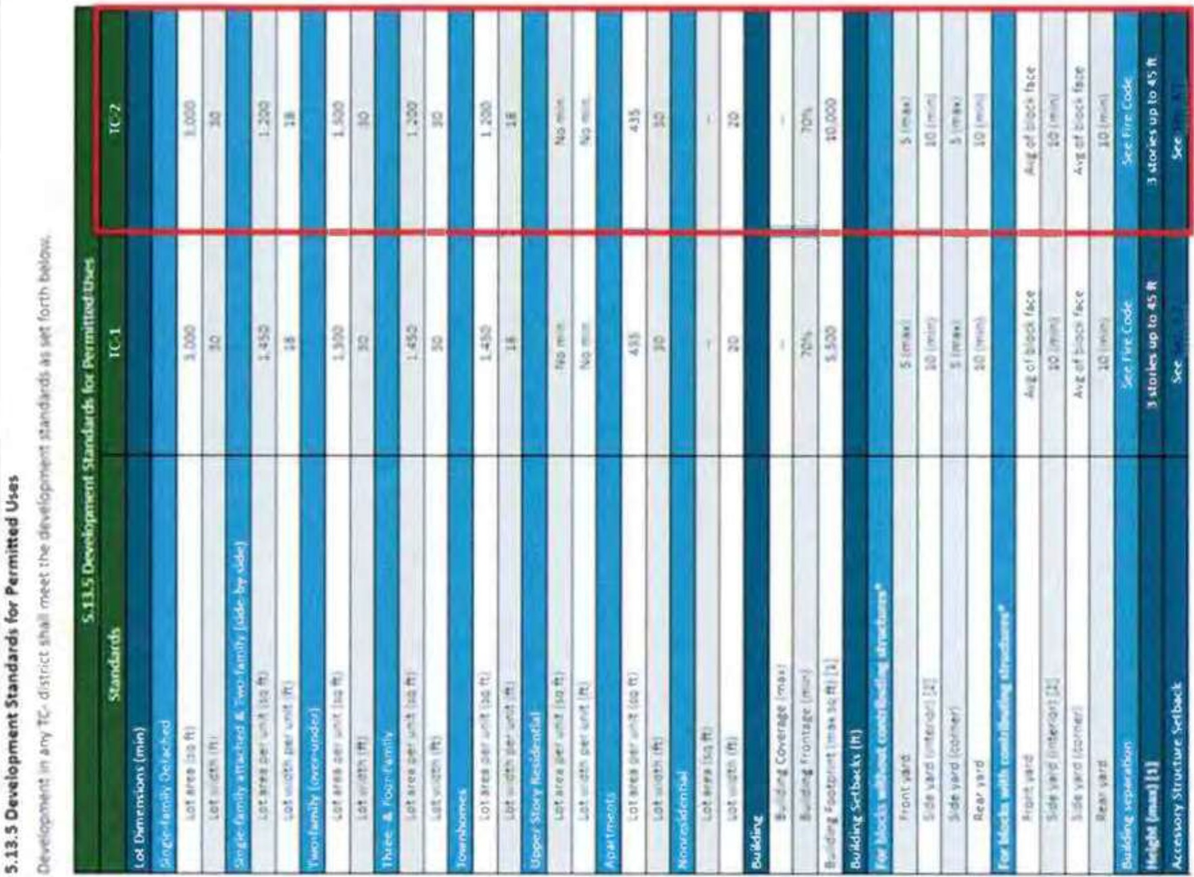
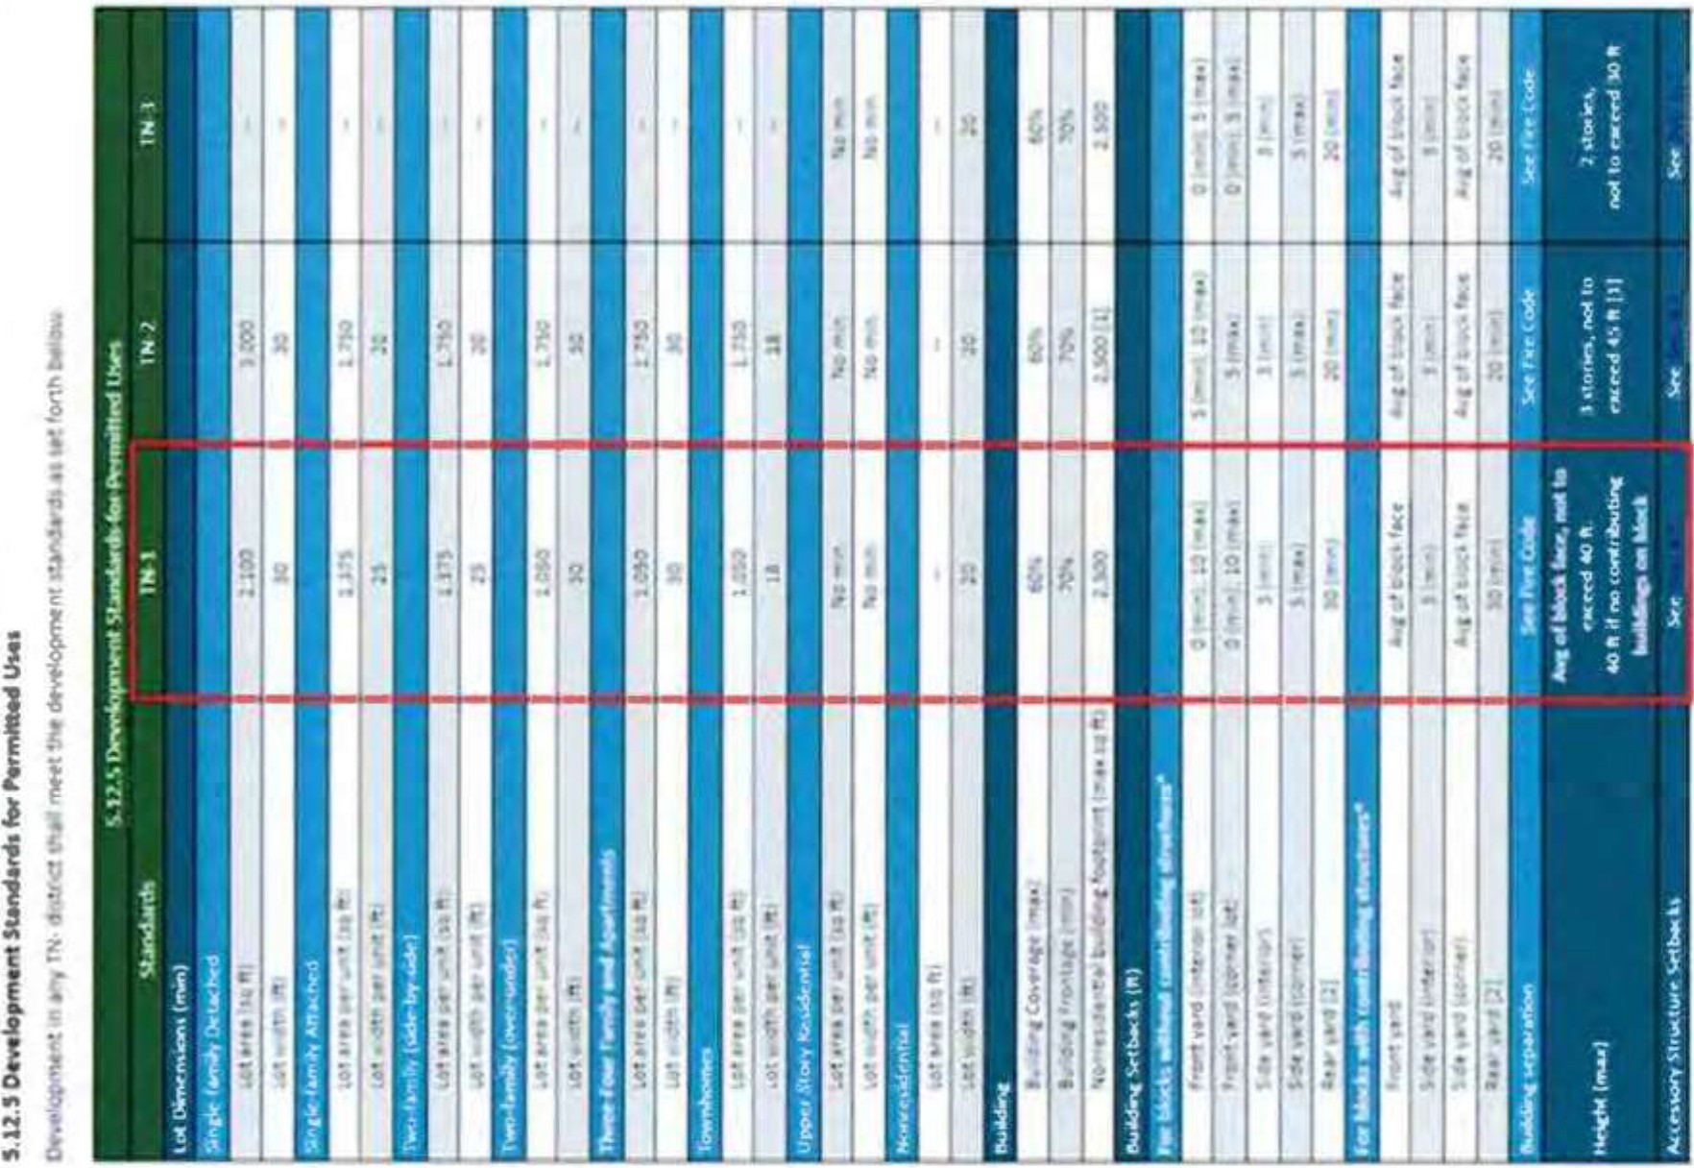


CHATHAM COUNTY-SAVANNAH

METROPOLITAN PLANNING COMMISSION
"Planning the Future - Respecting the Past"
M E M O R A N D U M

DATE: November 19, 2024
TO: THE MAYOR AND ALDERMEN OF THE CITY OF SAVANNAH FROM: METROPOLITAN PLANNING COMMISSION
SUBJECT: Future Land Use Map Amendment

PETITION REFERENCED:

Petitioner: Jeff Jepson

Agent: Michael Garcia

Address: 1001 and 1015 Whitaker Street, and 120 and 124 West Park Street

Alderman: District - 2 - Detric Leggett

County Commission: District - 2- Malinda Scott Hodge
Property Identification Number: 20044- 25001, 25002, 24003, 24002

Petition File No.: 24-005816-ZA

MPCACTION:

The Planning Commission recommends approval of a Future Land Use Map amendment from Traditional Neighborhood to Traditional Commercial, consistent with long standing uses on the subject parcels and adjacency to a minor arterial.

MPC STAFF RECOMMENDATION:

MPC Staff recommends approval of a Future Land Use Map amendment from Traditional Neighborhood to Traditional Commercial, consistent with long standing uses on the subject parcels and adjacency to a minor arterial.

FLUM Amendment File No. 24-00S816-ZA
MPC Page 2 of 2
November 19, 2024 Page2


MEMBERS PRESENT: 8

Michael Kaigler Dwayne Stephens Coren Ross
Tom Woiwode Laureen Boles Amanda Wilson
Karen Jarrett - Chairwoman Joseph Ervin

PLANNING COMMISSION VOTE: Approve Staff Recommendation. (7-0)

APPROVAL  Votes: 7 | DENlAL  Votes: | ABSENT | Abstain | Recused | Online
Jarrett |  | Welch |  |  | Stephens
Boles |  | Notrica
Woiwode |  | Amick
Ervin |  | Coles
Wilson |  | Ross
Kaigler Melder |  | Plunk

Respe ully submitted,
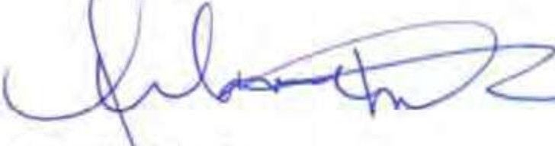
Melanie ilson
Executive Director and CEO

MW/sh Enclosure
cc Mark Massey, Clerk of Council
Lester B. Johnson, Assistant City Attorney Jennifer Herman Assistant City Attorney Bridget Lidy Planning and Urban Design


CHATHAM COUNTY-SAVANNAH METROPOLITAN PLANNING COMMISSION
11Planning the Future, Respecting the Past"

Council Report

To: From: Date: Subject:
City Council
The Planning Commission November 19, 2024
Comprehensive Plan - Future Land Use Map Amendment Applicant/Agent: Jeff Jepson, Evans General Contractors
Michael Garcia, LS3P Associates, Ltd.
Address: 1001 and 1015 Whitaker Street. and 120 and 124 West Park Street
PIN's:20044-25001, 25002, 24003,24002
Site Area: 0.97 acres
Aldermanic District: 2 - Detric Leggett
Chatham County Commission District: 2 - Malinda Scott Hodge
File Number: 24-005816-ZA-FLUM

Request:

The Petitioner requests amendment of the Future Land Use Map from Traditional Neighborhood to Traditional Commercial in association with a proposed office building and underground parking facility. The request is made concurrently with a request to rezone the subject property.

Background:

The amendment is requested in connection with a proposed development that will utilize four parcels to construct 3 office buildings with an accessory underground parking facility that is intended to serve both the proposed structures and the general public for off-street parking needs in the vicinity of Historic Forsyth Park.

On ch 28 202 Savannah's City Council endorsed a development agreement with Forsyth Park Commons, LLC for an underground public parking garage. Per the agreement, the partnership would result in the construction of a 2-story underground parking garage with 450 spaces to support the estimated 115,000 square foot office use. One hundred of the spaces are

Comprehensive Plan - Future Land Use Map Amendment
1001 and 1015 Whitaker Street, and 120 and 124 West Par1< Street Jeff Jepson and Michael Garcia
24-005816-ZA-FLUM


to be made available to the public during business hours and all spaces made available to the public after business hours and on the weekend.
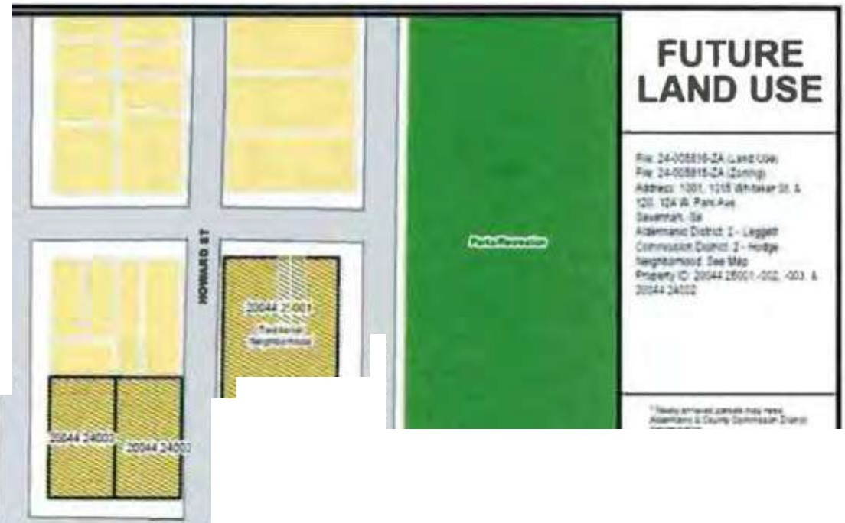
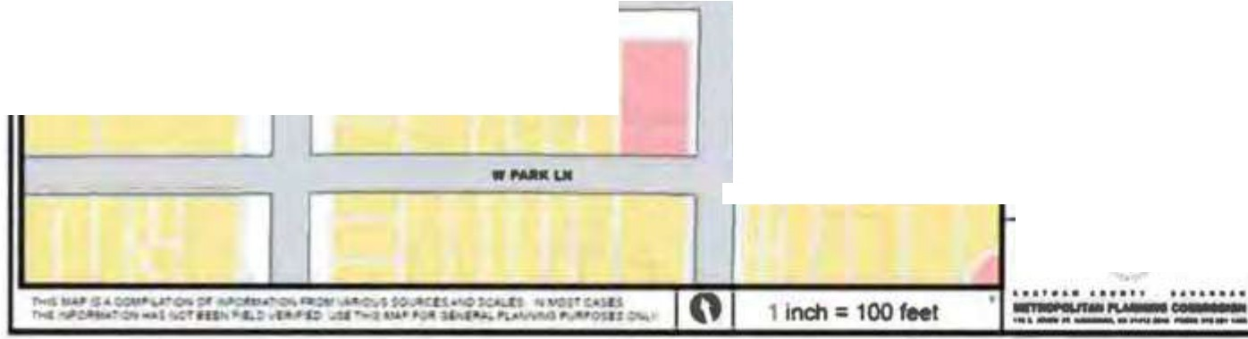

Weot,.T'OIIUI
•-UI
I : ,
l1
=
L _:-
i
·--
-·­
·•-"''-­
, 1
- ·-··-
•

Future Land Use Map
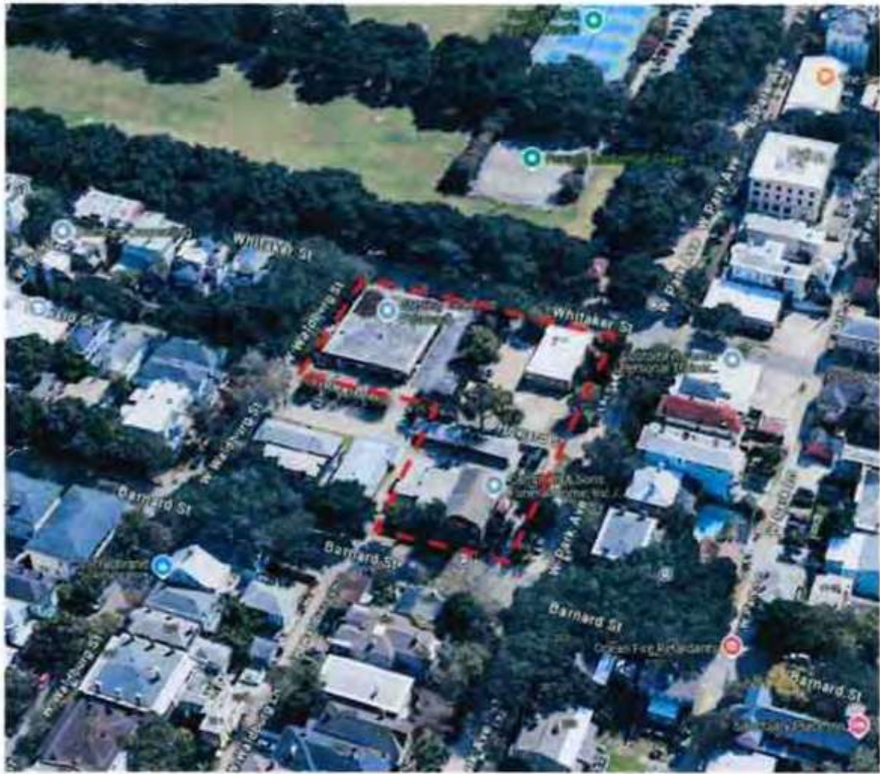

Subject Parcels

Comprehensive Plan - Future Land Use Map Amendment
1001 and 1015 Whitaker Street, and 120 and 124 West Parle Street Jeff Jepson and Michael Garcia
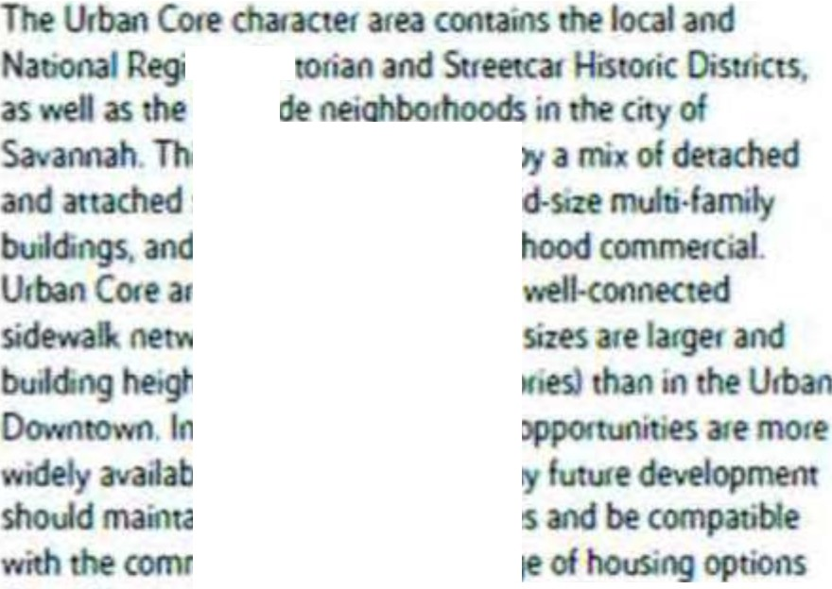
24-005816-ZA-FLUM
s er Vic
EaStsi
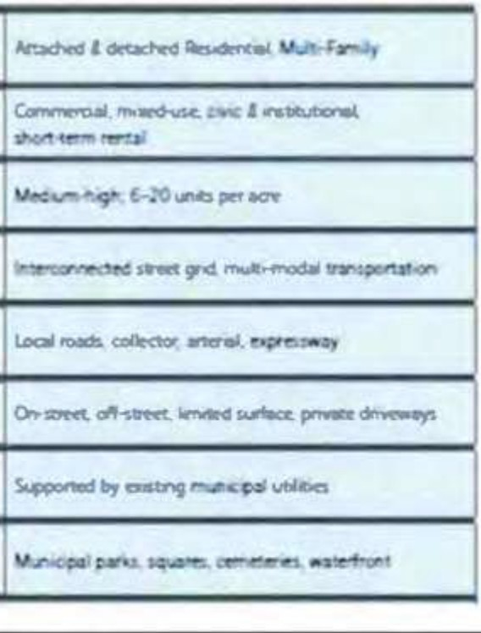
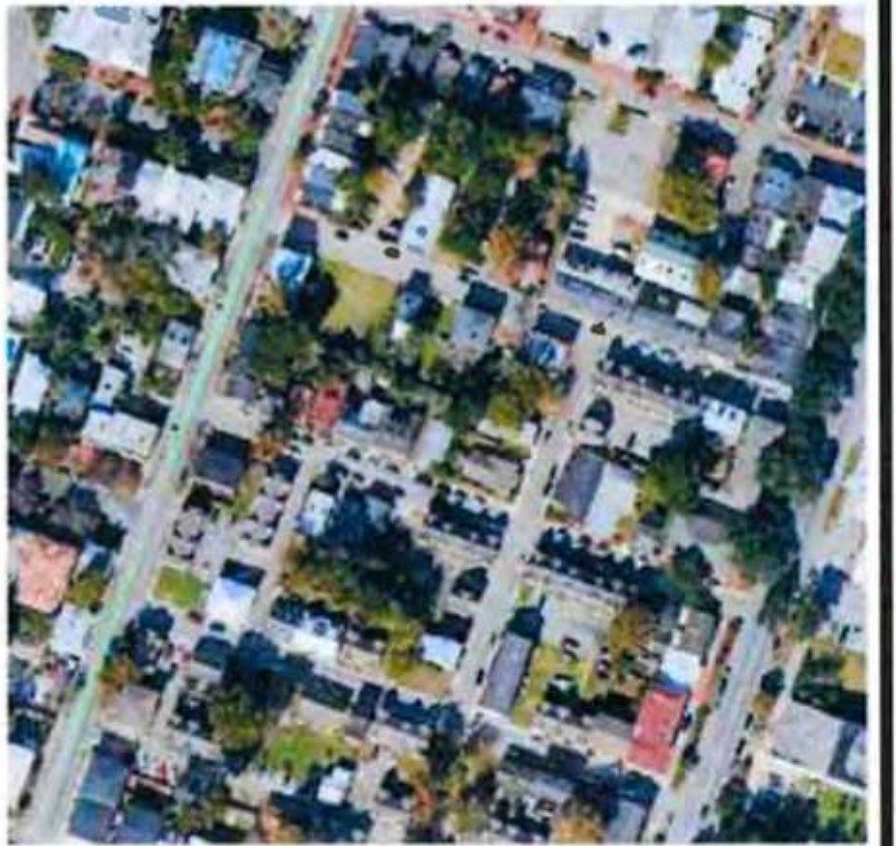
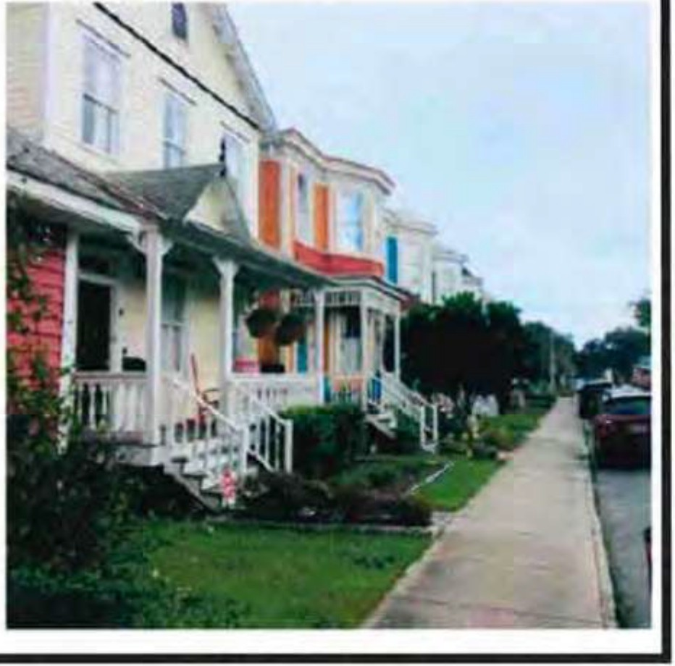
URBAN CORE
should be Co, t0 accommoda e
s, S'lud , small fam· es ·o,s and o he.<s.
NI AaYUSU SICO OAllY USIS DI SITY
TitANSPORTATION

1104'> FU CT. CUSS

PAJlltl G

UTIUllU

OPI SPACl
'Urban Core' - Plan 2040 Character Area Designation of the Subject Properties

Evaluation:

Within the City of Savannah, the Zoning Ordinance requires amendments to the zoning map to be consistent with the FLUM. In essence, amendment of the FLUM very technically signals appropriateness of only specifically identified zoning districts. NewZO requires a Future Land Use designation of 'Traditional Commercial' for property to be rezoned to a Traditional Commercial (1 or 2) zoning district.

Comprehensive Plan - Future Land Use Map Amendment
1001 and 1015 Whitaker Street, and 120 and 124 West Park Street Jeff Jepson and Michael Garcia
24-005816-ZA-FLUM

Consideration of the following points may serve to elucidate whether the proposed amendment meets the intent of published policy documents:

- The relationship of the proposed amendment to the existing and future land uses depicted in the Future Land Use Map.

MPC Comment: The Future Land Use map presently designates the subject parcels for 'Traditional Neighborhood' use. By definition, these include "Residential areas in close proximity to downtown or in outlying historically settled areas. This category includes non­ residential uses that are compatible with the residential character of neighborhoods."

The requested 'Traditional Commercial' designation is intended for "Business areas in close proximity to downtown or in outlying historically settled areas. This category includes commercial uses that should be compatible with the char<1cter and scale of adjacent neighborhoods, most often found along collectors and arterials. Characteristics include walkability, limited or on-street parking, and multi-tenant retail.•

Each of the subject parcels presently contains principal use nonresidential structures: two mid-century office buildings and a mortuary formed from the merging of two historic residences. According to the D1s1nct Resource M p, none of the structures in question were designated as 'contributing' to the character of the District. Demolition of all three structures is proposed contingent upon approval of a COA for the proposed office building. The structures to be demolished are not characteristic of the District's period of significance, neither are they conforming with regard to the current development standards of the District, which were adopted well after their construction.

The proposal would not introduce new or inconsistent principal uses but would introduce structures larger in scale and increased in intensity. Existing offices range in size from approximately 2,800 square feet in gross area to approximately 8,000 square feet. Proposed are structures closer to 10,000 square feet in floor area with multiple stories. Aside from the specific development proposed, however, it should be noted that the requested amendment is arguably more akin to a correction of the future land use map to reflect uses in place for several decades than introduction of something wholly new. The requested FLUM designation more closely represents the Plan 2040 Character Area designation of existing and proposed uses of the arterial-fronting site.

- The relationship of the proposed amendment to any applicable goals, objectives, policies, criteria, and standards adopted in the Comprehensive Plan.

MPC Comment: The requested 'Traditional Commercial' FLUM designation more closely represents the Plan 2040 Character Area designation of the site as well as the nature of its current and future uses.

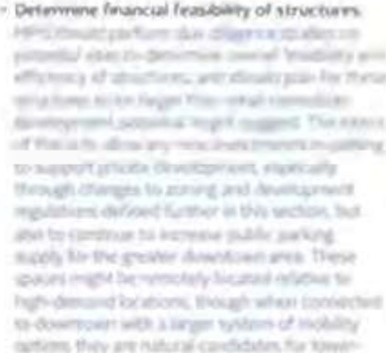

Comprehensive Plan - Future Land Use Map Amendment
1001 and 1015 Whitaker Street, and 120 and 124 West Park Street Jeff Jepson and Michael Garcia
24-005816-ZA-FLUM

The "Traditional" character areas (and associated zoning districts) are closely related by design and cumulative in nature, with each higher classification representing a slight increase in density or use intensity. Regardless of the use the intent of the District is that development be compact and walkable in its form, contributing to the relatively dense, historic urban context in which it is situated.

The specifically proposed development seeks to enhance District character through restoration of the traditional development pattern where it has been lost and construction of architecturally significant structures on the subject parcels.

- Other professional planning principles, standards, information and more detailed plans and studies considered relevant.

MPC Comment: The "Parkina Matters" study, conducted in 2015 and 2016 by CORE MPO and the City of Savannah, addresses parking challenges in downtown and other dense areas. The report proposes strategies to improve parking and mobility, such as encouraging a "park once" behavior to reduce auto trips and parking demand. The report also recommends the creation of small area plans to facilitate the strategic establishment of new structures in redevelopment areas likely to experience significant future parking demand.

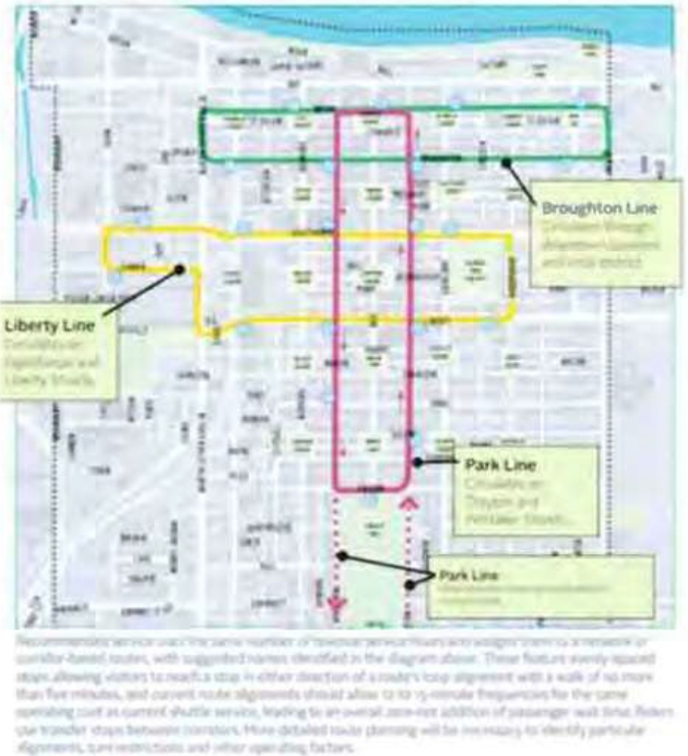
3,: Plan for ru ur parkm gara e.s and ex ansions
to supply through coordination with



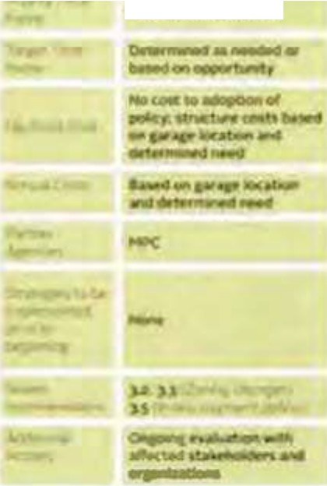
d velopment and land use planning
1--1,H\'nnj

Comprehensive Plan - Future Land Use Map Amendment
1001 and 1015 'Mlitaker Street, and 120 and 124 West Park Street Jeff Jepson and Michael Garcia
24-005816-ZA-FLUM

Additionally, the Forsvth Park Master Plan, while intended to be a guide, contemplates additions and modifications to the Park which could benefit from the provision of additional parking in close proximity.

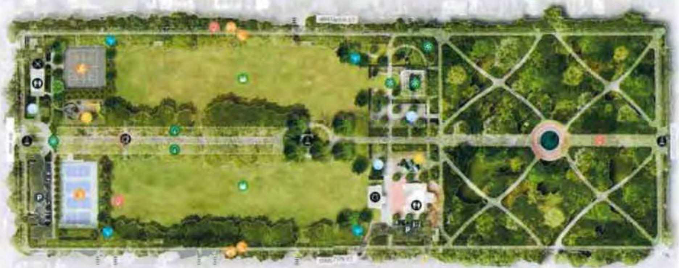
Tnt ,.,,., fors,cn P rt. OHtgo orooostd 0, Fn..,ds ol Fors11!1 Tnt D11n ,nc:udts 1r.
e oan.: \1.sen a,r1 ..'\ ..a'"-dsc• .!r;f'l,:e,c:s
•11t1oom lao!C,es aOdmona 91,dln, <;atll•• n9 ,pacts ana • 0,k1p.tn 1tOU!1d mo 011n,t1or 01

- Written comments, evidence, and testimony of the public.

MPC Comment: MPC Staff has received mixed feedback regarding the proposal, with greater acceptance of the present iteration than the previous concept. The Petitioner's consideration of and response to community concerns resulted in an initial withdrawal to permit creation of the modified concept for the FLUM and rezoning requests presently under consideration.
Public comments have included concern for: an incompatible scale of development, impacts to the structural integrity of historic homes in the vicinity during construction, destruction of mature trees, increased traffic on Howard Street, and the omission of archaeological study of the site.
Staff has received written opposition to the project, favoring maintenance of the more so aspirational 'Traditional Neighborhood' designation the site presently carries.

Recommendation

The Planning Commission recommends approval of the request to amend the FLUM from a designation of Traditional Neighborhood to Traditional Commercial, consistent with long standing uses on the subject parcels and adjacency to a minor arterial.

DEVELOPMENT AGREEMENT
THIS DEVELOPMENT AGREEMENT (this "Agreement") is made and entered into as of this 28th day of March, 2024, by and between FORSYTH COMMONS HOLDINGS, LLC, a Georgia limited liability company ("Forsyth"); SAVANNAH ECONOMIC DEVELOPMENT AUTHORITY, a public corporation of the State of Georgia ("SEDA"); and THE MAYOR AND ALDERMEN OF THE CITY OF SAVANNAH, a municipal corporation existing under the laws of the State of Georgia ("City"). Forsyth, SEDA and City are hereinafter collectively referred to as "Parties" and individually as "Party."
WITNESSETH:
WHEREAS, Forsyth is or will be the owner of six (6) parcels of real estate located in the corporate limits of the City of Savannah adjacent to Forsyth Park and identified by the Chatham County Tax Commissioner as PINs: 20044 25001, 20044 25002, 20044 24001, 20044 24002,
20044 24003, and 20044 24008, and being more specifically described in Exhibit A attached hereto and incorporated herein by reference (the "Property");
WHEREAS, Forsyth desires to develop the Property for commercial and office purposes, including a three (3) story subsurface parking garage and office buildings (the "Project");
WHEREAS, City desires to create public parking adjacent to Forsyth Park;
WHEREAS, in order to facilitate the Project, Forsyth shall convey the Property to SEDA and Forsyth shall demolish the existing structures on the Property and construct on the Property, subject to certain conditions set forth herein, a three (3) level subsurface parking garage for City (the "Parking Garage"), and two or more office buildings to be constructed above the Parking Garage (the "Office Buildings"), and as part of the Project Forsyth shall construct public restrooms at Forsyth Park (the "Public Restrooms").
WHEREAS, SEDA will enter into an intergovernmental agreement with City pursuant to which SEDA will issue a series of bonds ("Bonds"), at the request of City, in the approximate principal amount of Thirty-One Million Three Hundred Fifty Thousand and No Dollars ($31,350,000.00), for the construction of the Parking Garage and the Public Restrooms, including capitalized interest and bond financing and closing costs;
WHEREAS, upon completion of the Parking Garage and the Office Buildings, SEDA shall lease the Parking Garage to City and the Office Buildings to Forsyth;
WHEREAS, the Project will serve as a gateway entrance to City's Historic District and Forsyth Park and City believes that the proposed development of the Property, together with the benefits to be derived from the Parking Garage and the Public Restrooms, will be in the best interests of the citizens of City; and
WHEREAS, Forsyth, SEDA and City now desire to set forth the proposed development of the Property in greater detail and have agreed to enter into this Development Agreement to evidence such understandings, agreements and commitments.

NOW, THEREFORE, for and in consideration of the agreements set forth herein and other good and valuable consideration, the receipt and sufficiency of which are hereby acknowledged, the Parties agree as follows:
- Incorporation of the Recitals. The recitals of this Agreement are incorporated herein as if fully set out below.
- Project. The Property is located south of the Historic District and is generally bounded by Barnard Street to the west, Whitaker Street to the east, West Waldburg Street to the north, and West Park Avenue to the south. Upon the issuance of the Bonds Forsyth will convey the Property to SEDA by Quitclaim Deed (the "Property Deed"), and SEDA and Forsyth shall develop the Property pursuant to applicable laws governing properties located in the Victorian District of the City of Savannah. The Property is currently fully developed as commercial offices. The proposed development will include the demolition by Forsyth of existing structures on the Property, the construction by Forsyth of the Parking Garage in the subterranean portion of the Property, as more particularly described in Exhibit B attached hereto and incorporated herein by reference, and the construction by Forsyth of two or more office buildings on the Property above the Parking Garage on either side of Howard Street (the "Office Buildings"). To the extent that the subsurface construction of the Parking Garage is built under Howard Street or encroaches into Whitaker Street, West Waldburg Street or West Park Avenue, City shall, at no additional cost or expense, grant certain easements and/or encroachment permits under these rights-of-way in order to allow for the construction of the Parking Garage; provided that such improvements do not materially interfere with City infrastructure that serves the general public. The property is located in a FEMA Flood Zone X and it is anticipated that the post re-development storm run-off will be equal to the pre-development run-off, i.e., no additional burden to existing storm infrastructure. City and Forsyth agree to work together to improve stormwater design where practicable, provided that Forsyth shall be required to pay the cost of any stormwater improvements that are required as a result of the construction of the Office Buildings. In addition, as part of the Project, Forsyth will design and construct the Public Restrooms, provided that the location and design thereof shall be subject to City approval.
- Bond Authorization. City hereby agrees to enter into the Intergovernmental Agreement and authorizes the City Manager of City ("City Manager") to negotiate and execute the final terms of the Intergovernmental Agreement on behalf of City. The Bonds will be secured under the provisions of the Intergovernmental Agreement, which shall provide for payment by City of the amounts sufficient to pay the principal of and interest to become due on the Bonds, subject to the following terms and conditions: (i) the Bonds will constitute a limited or special obligation of SEDA and will be payable solely from the revenues pledged to the payment thereof under the Intergovernmental Agreement; (ii) the Bonds will be issued in the aggregate principal amount not to exceed Thirty-One Million Three Hundred Fifty Thousand and No Dollars ($31,350,000.00); (iii) the Bonds will bear an effective interest rate not to exceed six percent (6.00%) per annum; (iv) the Bonds will amortize over a period of thirty (30) years after the issuance of the Bonds with a maturity date of thirty (30) years after the issuance of the Bonds (the "Bond Maturity Date"); (v) the debt service schedule for the Bonds will provide for the payment of interest only for the first two (2) years of the Bonds; and (vi) the proceeds of the Bonds will be used exclusively for the design and construction of the Parking Garage, including but not limited

to improvements of adjacent public rights-of-way, and for the payment of capitalized interest and bond financing and closing costs.
- Funding. The construction and development of the Parking Garage will be funded by SEDA on a "progress draw" basis with the net proceeds of the Bonds. City hereby agrees to enter into a construction funding agreement with Forsyth pursuant to which the proceeds of the Bonds shall be made available to Forsyth (subject to the terms set forth in said construction funding agreement) to fund the construction of the Parking Garage. As security for the Bonds, Forsyth shall provide a completion guaranty for the Parking Garage in favor of SEDA and City. In addition, to the extent that any further collateral or security is required by the construction lender, SEDA shall, upon the request of Forsyth, grant a deed to secure debt on the Property in favor of the construction lender (the "Security Deed"). SEDA, City, Forsyth and the construction lender shall enter into a mutually acceptable funding agreement and/or intercreditor agreement to establish the priorities and rights relating to the Security Deed and the interests of SEDA, City and Forsyth.
- Condominium Declaration and Leases. Upon completion of the construction of the Parking Garage and the Office Buildings, SEDA shall record a condominium declaration ("Declaration") to create and establish a condominium unit consisting of the Parking Garage (the "Parking Garage Condo Unit") and two condominium unit consisting of the Office Buildings (the "Office Building Condo Units"), as more particularly shown and described on that certain Concept Plan prepared for Forsyth and attached hereto as Exhibit C. The Parties acknowledge that the Project could consist of more than two (2) buildings based upon further reviews and approvals required from City; however, the Parties agree that each building will become a separate condominium unit as defined in the Declaration and shall be considered one of the Office Building Condo Units. The Security Deed shall provide that the construction lender shall release the Parking Garage Condo Unit from the Security Deed in exchange for a new leasehold security deed granted SEDA on the Office Building Condo Units. The Declaration shall address each unit owner's responsibility with respect to operations, insurance, access and maintenance of the respective units within Project, including identifying certain portions of the Project as common elements and limited common elements. Forsyth shall provide SEDA and City with a draft of the proposed Condominium Declaration for City's review and approval prior to commencement of construction of the Parking Garage.
Upon completion of the Parking Garage and the Office Building, SEDA will lease the Parking Garage to City (the "City Lease") and the Office Buildings to Forsyth (the "Forsyth Lease"). The term of the leases shall expire upon the Maturity Date (the "Lease Expiration Date"), the rent paid by City under the City Lease shall be nominal ($1.00/year), and the rent paid by Forsyth under the Forsyth Lease shall be satisfied by its payment of the PILOT Payments (described below in Section 9). Upon the Lease Expiration Date, SEDA will convey the Parking Garage to City for a nominal sum ($10.00) and will convey the Office Buildings to Forsyth for a nominal sum ($10.00), and the Property Deed (described above in Section 2) will recite these reconveyance obligations of SEDA. Upon the Lease Expiration Date, the PILOT Payments shall terminate, provided that Forsyth shall remain responsible for any accrued and unpaid PILOT Payments.

Contemporaneously with the execution of the City Lease and the Forsyth Lease, City will enter into a parking lease with Forsyth (as more particularly described below in Section 8) in order to facilitate the development and marketing of the Parking Garage.
- Parking Garage Construction Agreement. SEDA and City shall enter into the Parking Garage Construction Agreement with Forsyth Parking Garage Manager, LLC ("Forsyth Parking"), an affiliate of Forsyth, to act as its construction manager for the Parking Garage, and such agreement shall provide for the construction of the Parking Garage for a maximum guaranteed price approved by City pursuant to a sole source designation by City and in accordance with plans and specifications approved by SEDA and City, and which shall further provide: (i) that Forsyth Parking shall enter into a construction contract with Evans General Contractors. LLC ("Evans") for the construction of the Parking Garage; (ii) that Forsyth Parking shall monitor the progress of said construction; (iii) that Forsyth Parking shall review and present requests for progress payments to SEDA and City on a "progress draw" basis; and (iv) for such other terms and provisions as reasonably requested by SEDA or City. In the event that Forsyth Parking requests that SEDA and City approve an amendment to the maximum guaranteed price set forth in the proposed Parking Garage Construction Agreement as a result of Unforeseen Conditions, Force Majeure, a change in market conditions (as validated by Means Guide to Construction Costs), or special conditions required by SEDA or City that would constitute a change in the scope of work of said construction contract, the Parties shall negotiate such amendment in good faith.
- Parking Garage Management. Upon completion of the Parking Garage and the issuance by City of a certificate of occupancy therefor, City shall maintain the Parking Garage in a professional manner and condition and provide or cause to be provided all services and shall make or cause to be made all repairs, to the Parking Garage, including without limitation, repair and maintenance services, trash removal, supplies, lighting, and any other services reasonably necessary to maintain and operate the Parking Garage.
- Parking Garage Lease. City and Forsyth shall enter into a master lease agreement which shall grant Forsyth (and its successors and assigns) the right from time to time to lease parking spaces in the Parking Garage; provided, however, City and Forsyth acknowledge and agree that the leased parking spaces may include (i) assigned or reserved parking spaces; (ii) assigned or reserved hours of parking; and (iii) permanent or perpetual rights to parking spaces that will be assignable or transferable with the sale or lease of certain parcels or development pad sites within the Project. All leases will include rates and terms that are in accordance with applicable City ordinances and policies. The Parties anticipate that the master lease agreement will provide for a total of 300 parking spaces to be available to nearby office and retail establishments and to tenants of improvements to be constructed in the future on the Property; provided, however, the Parties acknowledge and agree that not less than 300 parking spaces shall be made available to the general public from 6:00 p.m. to 8:00 a.m., Monday through Friday, and available to the general public on weekends from 6:00 p.m. Friday to 8:00 a.m. Monday.
- PILOT Revenue. Until the later of the Bond Maturity Date and the date that SEDA has conveyed the Parking Garage to City and the Office Buildings to Forsyth as provided above in Section 5, Forsyth agrees to make an annual payment in lieu of taxes to SEDA ("PILOT Payments") in the following amounts: (i) for calendar year 2024, $30,365.00, (ii) for calendar year 2025, $30,669.00, and (iii) for calendar years after 2025, an amount equivalent to the ad

valorem taxes that would be payable based on an assessed value of the Office Buildings of $55 million and the 2024 mileage rate, or an amount equivalent to the ad valorem taxes that would be payable based on the actual assessed value of the Office Buildings and the actual mileage rate, whichever amount is greater. The Parties acknowledge and agree that the ad valorem taxes referred to above in this Section 9 do not include ad valorem taxes on inventory or other personal property and that neither the foregoing provisions of this Section 9 nor any other provision of this Agreement shall be deemed to affect any obligation that Forsyth or any tenant of Forsyth may have to pay ad valorem taxes on inventory or other personal property.
- Distribution of PILOT Revenue. Until the later of the Bond Maturity Date and the date that SEDA has conveyed the Parking Garage to City and the Office Buildings to Forsyth, SEDA will distribute the PILOT payments it receives from Forsyth (the "PILOT Revenue") exclusively as follows: (i) first, the amount of Eleven Thousand Three Hundred Forty-five and 96/100 Dollars ($11,345.96) to Chatham County, which amount shall be increased by a compounded annual rate of one percent (1%) per calendar year, (ii) next, the amount of Nineteen Thousand Eighteen and 92/100 Dollars ($19,018.92) to the Savannah-Chatham County Public School System, which amount shall be increased by a compounded annual rate of one percent (1%) per calendar year, (iii) next, an amount equivalent to five percent (5%) of the PILOT Revenue to SEDA, and (iv) finally, the remainder of the PILOT Revenue to City's general fund.
- Indemnifications. In addition to the completion guaranty agreement referred to in Section 4, Forsyth will enter into an indemnification agreement with SEDA and City whereby Forsyth shall agree to release and agree to indemnify, defend and hold harmless SEDA and City, and their respective members, directors, elected officials, officers, agents and employees, of and from any and all claims, demands, liabilities, losses, costs, or expenses, including reasonable attorneys' fees, incurred by any of them which arises out of or relates to any damage or injury to any person (including death) or property in connection with the design and construction of the Parking Garage and Office Buildings.
- Inspection. During the pendency of construction of the Parking Garage, Forsyth Parking will permit SEDA and City and their respective agents to have access to the Parking Garage at reasonable times to conduct such surveys, studies, inspections and investigations as they shall deem appropriate.
- Notices. All notices that may be or are required to be given to or made by either Party to the other in connection with this Agreement will be in writing and shall be deemed to have been properly given if delivered in person, or sent by overnight commercial courier or by registered or certified mail, return receipt requested, to the addresses set out below or by e-mail to the email address set out below with an original to follow promptly by certified mail, or at such other address or email address as specified by written notice and delivered in accordance herewith, to:

Forsyth:

with copy to:

SEDA:

with copy to:

City:

with copy to:
Forsyth Commons Holdings LLC Attention: Mr. Jeff Jepson
1480 Chatham Parkway, Suite 200
Savannah, Georgia 31405
Email: david.paddison@seacrestpartners.com jjepson@evans-gc.com

Hunter Maclean
Attention: Managing Partner 200 East Saint Julian Street Savannah, Georgia 31401
Phone: (912) 236-0261
E-mail: bharmon@huntermaclean.com skachmar@huntermaclean.com

Savannah Economic Development Authority Attention: President/CEO
906 Drayton Street
Savannah, Georgia 31401 E-mail: ttollison@seda.org

Jonathan B. Pannell, Esq.
Gray Pannell & Woodward LLP 323 East Congress Street Savannah, Georgia 31401-2729
E-mail: jonpannell@gpwlawfirm.com

The Mayor and Aldermen of the City of Savannah Attention: City Manager
- East Bay Street City Hall, 4th Floor Post Office Box 1027
Savannah Georgia 31401
E-mail: jay.melder@savannahga.gov

Office of the City Attorney Attention: R. Bates Lovett 6 East Bay Street
Gamble Building, 3rd Floor Post Office Box 1027 Savannah, Georgia 31401
E-mail: BLovett@Savannahga.Gov

For purposes of this Agreement, the time of actual delivery, as evidenced by a signed receipt therefor, if made in person, or one day after deposit in the ordinary course of business, if by overnight commercial courier, or the date of postmark, if by mail, or on the date of written

confirmation of receipt by e-mail, shall be deemed the date of any notice, demand or delivery. Rejection or other refusal to accept or inability to deliver because of changed address or e-mail address of which no notice was given shall be deemed to be receipt of such notice, demand or delivery.
- Time of the Essence. Time is of the essence in complying with the terms, conditions and agreements of this Agreement. Upon any failure of a Party to perform in compliance with this Agreement, the other Parties will have all rights and remedies afforded to such Party at law or in equity.
- Entire Agreement. This Agreement contains the entire agreement of the Parties with respect to the subject matter hereof and no representations, inducements, promises or agreements, oral or otherwise, between the Parties and not expressly stated herein, will be of any force or effect.
- Successors and Assigns. This Agreement will be binding upon and inure to the benefit of the Parties, their respective heirs, legal representatives, successors and permitted assigns.
- Amendment. Any amendment to this Agreement will not be binding upon the Parties unless such amendment is in writing duly executed by the Parties. City and Forsyth acknowledge and agree that the Parties may need to execute one or more amendments to this Agreement which shall provide greater detail with respect to the rights, duties and obligations of each Party. The approval of this Agreement by City will authorize the City Manager to execute amendments to this Agreement that are in furtherance of the terms and conditions contained herein.
- Controlling Laws; Venue.
  - Controlling Laws. This Agreement and provisions contained herein shall be construed, controlled, and interpreted according to the laws of the State of Georgia and all duly adopted ordinances, regulations, and policies of City now in effect and those hereinafter adopted. Unless otherwise specified in this Agreement for particular issues, all City ordinances, rules, regulations and policies are applicable.
  - Venue. The exclusive venue for resolution of any and all claims, controversies, or disputes arising out of or relating to any part of this Agreement, or any breach hereof, shall be Chatham County, Georgia, and each of the Parties hereby irrevocably submits to the jurisdiction of the federal and state courts situated in Chatham County, Georgia for any such resolution. Each of the Parties hereby waives irrevocably the defense of inconvenient forum to the maintenance of such action or proceeding, and hereby irrevocably and unconditionally agrees that service of process may be made by any means permitted by applicable law or, to the fullest extent permitted by law, on such Party at its address set forth in Section 15 by prepaid certified mail with a proof of mailing receipt validated by the United States Postal Service constituting evidence of valid service, and that such service shall, to the fullest extent permitted by law, have the same legal force and effect as if served upon such Party within the State of Georgia.
- Definitions. As used herein, the following definitions shall apply:

  - "Affiliate" shall mean a person or entity that controls, is controlled by, or is under common control with, Forsyth.
  - "Control" or "Controlled By" means the power to direct the management and policies of an entity, whether through ownership of voting rights or other beneficial interest, by contract or otherwise; or to the acquiring or surviving entity in connection with a merger, consolidation, reorganization or sale of Forsyth, of all or substantially all of the assets of Forsyth.
  - "Force Majeure" shall mean any event that causes an increase in time and/ or cost of construction of the Project, if and so long as such event is caused by natural disaster, fire, earthquake, floods, explosion, extraordinary adverse weather conditions, declared or undeclared war, terrorism, riots, protests, mob violence, inability to procure or a general shortage of labor, equipment, facilities, energy, materials or supplies in the open market, failure of transportation, unforeseen physical conditions, strikes, lockouts, actions of labor unions, condemnation, court orders, laws, rules, regulations, orders of governmental or military authorities or any event of force majeure customarily found in construction contracts used in the building construction industry in the vicinity of the Project and actually contained in Forsyth 's contract with its general contractor, so long as such cause is not within the control of the Party undertaking same.
  - "Unforeseen Conditions" shall mean those conditions encountered at the site which are (1) subsurface or otherwise concealed physical conditions which differ materially from those indicated in the contract documents or (2) unknown physical conditions of an unusual nature, which differ materially from those ordinarily found to exist and generally recognized as inherent in construction activities of the character provided for in the contract documents.
- Miscellaneous.
  - No Assignment. This Agreement is a contract for specialized services and is personal to the Parties and shall not be assignable in whole or in part by a Party without the prior written consent of the other Parties, which consent shall not be unreasonably withheld. Any attempted assignment without prior written consent shall be void and of no force or effect. This Agreement shall be binding upon and inure to the benefit of the Parties and their successors and permitted assigns. Notwithstanding the foregoing, (i) Forsyth may assign this Agreement, without the consent of SEDA or City, to a parent, subsidiary or Affiliate of Forsyth or to an entity controlled by Forsyth; and (ii) City may assign or delegate certain rights and obligations under this Agreement, without the consent of SEDA or Forsyth, to the Downtown Savannah Authority.
  - Captions and References; Interpretation. The captions and paragraph headings in this Agreement are for ease of reference only and are not intended to limit, describe, supplement or be part of this Agreement. Any reference in this Agreement to "Section" or "Exhibit" shall refer to the corresponding Section or Exhibit of this Agreement, unless otherwise expressly indicated. Whenever the context may require, any pronouns used in this Agreement shall include the corresponding masculine, feminine, or neuter forms, and the singular form of nouns shall include the plural and vice versa. Whenever the word "including" is used, it shall have the same meaning as "including but not limited to" and "including without limitation." Any reference in this Agreement to "herein" or "hereof shall refer to this Agreement as a whole rather than being limited to the particular section or subsection in which such term is used.

  - Severability. In the event that any court of competent jurisdiction determines that any provision of this Agreement is invalid or unenforceable, such provision shall be deemed an independent provision and such determination shall not affect the validity or enforceability of any other provision of this Agreement, which shall remain in full force and effect and which shall be construed as to be valid and enforceable under applicable law.
  - Counterparts. This Agreement may be executed in two or more counterparts, each of which shall be deemed an original and all of which together shall constitute one and the same instrument, and it shall not be necessary in making proof of this Agreement or its terms to produce or account for more than one of such counterparts.
  - Exhibits. The following exhibits are attached hereto and incorporated by this reference herein:

Exhibit A: Exhibit B: Exhibit C:
Description of Property Parking Garage Plans Concept Plans

[THE REMAINDER OF THIS PAGE IS INTENTIONALLY LEFT BLANK]

IN WITNESS WHEREOF, the Parties have executed this Agreement under seal as of the day and year first above written.

Forsyth:
FORSYTH COMMONS HOLDINGSS, LLC, a
Georgia limited liability company

By: Name:
Title:

[Forsyth signature page]
[to Development Agreement dated as of March 28, 2024, by and among Forsyth Commons Holdings, LLC, Savannah Economic Development Authority; and The Mayor and Aldermen of the City of Savannah]

SEDA:

SAVANNAH ECONOMIC DEVELOPMENT
AUTHORITY, a public corporation of the State of Georgia

By:
Hugh K. Tollison, President/CEO

[SEDA signature page]
[to Development Agreement dated as of March 28, 2024, by and among Forsyth Commons Holdings, LLC, Savannah Economic Development Authority; and The Mayor and Aldermen of the City of Savannah]

THE MAYOR AND ALDERMEN OF THE
CITY OF SAVANNAH, a Georgia municipal corporation

By:
Jay Melder, City Manager

[City signature page]
[to Development Agreement dated as of March 28, 2024, by and among Forsyth Commons Holdings, LLC, Savannah Economic Development Authority; and The Mayor and Aldermen of the City of Savannah]

EXHIBIT A
[to Development Agreement dated as of March 28, 2024, by and among Forsyth Commons Holdings, LLC, Savannah Economic Development Authority; and The Mayor and Aldermen of the City of Savannah]

DESCRIPTION OF PROPERTY
[on following page]


c1xhiblt A
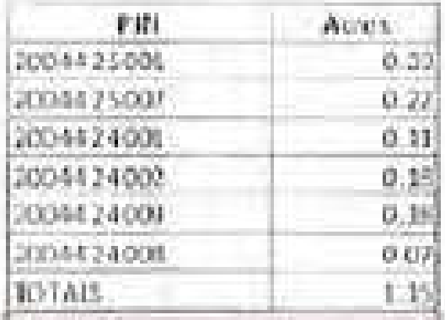
Legal .Description [at "chedJ



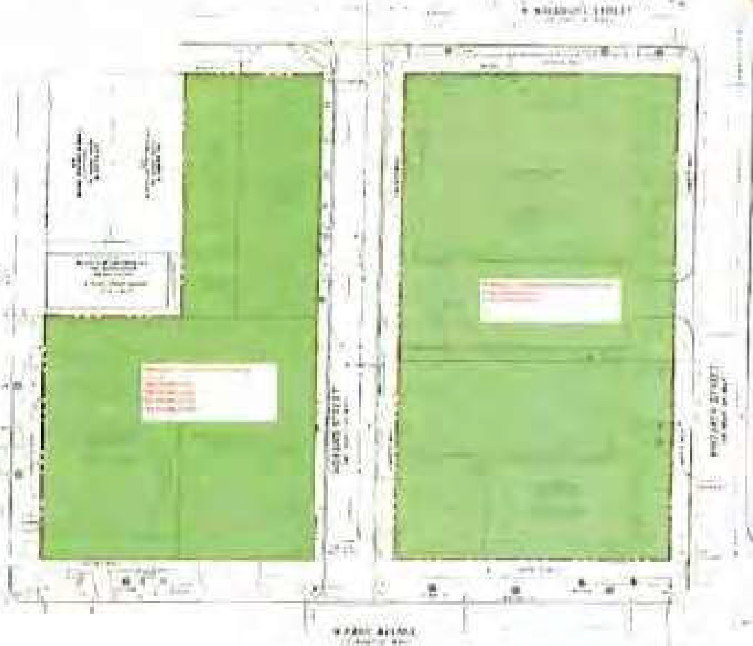
--
I •

EXHIBITB
[to Development Agreement dated as of March 28, 2024, by and among Forsyth Commons Holdings, LLC, Savannah Economic Development Authority; and The Mayor and Aldermen of the City of Savannah]

PARKING GARAGE PLANS
[begins on following page]

&b.wilR
a, 111gG .1· ePLlm
[a.itac11erlJ

For· rfb : {!llwmon Hioldin I
No'l' mbr,;r . 2023
City of.·av:mmth
AtlD: J y Md i::r, ity ll'l:tlger
2. E SL B y-SI L
Savarmah', ,eo1gl13140I

Det11: Mr, M•idrr
Atti1i.hcll be.re is a r.::t.i ikd w:Jl·t::.5l1J;'.ilif,l iliJd prelim irtilry Je ign a,11; 1.fc r !J 11ew lhru::• stoeyunderground gorage located al the.corne-rof WhJtak.e r ,md Wes1tmt .street&. he cost e tlmate Wai;; d vtla,}1,eudsing ariasIJ'ui!t/uJ1derg.roun.dlllilil)' SllNfW p1;ep:aredhyl(mrnas mtJ Hutton ngt11cersmd a grn-tcdmioal i1rrostigatio11prc rcd rra,oor1. 111c c n:ooptd:;sigfl
·prcp11red-by clson 1md GreenHn;;:: An hitecls, :md we btfav i •[WJY• d :i- for mt!XimYm
lrnffic.clisper·itm Hl pt.flt lniffic iril rv 11>, T.hf$slrn-1plit,li will he uptlnleLI Wilhili i.il1T111ffie
- 1np8ctAna sis a:s parl of ne _. Yii desig11.
Theplans showt-,,o I ew offo::e b-1.1ildi11,gs.in ilt.afo'lle-.the ga:rage witli a restoredHoward S,!{eel, irnilar to tlm'l:aae t ti e: l.ls1ryLine Hlo1el, 11,e irnilding com:ep:ts: a e com:eptual n 11atu11e₁ and we l .i:Ye nof :st.1rt d any verfo: I :building; tolic·•·pl: d11!-1grt 1t l o:tp:rinls are Rn· i:.iOOri::lnJ tii, ari l illusi.rativ pm·p1.1ra 11.nly as 1h gatage d ign .imd ir ulllilion11eed.s I 62 develo dround v.;lmn buildings·rern a'lld compone11ts· oclmling; foumllli ion.-s 81:airwel.ls.,p,ublic .aiccl.'l1l!S:atra imd1,'cntilation and eb'llitor·shafts. The ,rertk:al dcsigll uf lhc buildiing:i \ •ill be r ll of a11 il'I ·lt1si pro(;r., s Ihat mciud :I; r:sh ebolcl r:,;i111.:h,1din 'llr;: city, I e Mrc f.!lfld the1 hllortiood'El OCi!l:lhl)ll,

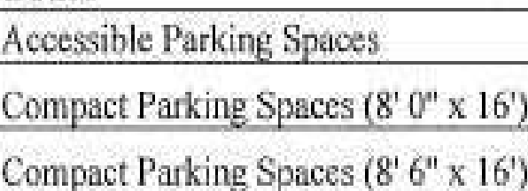
'lll'YPE
cou
1
]
·
•
.Parkin S·11.CtS
Snmi:fard
raralle! rkt

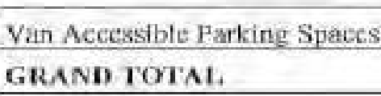

Ji i.s antk:ipElli:;il Ilia.I 1li.t: fiib,r¢ tJ[liot, 'l-er11anl- wm u1re flppmxi11:m1ely 301}pad:111,g .sp::111.:1:s
during bu&ine!l.S h.aurs h::[)Vlrl,g l:88 s ces: available for puMic tmrking during blll!-5im:=s5l:murs :iim!
.all 48& :ilJJace:sDI' ii I· I'm- p,1bli ·fig llfief I r anJ V1.1eek.etulls_The 09-n.oe:pt .drnwing oo-rn:t:m l te:ra puhltc ru:ress s!a.lrwe.ll and!:leva r al ltic. oorn of . ark aud Vihil « : lht: CIJil'renHy lorntE:d <,rosswi:iUr,..
Th-eOOM£StlmAf:Cam.cocci hcre-1 l·Ola2li;:;=t.44·1\6110.12 f.l.ili:I ind ude::;rof::S:Ltl'fudng all ,;1 ru:ljoining
·11fe,zl. ti$ wtl! as a :n 000 000 design and ,coru1ni1,0ti1ori cm1ling ncy, W haYQ1Zv1dt1 dl,!!1-
rn,m • r Df garage w:illl .. , (em_ inclmling deep -soil mh:ing ( gM), slu1'1)' wallE·.and:sheet piles.
We ha'i"eeJ,ecteo]mlld inch..1dt'!d in our pricing; a Jow 1iibra1:11ltm sli«:1pile syMern lh·.t lias hee11
15il fiilly i.n aYl:\mtl'lli in.lh p s.1.

We look forward to n1-ocfing rith yvu riitd :yuLtl' t m Lo disc:l)g.s next s.tep "aittd are cernrinly
,1.f111dl6ib i::: to·afl:,wi.:rLL1Y q11,.:.:il i<;11iS you.may lm e-


Je 1-ey r. Jepscm

EXHIBITC
[to Development Agreement dated as of March 28, 2024, by and among Forsyth Commons Holdings, LLC, Savannah Economic Development Authority; and The Mayor and Aldermen of the City of Savannah]

CONCEPT PLANS
[begins on following page]

Exhibit C

NELSO

■I
••
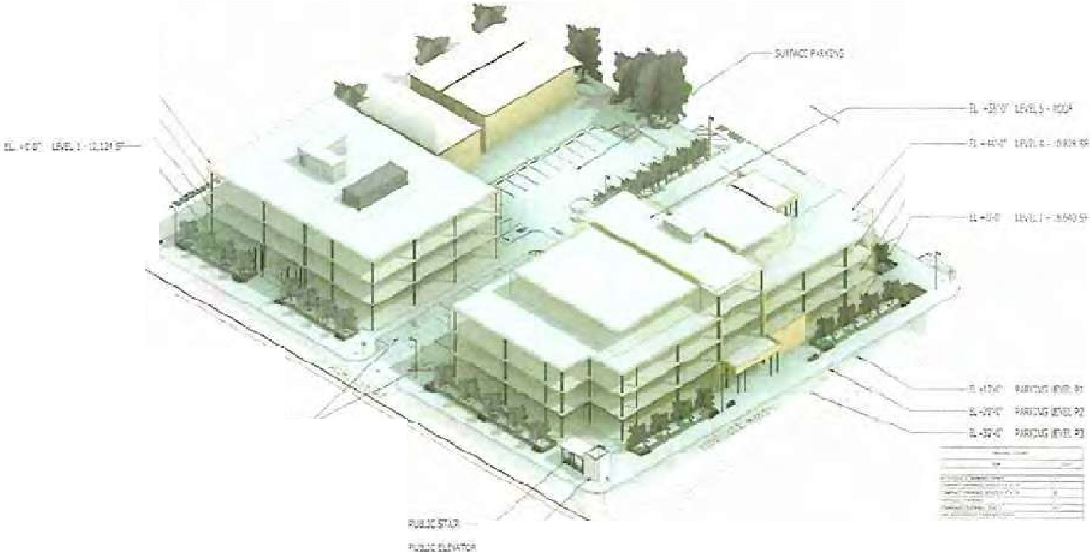
;ll.:.Jlt.,1. "'"
..J..:.!:.
TOTlLROO.Llil:11 "$1'
TOJ'1P'J.O"'N'.;C!K.11 4tf.S,J.CE5'

n_..;.:-.":,'if. _!.lt'°Y -
a.,-:•t...",!.kt.!;" ­
n.-:r-:-i:.:.; ,rn,--
---!.-Jr.- ui,r.l-: :P
tl-11'-T lt.1, - M
r1.:.:..ui;1smc:r.
r.J>._<,-.;Q') -

NELSO!i!

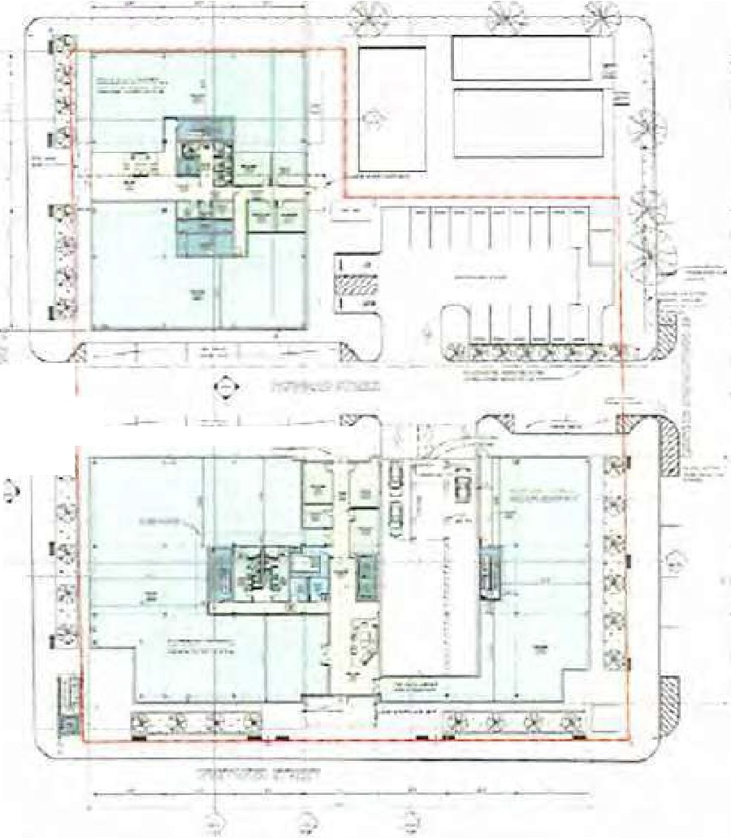

I • I'-, •-------
r.;
,-,b

HELSOt,;

- l
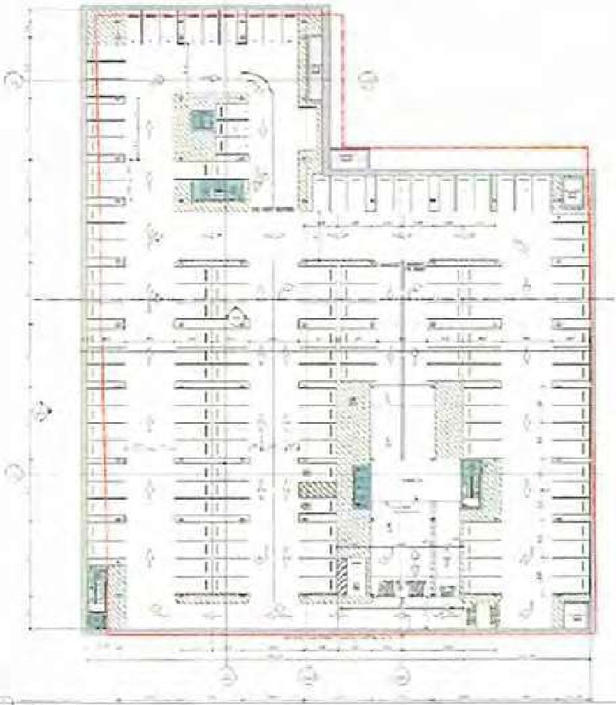


i

-=,..,..,,c-.,.:,:..,;;--- NELSOR


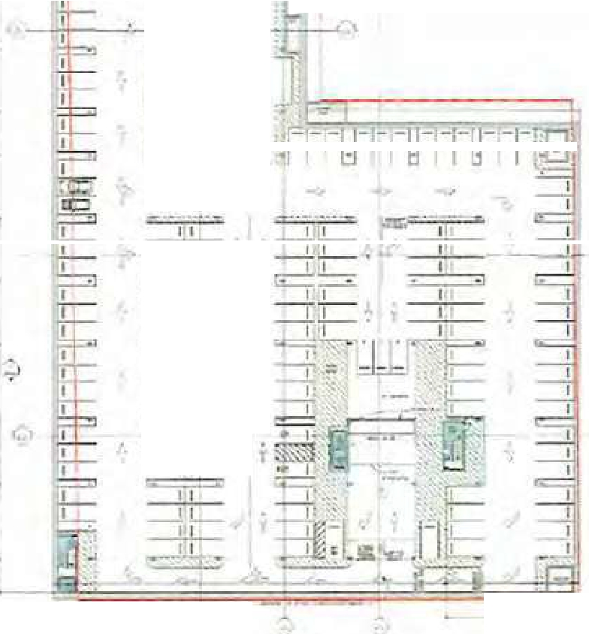


- T=
-1-•
_I_
--1-,-
--
.
,,
I· 1,1,-:o,
'II' .
=4,,,:,b_
-,''.-
7--,P-,-

- 22- EXHIBITF

vans ,. I '""" "-·

t=NEMl.
'""' I un1C#t
..,
llf\•l 'IIIJ'

[ON'TMCRJIR5 ,I ,w_,. . C:ll; n,
:!I •I I
- -

c:31 WP!I< O,-.<.'tl11,lly1I c..,.11. Q,v.ll1Ulr'
--...1. ft ' uucc, ¥".

,'lf.la'_r,..,1.•■ •-II■• "Ulilltll I.
□!i. IGEllf & .f'l;!'i.'JRI
I ·,,.

... , , ... ;-.111"-t
:5 1'3. 5t:!l,1 u

.lL.UJLi !,CH,<.s.
...,.....Jl,I 1, rfln (il3;;
1ifrOJW,- F,,i.JI -
4,( ·U.31,_5n. 1
(,I r-10 1J51j,.2!1'5.7.
Lt MO :$ ..r.!lll.4t

-Ct.I
Ul
Ml:lm!ll?A,nON
l'ilt.llL fil:Al'll!Nt!I
.•n11 i,...,
!ll,11[, liO:

'.Iii 11.;a,,,,,t u.11 --:-j' t - - -,-11·,··' ....... •• '"

□2
O,t.qf,[J(J
f,.2!1[)00
UDIUJU """UJU
ll:'.!4LIJIJ
l.'IEMO..ITTOO
'io!l E!l
IJORI',' !I ,·
c•.1. _111 11'!(1 tll..lU11 "1
.Upnar Lurll

,1411,!1,ll□D•,IHI
J L!!t $1X!,111!11.t1Q,
SLlEcJI...II. C al'!d □ li!l2 5F j[J;l!.i;l 41In Sul> 8!ll
u.. SF lfy;IL."11'1I1r, SuQ IJ
...i,.,' l"'1U<1Y In 5u.lUI
;200.(11 t

.,.","".L.U.U..,,C.,'_"".'f,f.i.''.",N. ".lng
- .2',tJ-'1 SF --:JrauM<iTn li'f;" 'if I
d,!I u,mu SF- ln::1i.L1o,t l 5:ul> Rill

.'.4u.JU

2'1000 i,.141'.m
!; Ar• ,,_.51N<iiJnu;
O,t •nil O,.p ','low- 1.1,,.,.
_/fFCl'l'ler l!Ce!LIDII
,;:QIIIV]l """'· (i<,[l,Y,fr/ill
r;f; S UJ"e li;i!l'ilCStlOII
L■al P"i111J'Al.bo""°5 .AD•Wl !I
,-, p.'po' 57□ IF i ,1l!lll.11f
3 'El• t"1,5 .ilt
,.
...
I i\L
,J.
...i.

D-,
rn;,;r,.Q JllXW l en:
ll\DJJ
, l (llll'D
llccµ:I
CP. Klil
1:rm1m_connt
(;Or, ,rua:01 ErlfnrlrAr
:5d! nnce.- lffit.cill
:;IUI f'ellil!!·- eJ;Ju•di
5.f, ill•n
5- .;::pocn:,n«

1:c n.1 u-
.fl0,000,11
'•
!UC f •M1fi,o
Ll O lf :$l,lf9,II
- I.:! !tL,il)IU.O
:,,,, 11.ii,,.,u,D
fi;g,.w{J_'il(
ll.1!

1 ........, 7nlo\ •ro::•cocn-
lU·
Ell r II.U I

3IOOID
H!XW
o!i>r<!ill 1'1•1rtoi,;-ar,cn • V.acT"'c!,t
or Moln:-1.,.,n:.. - iwl!ll•r

i,.l,J\l l K.
, ...,.11 111i, l),D
_{l'fl'IIH} u:r,.,...u,,,
I
I

li111m,!, ,n, Li

ll.)ll

n o[J
:u ,.,.,
)1000:, jJOOO<)
s11b,&lc1 • EA K rH•JIO'ilK
P'JDUU.:.ZI!:-
.G1&\i119tL. '{C
lilik ti""""H01J1-for er,,..,..
fl, lEif,l!Oll.OC
I Is: 10,IIIIQ,ll
^{1W} J rti· ·
B5,1,la d <i

.!CKXJ<J 1lsulufl♦1•1-1
B&,,J'll Cl' lrkludoH'" 50!> "'•

I )Ill©:)
Hoco:l
.l1(1cnJ
,OU!Di.1
'l 1,U.1

l l.litD:l
rnJt..:o "TI?tcil J1 000
IO□l!D
UDl:3
Jl1GQCO
lil>o•t PIiie 'W•• T<!!•-"!I'
noh1[)'.J<•rv 1Je. c.,l 1J -Y1Eiluo1us B R.rlll•I<!.
Fln;: Gralllno • :,;111 ,. 11'2;
••n•
:,,. r,g. <,,ree11· r,a1:n
mn·t. B■lfl.Ws1.u,
Cisp :m,,,,t■IJw>:k. !illl<lct Flll
TIIP !;<>J I C'NLn s:,,.c,i
"-=' &.·vi• Mat" lor Earth,•••"
!;lalkllll O,,,t, "- Ci.i:!111'
O;J:not • P \ •l"l r<- Stant _, 11rln11te·n,;,,

.,,..,
J't,,01,Q ST- $<.19,,Uo..O
;Ul 1:1, $!, l'7, 00,0
1 L.!i !P'Cl<d«l 111 b ili<I
, MJl'l'}j f.0.lllloQ,01
.t.. Id :!Ir S1,Z1l,1
5 l U,13c!S,7
j.;!,(I{ '1,Sn 10NS u.q,4 ,01 I
U._111 .J. t.:Y ,a ,.,5
:;o,s;l][ -io L'1 1},f'U.J
c
'J IS c .ooo.ru
· :-oii LI' I (5,Mi1""'
Ci.Ila u :., tau.
-I 1.S ,n.,000.•000,."°

j:J
Jli®'J• ll◄llal
liT0'\1-'i!:.WC'!.
Gi.litt:rh l'IIIOf l)ri,1,1 Tf l'll'l.,.,.. I L [,A l ,7 ,..
Umor l•b Llr,:lmlroins I Ii" _¥Oil Lt fi:l.li!rGAX
,
,n:1,.-a --O( P,/J

::m w
Ul'l"U'la
{OD --Li"' rlof, O,a
---

.:i]
[D
l. •xt::p
;i□·w,
!Q'D
_isn
Lr 1-'U,B-l◄mr;
$.llil+i D,&

]]iOOO ,Mlll IS .3 EA H'1,5:JQ,,;i

!Jl◄(:00
ixi
Gr to:llll
ur:;:.<,tJon rill• ram,Jncrt;lJ1i1on:fr,1r,o-
J !j. ' ll, tlg,q
, l'l!LL'M I · ,,.A_□UD.U

!11'.!I

fl EW
_;iu,Sg.ttOC UP'
I

vans
{ll,tl'i r...,)>l..,) •!h
"' 14r,1r11..
'
J,,r.jt1i,r Hf.a, :.11,

ti:El'lil:EMl .Lhl /m.·111U
CONl'AACTOliS SJ ' ll■LUJt lt 511.
, ....1 ...."i+, I

t--C!il:
l)lliOO

- Fl" IJ=
V,o,l,f Dlea:rll>II•
-.,11,:
'-,!:UiiUly
"·"
l-0 u
tll..O.'.IEr
.fl,OOll.01
c.,..-,n,,u1
/SF
I

lUOOIJ
IS1t:'1 P
l. f;I,
- ,5110.rx

·U,000
lltll'i,n;PIG.¥0flt'1r &-'IN!
1 i;}l.
ffi,000,,i)I

3 .1,Jl!'fMir" §•1El! ,! 6, M'.11 <.I.
..

J] OO[]
ll"l'\IC.
.Lt;, IS
n.i, !li,.O.
---

n .
)] 00)

;:t
Ms■,
Cvllnr.d tol•lllly

tlJf p;,._ylN(; icatM
- &,
t
I
Jlll oonQ
-

I

Jµ7,E91,i!'.4 o:,c

i21]1'.l
C-11n...,1 !'••11111
.II' U1•1<
(i :5 s
J50.121

j }.313
c 1 !!•r.kll5@ C:Q(,[1 11,,.
Cil=i;li •
(, S""
U•3:',.1li

n.=J1J
r.!Bll
'-1il.11!

,.",..,
INViP
-1!5
[; U:J!i Cg'JCt!U F'.O,t"III

l<!llt'IA1.TP
L• I'( V<Jl\' _!Jlrwr

"r :.r
"-"" :,;r
  - ,1 ·2:
s
o.J::. >C
I

ti,11 s
.J!h,i;,,
.U.:'tl,. 51.0(
U17,(l(_

SllHF,O

:sie.7, o ,01 J,;:1:

l..lJ.Llllo
□l'oornllVo ,,J"J
Hi1Wi!ril !!.!
',i;@H v
'°tl&1Wl,1,1

11.Y l
U>,I
1o11 ti6\v1ar •<l!.I\IJJ'ilrwA..-,, MJ
rr.l'llc i:.in1rn1
&,{f00 iY
t
tlX.Q(lf.t;:1)
•=•..,{LO

11 m.1rrus !I " Iii.Ma:
111, Cl:l.iat \I.ell'

,nn3 1 'ffijf11( Sl;JD3fi
]HU..l I !>IQfl Hr t'ifllr,:J
1,.;
ll E;l,
.W,111111.!ll
12.000.01,

nnz,i
WnRU1-:ncp_;,,
"',uj ----.,j,
5 ;Iii, /00.0!

J-1,ZJ
rnr,::!t"
t>.,..,m,,..t lta'c<K1g>
11;1- K1'ifli,_,,_.l,i
.OljQ
1
;;.,,
LS-
i ,l!Da.□1
2!,,0 IJ..al

3l !Mifil:l.lAl,EIO\.SSIT!' JM"'IIOJEIIIEIJT:s
--rr--
tJ63.. .(H
l!.m

Jnmi
n,mn
PIIC.Ctl,b
J"tll'lllff-1;'•.,,•l

--i..ian ;r_pe:!ii'Hntcn:::1:
.;i-.111'.J
1i
·
-itai"si'tiMt .•

1111■n"
- ,: ''"" -

. - Sf I_ ' L Q =-
H- •l:JI·~I.-. " '

" · l-!IUND.r,,'11{1 5

;f&!,"1.6 . 0•• $'.
-
. .
"'11,(r.

IIJ:3l!CC,
mncru
u,,.
,,;i-, 111 I
!lje_,;al ll'll Vli!II
JJ 1,nieEr YWlv 1.\'
SlnD='e.Sl<ff
l:t r;r
1,5(10 t:I'
11,,U.Q,,.!li:llil, I
lrl(lkHll:D!11 ''"
lll.llO, .

!JUD I "''"""'"'"' I V.,I !irol_Jti;.·
llr"lltt
Lll) er
tl!i!J,.o □.O• I

D.nooc
r-Ill-'.f.,.,..
,.,, ,I

Olr,Q<i'N f" l!l'ffi. o:>,,t'rt!': i::ol!iJl Psinolo """"f Wair·

l .'11,"o<lll :Lla
11:1 10.i -.,...,
L,r...,.,..,,-
..,,,... _{u}
il D'
Ci J..f
'""""""in;.; la!)d I
IIIQII•"" 1!1SI.Jb aid
lmlil<<dlr!'l•"' !!I•

Di3CO!i
f'odkUII L■""1 Tr•=••f.!51;.b
••n"JO<
z.:wQ
Pl Indal In ilJb Blc

Q)J
03
Ol OOO
f'T po,:Hle>IT'IS Pfl'.M,.., •
,... fl,1"4
l2''i<lP
:a,o a; C'I
:l,U 0/
l•9
IJJC!Vt.:111:..1l!l'i:a.!bctic
l,t,::llie'ir.tht Ill
l11t:1C1.oao hH,o,1 I!

03JC!llll
T ;...rc,..,., - ;:;nd w., lm!
l L!:"
ll' MO'J,IH

m1000
13t lr n,i!r fl.Mci!I
l i.11
iao,r.,oo,,o,;
I

II IS'.,ijJ!S
I Jl,'i!lm, g[ . ·t ,1•

'1133illl Si,Ja D[4
Cl O!lll - • fot.lffll•IL->n

:ll'.I" lhlclt

lll.! Of
,p,vaopoo,o,
l,1.fuOll'il l<Irub l!I!

CJJOIH!
El••Mor fl!
?i r;'(
f l ;:t!l:I

II
[I] 8ll0
Ml.:;,tl:I.Ui.'lEIJl i;QNr.R,t:lt
n-iP.z- i.

'
lll'!l .f.JJ:

:0.5111MX
UZ. 00,Qi .J
l

" - : ' -
,..
- ...:• 1,_ .

llllB

f/'4
O>ll)QaO
flo!OD O
'111-!Ail'
O'ilJ l'la,k-A<<flJ ll 11
Br!o:I<

lH!l
Hil
,S.F..

1,1 ,SDQ.O
-
s:ii,,pot.□:
I u; o.1111 c,1

(lia,i, t\lr"' '"""
vans
....Jwn,!-:; h!J111Lll:.iN1i
L : J • fil ■li.ii.

,GCDEtfNl'ReAAtlfAO.RS

r W O,=:,JpU n
lls' -',f jDIJ
1w l■aSIJl1 F J)),;ti!;
I I, •
uotalfs--f°Qdl)

Ur,!t

1!!1..Dt._m

G.rt!Jlf'"T1'tll

Jnr-

- 'Ulflllll"
·
lii 1-lJ:!l=

111'.l;.aOO.ll(
111·,
-0,di

[);1 11lll M t,i!ta,- l!.llrl.,-c.;i Ett.
DSSOOt, f.r lr,is
,o lf
,i PJ
l .UILQ
[Ji,IXIQ.Qi

cn ooo l'lll!fBi31iai "',
100 EA
i,Z'5, ll0.0

, .,i;N;IQ Gr.!it-Qfif.pr' l/,;'-111,, ns-1
--

, 1015t5 6.1.l:Qli;1f,i(l
lis3oOI) tifJi:iln::i • M-,
. ""'-
.,I "TUt,i -
lCJ, u0.-0

f'l'i',ZIJ,,_,.:

.f7 6.IJI

·a.u

ci.•fli•<11•-'llro

i,liJis c t,et!O'i:
111.!,!_ !!_:'jj --
:.r
f l,2 G,.0:

$1!.00 .D
---

IHl'1

JY,[IJllli
-
Fr ·:5t;u,_.,...,,,.;,,,
. '"• •
' ""
...
f8,lt01)J,1;

·•u1 ' 'J-JI)'

Iii \Wllffl !I l'j!lfll!7•!1'!,13
m • -ei.
,t!,J

,;11D il' w-.-,,rool!,\l)"ll.tl w t;;- Pi'•H'r.1[!1
- t{J00J 'i'rl>too>rnoA.na Tn!n1fllr S\ab la C..-omn,,.,.,,..
11' ,Jl :s;
J:l.,rn,
,51P
11r
¥ S, LO"
ft go, ,!'5.(l;

llffiilc M;,ni,ra 1'!'"1. mn.•1/nJ (flVoll,;
-Wl!OOD! l;l or 11'1!\\IJLi:,rptN/111
, IIO t,-ODQ
61'
i.r
Ul . "-"'
- r+. DO.O

ll'f l«'IJl'i
l4.l!illD,ijl
!Lill

<Jf>UW,
'1'!1,1111ll:i::if.f ml-a5!!1'11!11
HU 5F
tll, OWJ.

C!, ROOI' SJEc.lJ,t "[IE'!!,
w, ·oo 9r lt"Tlll"l!r - S•IL"I'

I 1.

lJj.

$ i,oo,i;:i:
t10,ooo..□1' QiOl

or7 oa
"li:oQ-n>v;,,r - ff•n/;ol
j LI
U,IIDO;i;,;

ll? QIIUl..liJh:!i
.,-:IJillllLi--.r•.-iitr.111

!,o!airli • "'

  - s ...
IK.! J.ll\
111,1,

07!1' 00 ui.-l,.J'l_da(;EJ•JC!i

-
J!IJ,5(1.'S SF

'
1,;>;,0D .C,:

J

rTilill

ll'i
reoaoo
fl:fl;Xll\ HJ11!(11:1U: I:, Fft.!ltJ=-
Elllt61JC<ttlltli/;'tl' rt10lfl 5,

( '/Q"j

io l,!\
no□IJll,i:,;
J"(! all\i:01 il,zc
I

DI! l'.U,-!l!;JI, r■u,t(IIZ
!,fi,5f"!.Ili

(l.!k

Cflb1i)Q!l
!3'1t,'1' p,,,o,;;:{d1>1ii,!•
1 I' l --t'.t,;:::il.11:..1.CI!

ln'>WIJ =""ia:u srnem
r.t,(,n--im a:
L>'Q 51'
'l',Dl!l!l,Y.
-

r,,

{1g,l,1,ii1,El,i.Clij$E ETTEllim. liAlllT
"""'"'-"' M!l rbMi'!r

trl EA

-"'L[
3..Il,11.ot
11..111

D!i900D, Fll!l!BOlli!
100 cm
;!lti-li,lil' I

OS: -VAAttfC!llSt lllffliJ,O 1:!"Jpff
~·••l} Q, Ml><-Pol-ut

f!l'J',_,_ ··

l!E.·• 1-.. 1.□
:14!1',69 ,
o,:,:;u

_<B30M, ldl<n<r Eroi:!,; W■II•
,Jig
SF ,,t,1514,i;;

.d .:1 .-• l-·I
jJ) is;,tt:;J.llf,ES
!JXXR!O! A"" =r,:iuahDll -!i" llW,11T01d
.... ,... c....
,,.. !aU!V,l,tQ.iiS
l'i2000 Ha fUs HYdf d[["- q!'

;?;;

EA

S"'-"'-'"""

t:ns;OOD.1X

L llllll1III,
!!], ti

c•Dol!I.IJ.!..!i'•J
J;J t,lli:!!lu
'-"'"Ill
l!.,.Dl

'lili
;!-1

van!!i
ENEf.lAL
itO RACTORS

go,-11.







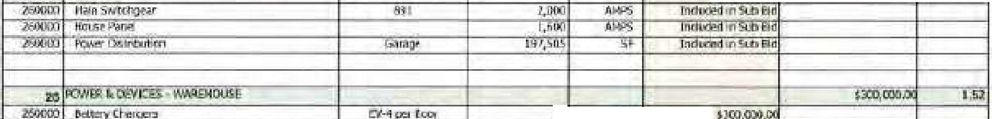






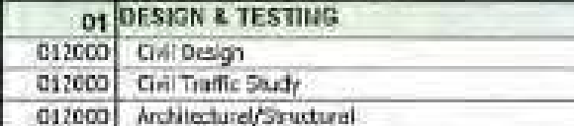
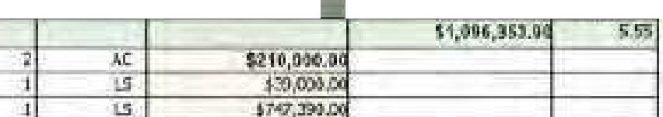


- roll<'l'lm
-
iJa.,I •

.l>Jl>:l Ft

""'' il'/11111,n
r;_,. i,,;-M
o!l'l'li
.n '#•
1.H -

i
!fl
lllJi;)(,ff

Jlww
°'l'"'I"'111
'iF

i-=•, i,;,.lJ!llii G CA, tio,o.ouc

l-,.'=' 1mirt-""'=n:;.=::.:;.;;:lhl o,J'""'Ai""rp""ln-g--------li------+ ,,1ll;:+...-_;;EA,
_,,..Mlme!"";..1,>;;1,r:;,l--------4 l

-- , .._,. -1-------f-----+----+-----'--'----'-"+--------4---

Blllllll S41l Eid -----

2J.lQOJ 'lc,11111.1.,1r..1>
'""'"'11= 0 [/Cl' """"'-"
l:l'H ll!clirleil., :a..ud,
EA. Tl1 """1"1 1itd

' . -- -

-•-·

I nld ftlllltl•.111'

ll CA'

l.!l
I

.

,.

ClµiW
sr l!Jll•C<J···

1-.,, .,.m.,;·c;o;;:1·,i'tc::efs::f'====----------;-------+----...-1----:!i.F+--- c.:: 0-------1; 1

11-.1.VJOO ILC,CW!clics
lllll!W Te, g
l,... Lj I
I, U

lb,U.JJ.ilJ

)
GENERAL
vans
,,,..
tlm.. ,
h t
<HIH1:
Pll!IIJ
I IIV<l l.,,•uh
J"
(i1n.e.
OO Ol1$
_Jhllfil I\ I
,
11
111 11-1 00,;,n
""""'oo\i5:i o....-.r1J,tilfyr,, ,.,
ill ra,umv
fflll'I 11-• llJtpflan
..,. !.i.:t l 110]I
-
l
1'!1Ltl. -
J
1 1,.."(;f,
,I.
"Ql!lllit:111/
-
··""
=
I
u,n
' ',-
l!ll
--
Gtal]lll!wl
l -
..
,. 111r J ,... 111

i-,:g;lt!lli A2 [11111
- lhu,
i17:i..7'11 5:1
n'l:m.l!I
. -• o.
.
, 1,2'Jl,SU,1
hHO,U
111:(m ......
IJt C J,EOVlil'l "'l'/ll·
..
10
oriooo c.>ri,ar•f• c.,.11,..,,1 t,91-',
2,11,
I
...- --••l;a,!r -
L&
.L1i
J f,B;
5i;e;,g,an
·:c;a I
s;m
1:;
.u
z:,,. tt, ._,, ,-.-=-·u·r
M'!Uijil,PI' 1 11
17ifftm
""""lirnm ,mh
11-n:i,o:i
1n /!,W,l'!,'J\Mft
'i
•• il\• Uno-·IW"l="Q•
lai'i"ima ...un P, """''"''
i'fiilll!n ,,,m.-u m
1, Li;
1' L
11tillJi1lll""
J1 D
5..., ttla,0
$,15,:@1100
f£1b.l CJTOJ,.;._
- ...T .,;---_ :· -·- -_:,: Ct.;.- _:r= ; -
- --
,-1,iB. 4- ,!\9dl Jk,lt!:i

-=•-=
--

SAVANNAH
Planning & Urban Design
20 Interchange Drive, Administration Bldg.
Savannah,GA,31415
Phone: 912.52S.2783 / Fax: 912.525.1562
www.savannahga.gov/planning

Rezoning (Map Amendment) and Comprehensive Plan Future Land Use Map

no E State St, Savarinah, GA, 31401
Amendment Application
P.O. Box 8246, Savannah, GA, 314ll-8246 Phone: 912.651.1440 / Fax: 912.651,1480
www.thempc.org

Please type or print legibly. Attach additional sheets, if necessary, to fully answer any of the following sections. Incomplete applications will not be scheduled by the Metropolitan Planning Commission (MPC) until deficiencies are corrected. Additional instructions and information regarding the amendment process are attached. SUBMIT AN ELECTRONIC COMPLETED APPLICATION TO PLANNING@SAVANNAHGA.GOV. Applicants are requested to
contact the MPC staff at 912.651.1440 or City Planning and Urban Design staff at 912.525.2783 prior to submitting an application.
- Subject Property
Street Address(es): 1001 Whitaker St/ 1015 Whitaker Street/ 120 West Park/ 124 West Park
Property Identification Number(s) {PINs) (Note: Attach a boundary survey, recorded or proposed plat, tax map or scaled plot plan to identify the property boundary lines.): 20044-2soo1120044-2soo2,20044-2400312oo«-24002 Total acreage of the subject property: _.9_7_A_c_r_e s _
Existing land use(s) for the subject property (e.g., undeveloped, restaurant, auto repair shop, multi­ family): 2-story funeral home and carport, 1-story structure with surface parking, 1-story structure with surface parking
- Action Requested
  - Type of Request.
Rezoning (Zoning Map Amendment)
    - Comprehensive Plan's Future Land Use Map Amendment (If proposed rezoning does not fit the designated Future Land Use Map Category)
  - Application History. Have any previous applications been made to rezone the subject property
(Certificate of Appropriateness (COA), Subdivision, Site Permit (General Development Plan), Business Location Approval, Text Amendment)?
□ Yes No If yes, please provide the Plan/Permit File Number(s): _
  - Rezoning Information.
    - Identify the existing zoning district(s) for the subject property: -TN--1----------
    - Proposed zoning district(s) for the subject property: _T_C_-_2 _
{Only one district should be proposed unless there is an extenuating circumstance. If more than one district is desired, please provide supporting rationale as part of this application. A zoning district must be identified or the application will not be processed.)
    - List all proposed land use(s) in accordance with the Zoning Ordinance. (Refer to Zoning Ordinance Article 5 Sec. 5.4 Principal Use Table. If your desired use is not listed, contact the Planning and Urban Design Department for a use determination. Planning and Urban Design by contacting 912.525.2783.)
Office (General), Retail (General), Parking Facility

The petitioner will receive notification to obtain and post the Public Notice Sign(s) from the City's Planning & Urban Design Office at least
15 DAYS PRIOR TO THE PLANNING COMMISSION and CITY COUNCIL MEETINGS.

Re2or1ing (Map Amendment) and Comprehensive Plan Future Land Use Amendment Applicat!on File No.------------- Revised: 2.2.2024 Pagel ofB

  - Comprehensive Plan Future Land Use Map Amendment.
Sections 5.5 through 5.17, subsection 2 of the Zoning Ordinance titled Comprehensive Plan Future Land Use Map (FLUM) Consistency list the permitted Future Land Use (FLU) Category(ies) for each Zoning District. Chapter 5 of the Chatham County-Savannah Comprehensive Plan lists and defines these categories. If the proposed Zoning District ls not allowed within the current FLU Category designated for the property, a Comprehensive Plan FLUM Amendment is required, As part of the application review process, the Planning Commission and City will evaluate and detertnlne if the proposed Zoning District requires a FLU Map Amendment.
    - What is the present Future Land Use Category designated for the property? Tradmana1 Neighborhood
    - What is the Future Land Use Category that allows the proposed Zoning District? _
Traditional Commercial
Ill. Rezoning Review Criteria
Describe the purpose of the requested rezoning. Please refer to Sec. 3.5.8 for the review criteria that will be used when considering your petition. ...::S:.::e:.::e...::a:.:ctta=ch:..:..:e::..:d::...;E:::xc::.h.:..:.:ib::..:.i:: t _

IV.
Is the subject parcel located within 3,000 feet of a military base, installation or airport, or within the 3,000 foot Clear Zone and Accident Prevention Zones Numbers I and II as prescribed In the definition of an Air Installation Compatible
Use Zone that is affiliated with such base, installation or airport? □ Yes □ No
Neighborhood Meeting
A neighborhood meeting is required as shown in Table 3.2-1. Types of Required Public Notice for Applications, or indicated elsewhere in the Zoning Ordinance. If an applicant fails to provide neighborhood notification consistent with the requirements, the public hearing will be postponed until after such notlfication has been made. Please complete the following information.
- Neighborhood Association: Victorian Neighborhood Association
- Neighborhood President: ....:N....:;a::.:n.:..::c_..y-'-M;.;.;a:;.;.ia=------------------------
- Method of Notification: Posted online I Monthly meeting
- Date Notification Sent: November 1, 2024
- Date of Neighborhood Meeting: _N_;o. ;.v..;_em_b_e;_r_1=2l.,..2;,;.;..;.0..:c2_4
- Time of the Meeting: _
- Location of the Meeting:
- Date Notification Sent to Planning Director of the Scheduled Date, Time, Place:
- Date of Planning Commission Meeting: _N_o_v_e_m_b_e_r_1_9. 2,_0_2_4

- Property Owner Information
Name(s): Various property owners - see letters of authorization
Registered Agent ­
(Or Officer or Authorized Signatory, lf Property Owner Is not an Individual. Provide GA Annual Registration.)
Address: ­
City, State, Zip:-------------------------------
Telephone: Fax:
E-mail address:----------------------------------

Rezoning (Map Amendment) anQ Comprehensive Plan Future Land Use Amendment Application Revised: 2.2,2024
File No. _
Page 2 ofS

- Petitioner Information, if different from Property Owner (If the property owner(s) will have an agent serve on his or her behalf, the owner(s) must complete the attached Letter of Authorization. If the agent changes after submitting the application and the agent is not the property owner, a new authorization form will be required,) Narne(s): Jeff Jepson
Registered Agent: Evans General Contractors
(Or Officer or Authorized Signatory, If Petitioner Is not an individual)
Address: 1480 Chatham Parkway, Suite 200
City, State, Zip: Savannah GA 31405
Telephone: 912-629-0222 Fax: _ E-mail address: ijepson@evans-gc.com
- Agent, if different from Petitioner or Property Owner (A signed, notarized statement of authorization from the property owner Is required and must be attached If this section applies. ff the agent changes after submitting the application and the agent ls not the property owner, a new authorization form wlll be required.)
Narne(s): Michael Garcia
Firm or Agency: LS3P Associates Ltd. Address: 321 West Congress Street City, State, Zip: Savannah Ga 31401
Telephone: 912-695-2111 Fax: _ E-mail address: michaelgarcia@ls3p.com

Contacts
Planning & Urban Design:

The Planning Commission:

20 Interchange Drive, Administration Building, Savannah, GA, 31415
P.O. Box 1027, Savannah, GA, 31402 (Phone:912.525.2783)

110 E. State St, Savannah, GA, 31401 (Located at the State Street Garage)
P.O. Box 8246, Savannah, GA, 31412 (Phone: 912.651.1440)

Rezoning (Map Amendment) and Comprehensive Plan Future Land Use Amendment Application Revised: 2.2.2024
File No. _
Page 3 ofS

VII. Letter of Authorization
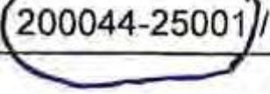
As fee simp ...o.,mn,,r-r th ubject property that is identified as Property Identification Number(s) (PIN) 200044-25002 I 200044-24003 / 200044-24002 ( we)
authorize Jeff Jepson (Agent Name) of

E_v_a_n_s_G_e_n_e_r_a_l_C_o_n_tr_a_c_to_r_s
(Firm or Agency, if applicable) to serve as agent

on my (our) behalf for the purpose of making and executing this application for the proposed request. I (we) understand that any representations(s) made on my (our) behalf, by my (our) authorized representative, shall be legally binding upon the subject property.
Property Owner(s)
Name(s): .5(dlc!L&r>t S( l 1-l-Cc
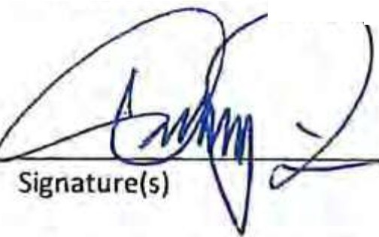
RegisteredAgent: OA-V(IJ f. /Jll4(}iSf)/LI (}1/l,yl1-1t,1Vl mt-ri 6t
.-1rcrrn,,..,.er or Authorized Signatory, If Property owneri;tot an individual)
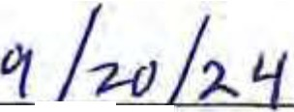
Date /

Witness Signature Certificate
State of Georgia =' County of Q\ ,4-(...-- , Signed or attested before me on q {(71}
J:;,f
J11 Date
by ) / U0 r.
(Printed name(s) or lndivldual(s) signing documentl v

who proved to me on the basis of satisfactory evidence to be the person(s) who appeared before me.
Personally Known or D Produced Identification Type of ID _
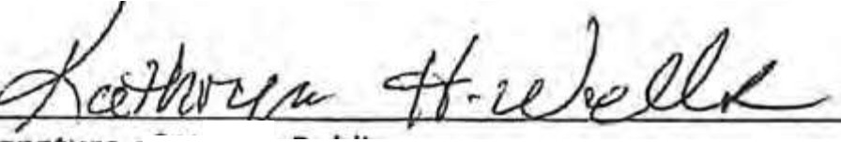
Signature of N-OtryPublic

-!!!!!!!- !!!!l!!!!!!!!!!l!l!!-!!!!!!!!!l'I
KATHRYN H, WEU.S
Challlam Courtly
My Commission Elq>lm
October 23, 2026

(Name of notary, typed, stamped or printed) Notary Public State of Georgia

My commission expires: _

Variances for Development Plans (Planning Commission Applicationl Revised: 2.2.2024
FIie No. _
Page3 of7

VIII. Disclosure of Campaign Contribution Form. To be filed within 10 days of filing this application. This is required to be filled out by the Petitioner, Property Owner, and/or Agent per the Conflict of Interest in Zoning Actions Act (O.C.G.A. § 36-67A).
- When any applicant for rezoning action has made, within two years immediately preceding the filing of that applicant's application for the rezoning action, campaign contributions aggregating $250.00 or more to a local government official who will consider the application, it shall be the duty of the applicant to file a disclosure report with the governing authority of the respective local government showing:
  - The name and official position of the local government official to whom the campaign contribution was made; and
  - The dollar amount and description of each campaign contribution made by the applicant to the local government official during the two years immediately preceding the filing of the application for the rezoning action and the date of each such contribution.
- The disclosures required by subsection (a) of this Code section shall be filed within ten days after the application for the rezoning action is first filed.
(cl When any opponent of a rezoning action has made, within two years immediately preceding the filing of the rezoning action being opposed, campaign contributions aggregating $250.00 or more to a local government official of the local government which will consider the application, lt shall be the duty of the opponent to file a disclosure with the governing authority of the respective local government showing;
  - The name and official position of the local government official to whom the campaign contribution was made; and
  - The dollar amount and description of each campaign contribution made by the opponent to the local government official during the two years immediately preceding the filing of the application for the rezoning action and the date of each such contribution.
- The disclosure required by subsection (c) of this Code section shall be filed at least five calendar days prior to the first hearing by the local government or any of its agencies on the rezoning application.

Please answer the following questions:
  - Within two years immediately preceding the filing this application, have you and your agent (if applicable) made a campaign contr!,bution in the amount of $250 or more to any of the local government officials
listed below? D Yes l2f No If you answered "Yes", please complete Question 2.
The Mayor and Aldermen of the City of Savannah
Van R. Johnson, II, Mayor | Linda Wilder-Bryan, District 3
Kesha Gibson-Carter, At-Large (Post 1) | Nick Palumbo, District 4
Alicia Miller Blakely, At-Large (Post 2) | Dr. Estella Edwards Shabazz, District 5
Bernetta B. Lanier, District 1 | Kurtis Purtee, District 6
Detric Leggett, District 2

 | Chatham | County-Savannah |  | Metropolitan | Planning |  | Commission
Loreen Boles |  |  | Ruel Joyner |  |  | Joseph Welch
Travis Coles |  |  | Wayne Noha |  |  | Tom Woiwode
Elizabeth Epstein |  |  | Eula Parker |  |  | Jay Melder, Ex-Officio
Joseph Ervin |  |  | Dwayne Stephens |  |  | Lee Smith, Ex-Officio
Karen Jarrett |  |  | Malik Watkins
8. If you checked "Yes" to Question 1, complete the section below:
Contribution
Name of Official to Whom  Contribution was Made | Official Position at Time of  Contribution | Date of  Contribution | Description & Dollar Amount of  Contrlbutlon
- -·--·
J

David Paddison 09-20-2024
Signature of Petitioner or Petitioner's Agent Printed Name Date

Variances for Development Plans (Planning Commission Appllc;illonl
Revised: 2.2.2024
AleNo. _
Page4of7

VII. Letter of Authorization
As fee simple owner of the subject property that is identified as Property Identification Number(s) (PIN) 200044-25001 1200044-25002V 200044-24003 J 200044-24002 ( we)
authorize Jeff Jepson (Agent Name) of
E_v_a_ns_G_e_n_e_r_al_C_o_n_t_ra_c_t_o_rs (Firm or Agency, if applicable) to serve as agent on my (our) behalf for the purpose of making and executing this application for the proposed request. I (we) understand that any representations(s) made on my (our) behalf, by my (our) authorized representative, shall be legally binding upon the subject property.
Property Owner(s)

Name(s): 1015 Whitaker, LLC

Registered Agent: Key D - Compton
(Or Officer or Authorized Signatory, If Property owner is not an individual)

/4 9/20/2024
Signature(s)
Date
Witness Signature Certificate

State of Georgia
County of Chatham
Signed or attested before me on 9/20/2024
Date

by Key D. Compton
(Printed name(s) or lndlvldual(s) signing document)

who proved to me on the basis of satisfactory evidence to be the person(s) who appeared before me.
g; Personally Known or D Produced Identification Type of ID _


Jean Logan McC11JJaugb
(Name of notary, typed, stamped or printed)
Notary Public State of Georgia

My commission expires: 1_2,;_/_1_7""'/_2_0_2_7 _

Variances for Development Plans (Planning Commission Appllcatlon) Revised: 2.2.2024
FIie No. _
Page 3 of7

- Disclosure of Campaign Contribution Form. To be filed within 10 days of filing this application. This is required to be filled out by the Petitioner, Property Owner, and/or Agent per the Conflict of Interest in Zoning Actions Act (O.C.G.A. § 36-67A).
  - When any applicant for rezoning action has made, within two years immediately preceding the filing of that applicant's application for the rezoning action, campaign contributions aggregating $250.00 or more to a local government official who will consider the application, it shall be the duty of the applicant to file a disclosure report with the governing authority of the respective local government showing:
    - The name and official position of the local government official to whom the campaign contribution was made; and
    - The dollar amount and description of each campaign contribution made by the applicant to the focal government official during the two years immediately preceding the filing of the application for the rezoning action and the date of each such contribution.
  - The disclosures required by subsection (a) of this Code section shall be filed within ten days after the application for the rezoning action is first filed.
  - When any opponent of a rezoning action has made, within two years immediately preceding the filing of the rezoning action being opposed, campaign contributions aggregating $250.00 or more to a local government official of the local government which will consider the application, it shall be the duty of the opponent to file a disclosure with the governing authority of the respective local government showing:
    - The name and official position of the local government official to whom the campaign contribution was made; and
    - The dollar amount and description of each campaign contribution made by the opponent to the local government official during the two years Immediately preceding the filing of the application for the rezoning action and the date of each such contribution.
(d} The disclosure required by subsection (c) of this Code section shall be filed at least five calendar days prior to the first hearing by the local government or any of its agencies on the rezoning application.

Please answer the following questions:
- Within two years immediately preceding the filing thls application, have you and your agent (if applicable) made a campaign contribution in the amount of $250 or more to any of the local government officials
listed below? □ Yes lmXNo If you answered "Yes", please complete Question 2.
The Mayor and Aldermen of the City of Savannah
Van R. Johnson, II, Mayor | Linda Wiider•Bryan, District 3
Kesha Gibson--Carter, At-large (Post 1) | Nick Palumbo, District 4
Alicia Miller Blakely, At-Large (Post 2) | Dr. Estella Edwards Shabazz, District 5
Bernetta B. Lanier, District 1 | Kurtis Purtee, District 6
Detric Leggett, District 2

Chatham County-Savannah Metropolitan Planning Commission
Loreen Boles | Ruel Joyner | Joseph Welch
Travis Coles | WavneNoha | Tom Woiwode
Elizabeth Epstein | Eula Parker | Jay Melder, Ex-Officio
Joseph Ervin | Dwayne Stephens | Lee Smith, Ex-Officio
Karen Jarrett | Malik Watkins
- If you checked "Yes" to Question 1, complete the section below:
Name of Official to Whom
Contribution was Made
-
Contribution Official Position at 11me· f
Contribution
Date of
Contribution
Desalptlon & Dollar Amount of
Contribution
I
'
..
r--;.
-
' ,
...
,

i"';)/41:A.

Key o. Compton.

9/20/2024

Signa;J'j of P tioner of Petitioner's Agent Printed Name Date

'-"
Variances for Development Plans (Planning Commission Application)
Revised: 2.2.2024
FileNo. _
Page4 of 7


VII. Letter of Authorization

As fee simple owner of the subject property that ls Identified as Property Identification Number(sJ (PIN)
200044-25001 I 2000 4-25002 / 200044-24003 / 200044-24002

authorize Jeff Jepson

(Agent Name)
( we)
of

E_v_a n G_e_n_e_ra_l_C_o_n_t_ra_c_to rs (Flrm or Agency, if appli bl ) to serve as agent on my (our) behalf for th purpose of making and executing this applica ion for th propo d request. I (we)
understand that any representations(s) made on my (our) behalf, by my (our) au horized repr nta iv, shall
be legally binding upon the subject property.
Property Ownerlsl

Name(s): fo ,--1._ ·L:' LL :_tt...!....."_:_r.:::....d.:_I-=t+-s ,L.:::::::.=0 <: ----=--=------------
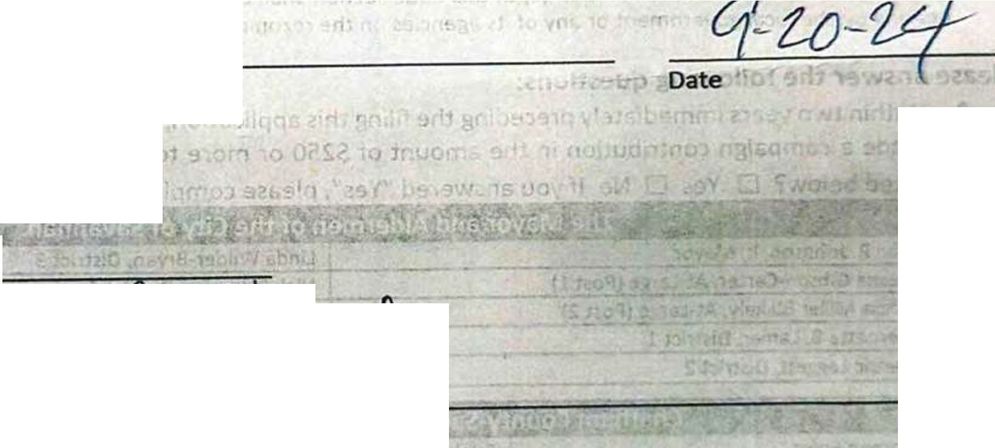
,
Witness Signature Certificate
Stateof a
SI\$
County ot Jvµll l
Signed or attested before me on Zi;:2-1?:2-!-L::.J
)• ··-
who proved me on the basis of satisfactory evidence to be the person(s) who appeare_dbefore-me.

.Personally Known or □Produced Identification Type of ID .Ovtvif$ lAllrS.l
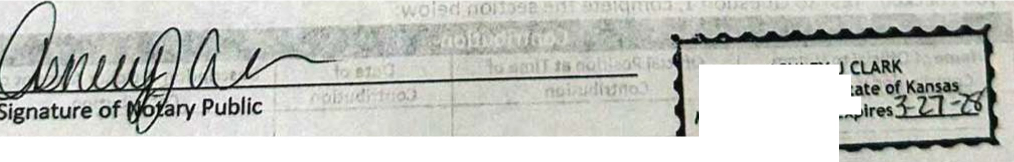

ASHLEY J
Notary Publk • St My Appointment

(Name of notary, typed, stamped or printed) Notary Public State of Georgia

My commission expires:: 2 - l, 71.:_· z;, --...,,,_--,,--=:-::--

vartances for Development Plans (Plannlns Comm1ss1on ••...Jlcatlon)
Revised: 2.2.2024

FUe No.

Pap3of7

EXHIBITG

VIII. Disclosure of Campaign Contribution Form. To be filed within 10 days of filing this application. This Is required to be nlled out by the Petitioner, Property Owner, and/or Agent per the Conflict of Interest in Zoning Actions Act (O.C.G.A. § 36•67A).
- When any applicant for rezoning action has made, within two years Immediately preceding the filing of that applicant's application for the rezoning action, campaign contributions aggregating $250.00 or more to a local government official who will consider the application, it shall be the duty of the applicant to file a disclosure report with the governing authority of the respective local government showing:
  - The name and official position of the local government official to whom the campaign contribution was made; and
  - The dollar amount and description of each campaign contribution made by the applicant to the local government official during the two years immediately preceding the filing of the application for the rezoning action and the date of each such contribution.
- The disclosures required by subsection (a) of this Code section shall be filed within ten days after the application for the rezoning action is first filed.
- When any opponent of a rezoning action has made, within two years immediately preceding the filing of the rezoning action being opposed, campaign contributions aggregating $250.00 or more to a local government official of the local government which will consider the application, it shall be the duty of the opponent to file a disclosure with the governing authority of the respective local government showing:
  - The name and official position of the local government official to whom the campaign contribution was made; and
  - The dollar amount and description of each campaign contribution made by the opponent to the local government official during the two years immediately preceding the filing of the application for the rezoning action and the date of each such contribution.
{d) The disclosure required by subsection {c) of this Code section shall be filed at least five calendar days prior to the first hearing by the local government or any of its agencies on the rezoning application.

Please answer the following questions:
A. Within two years immediately preceding the filing this application, have you and your agent (if applicable) made a campaign contri,bution in the amount of $250 or more to any of the local government officials
listed below? D Yes d No If you answered "Yes", please complete Question 2.
 | The Mayor and Aldermen of the City of Savannah
Van R.Johnson, II, Mayor |  | Linda Wilder-Bryan, District 3
Kesha Gibson-Carter, At-Large (Post 1) |  | Nick Palumbo, District 4
Alicia Miller Blakely, At-Large (Post 2) |  | Dr. Estella Edwards Shabazz, District S
Bernetta B. Lanier, District 1 |  | Kurtis Purtee, District 6
Detric Leggett, District 2

 | Chatham | County-Savannah |  | Metropolitan | Planning |  | Commission
Loreen Boles |  |  | Ruel Joyner |  |  | Joseph Welch
Travis Coles |  |  | WayneNoha |  |  | Tom Woiwode
Elizabeth Epstein |  |  | Eula Parker |  |  | Jay Melder, Ex-Officio
Joseph Ervin |  |  | Dwayne Stephens |  |  | Lee Smith, Ex-Officio
Karen Jarrett |  |  | Malik Watklhs
- If you checked "Yes" to Question 1, complete the section below:
Contribution
Name of Official to Whom  Contribution was Made | Official Position at Time of  Contribution | Date of  Contribution | Description & Dollar Amount of  Contribution
- '

Signature of Petitioner or Petitioner's Agent
Brad Baugh
Printed Name
09-20-2024
Date

Variances for Development Plans (Planning Commission Application) Revised: 1.2.2024
Flle No. _
Page4 of7

- Application Fee
The non-refundable filing fee is based on the type of use for which relief is requested. Make check payable to City of Savannah.
Rezoning/Comprehensive Plan Amendment: $3,500.00 + $50.00 per acre
□ Planned Development: $1,100 + $155.00 per acre
- Application Checklist
Pursuant to O.C.G.A. § 8-2-26, this checklist must be completed and submitted with each permit application. Please check every item as either "Y" for items that are included with the application or "N" for items that are not included with the application. Items without an "N" checkbox are minimum requirements initially due with the application if applicable.
Yes No
Kl Part I. Subject Property Part II. Action Required
Part Ill. Rezoning Review Criteria Form Part IV. Neighborhood Meeting
Part V. Property Owner Information
D Part VI. Petitioner Information
  - Part VII. Agent
  - Part VIII. Letter of Authorization
Part IX. Disclosure of Campaign Contribution Form Part X. Application Fee
Part XI. Complete Application Checklist
Part XII. Certified Application (Signed application)
Survey. A scaled or dimensioned boundary survey, tax map, plot plan, or sketch showing the subject property (Original not scanned if produced electronically and not recorded).
Legal Description. A legal description of the land by lot, block, and subdivision designations,
or if none, by metes and bounds (Electronic or digital Word document).
  - Concept Plan of the proposed development if applicable
Please note: Supplemental information may be required during plan review to address deficiencies.
- Certified Application
By my signature below, I certify that the information contained in this application is true and correct to the best of my knowledge at the time of the application. I acknowledge that I understand and have complied with all of the submittal requirements and procedures, and that this application is a complete application submittal. I further understand that an incomplete application submittal may cause my application to be deferred to the next posted deadline date. I understand that the approval of an application for Special Use Permit by The Mayor and Aldermen does not constitute a waiver from any applicable local, state, or federal regulations.
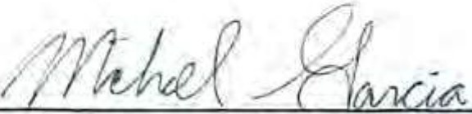
Michael Garcia 10-28-2024
Signature of Petitioner or Petitioner's Agent Printed Name Date

Rezoning (Map Amendment) and Comprehensive Plan Future Land Use Amendment Applicatfon Revised: 2.2.2024

File No. _
Page 6 of 8

RETAIN THIS PAGE
Instructions
  - Applicants are requested to contact the Metropolitan Planning Commission (MPC) or the City's Planning and Urban Design Office (City) prior to submitting an application.
  - If the project is a Development of Regional Impact (DRI), the project must first be found "in the best interest of the State" before a rezoning application can be reviewed by the Planning Commission. MPC staff will notify the petitioner or agent when a request qualifies as a ORI.
  - The application form must be complete according to Sec. 3.1.4 including the appropriate fee and all required supplemental materials before it will be processed and scheduled for a hearing. If the property has been purchased within the last 12 months, please provide a copy of the Deed.
  - All applications must be submitted electronically to planning@savananhga.gov. If the document size is larger than 20 MB, please contact 912-525-2783.
s. The petitioner or agent may include exhibits (e.g., letters or photos) to support the request.
6. A schedule of the application deadlines as well as the Planning Commission and City Council meeting dates are part of this application.
Rezoning and Comprehensive Plan's Future Land Use Map Amendment Process (After the Application is Submitted)
- All rezoning applications will be considered by the Planning Commission at a public hearing prior to the Mayor and Aldermen
olding the zoning hearing.
- Once an application submittal is determined to be complete according to Sec. 3.1.4, the MPC will schedule the petition for review by the Planning Commission and prepare a staff recommendation.
- The MPC will notify the petitioner of the public hearing date and time as well as publish a public notification in the newspaper.
- The petitioner will receive notification to obtain a Public Notice Sign(s) announcing the petition from the City's Planning and Urban Design Office at located at 20 Interchange Drive, Administration Bldg. The petitioner must post the sign(s) at least 15 DAYS PRIOR TO THE PLANNING COMMISSION MEETING according to Sec. 3.2.6. If the signs are not posted at least 15 days before the public hearing, the petition will be rescheduled.
- The Planning Commission meeting will be held in the Arthur A. Mendonsa Hearing Room at the MPC, 112 E State Street doorway.
6. During the meeting, an overhead projector and computer are available for use. The overhead projector can display all paper items (e.g., photographs, maps, site plans). PowerPolnt presentations must be provided to MPC staff at least two days prior to the hearing. A copy of any materials used to support your petition must be submitted for the record at the time of the hearing.
- The Planning Commission wrll make a recommendation to the Mayor and Aldermen regarding the petition. The Planning Commission's recommendation may be to approve, approve with conditions, continue or deny the petition.
  - Once the Planning Commission has made a recommendation, the petition will be forwarded to Mayor and Aldermen for
consideration. The City will notify the petitioner of the date and time of the City Council meeting and publish the public notice for the zoning hearing in the newspaper. In addition, the petitioner will receive notification from the City's Planning and Urban Design Office to obtain a Public Notice Sign(s) announcing the petition. The petitioner must post the sign(s) at least 15 DAYS PRIOR TO THE CITY COUNCIL MEETING according to Sec. 3.2.6. If the signs are not posted at least 15 days before the zoning hearing, the petition will be rescheduled.
- The Mayor and Aldermen must have at least two meetings to consider the petition and Planning Commission's recommendation; a zoning hearing and then the first and second readings of the petition. The first and second readings may be held at the same meeting as the zoning hearing.
- Once the Mayor and Aldermen hear the petition, they make a recommendation to approve, approve with condftions, deny,
continue the petition to the next meeting or a date certain, or remand the petition back to the Planning Commission for further study.
- Notification of Mayor and Aldermen's final decision will be sent to the petitioner by the City.
- The petitioner or agent should be ln attendance at all Planning Commission and City Council meetings. If no one is present to represent the petition, the petition may strll be discussed.

Rezoning (Map Amendment) and Comprehensive Plan Future Land Use Amendment Application File No ­
Revised: 2.2.2024 Page 7 of 8

RETAIN THIS PAGE
2024 Application Submittal Deadlines for Planning Commission Meetings with City Council Meetings
Application Submittal Deadline (Appl/cation submittal deadlines are on Tuesdays unless otherwise noted.)  Submittal Due: 5:00 p.m.  Submittal Location:  lanning@savananhga.gov | Planning Commission Meeting Date (All meetings are scheduled for every three weeks on Tuesdays unless otherwise noted. Contact MPC at 912-651-1440.)  Pre-meeting: 12:00 p.m. Meeting Time: 1:30 p.m. Meeting Location:  MPC  112 E State St  Arthur A. Mendonsa Hearing Room | City Council Meeting  (Zoning Hearings and 1st & 2nd Readings) (All meetings are scheduled for the second and fourth Thursdays of every month unless otherwise noted. Contact 912-525-2783.)  Meeting Location: City Hall, 2 E Bay St, Council Chambers on the 2nd Floor.
Meeting Time:
2:00 p.m.
DEC20 | JAN 16
JAN 12 | FEB 6
FEB 2 | FEB 27 | FEB 8 | FEB 22
FEB 23 | MAR19 | MAR14 | MAR28
MAR 15 | APR 9 | APR 11 | APR25
APR 5 | APR 30 | MAY9 | MAY23
APR 26 | MAY21 | NO MEETING | JUN 27
MAY17 | JUN 11 | JUL 11 | JUL 25
JUN 7 | JUL 9 | AUG8 | AUG 22
JUN 28 | JUL 23 | SEP 12 | SEP 26
JUL 19 | AUG 13 | OCT10 | OCT24
AUG9 | SEP 10 | NOV 14
AUG30 | SEP 24 | NOV 26*
SEP 20 | OCT15 | DEC12
OCTll | NOV5
NOV1 | NOV19
NOV22 | DEC 17
DEC 13 | JAN 7, 2025
* Regular City Council Meeting may be rescheduled due to the holidays.

NOTE O.C.G.A. § 36-66-4(a). A local government taking action resulting in a zoning decision shall provide for a hearing on the proposed action. At least 15 but not more than 45 days prior to the date of the hearing, the local government shall cause to be published within a newspaper of general circulation within the territorial boundaries of the local government a notice of the hearing. The notice shall state the time, place, and purpose of the hearing.

Rezoning (Map Amendment) and Comprehensive Plan Future Land Use Amendment Applicatfon Revised: 2.2.2024
FIie No. _
Page 8 of8

-.)pENGAGE DESIGN TRANSFORM

November 1st, 2024

EXHIBIT A
The Planning Commission
20 Interchange Drive -Administration Building Savannah, Georgia 31415

fl CHITEC1URE

lt,1ERIORS
RE: (Forsyth Park Office Buildings 1-3) Dear MPC Staff,
This petition is requesting a Zoning Map Amendment (Rezoning) and a Comprehensive Plan FLUM Amendment for the properties at 1001and 1015 Whitaker Street and 120 and 124 West Park Avenue within the Victorian Historic District. The properties consist of (2) single story structures, mid-century is design aesthetic, with adjacent surface parking along Whitaker Street and a 2-story brick building with a surface parking lot with a multi-bay parking garage along Park Avenue that is the former location of Campbell & Sons Funeral Home. The current structures on these properties are non-contributing structures to the Victorian Historic District and have previously been approved for demolition under a separate submittal in 2023.

The proposed Rezoning for these properties is to rezone from a TN-1 to a TC-2 and to amend the Comprehensive Plan FLUM for these properties from Traditional Neighborhood to Traditional Commercial.

This petition proposes new construction of (3) Office Buildings and an 3-story underground parking deck that is intended to be leased to the City of Savannah as a public parking amenity:

Building 1 is proposed to be a multilevel office building (3 story structure with a recessed 4th story) with the main entry fronting Whitaker Street and includes vehicular access from Howard Street to the underground parking deck within the ground floor building footprint. The vehicular access is within the ground floor building footprint to minimize visibility and maximize the parking deck efficiency in terms of parking layout and public access.
Building 2 is proposed to be a multilevel office building (4 story with a recessed 5th story) with the main entry also fronting Whitaker Street. This building mass will include approximately 3,000 SF of ground floor retail space and vertical circulation for public access to the underground parking deck. Buildings 1 and 2 masses are intended to be separate buildings but will be connected by a bridge for the upper floors 2-4, providing a pedestrian pass-through between Howard and Whitaker Street.
Building 3 is proposed to be a multi-level office building (3 story with a recessed 4th story) with the main entry at West Park Avenue,

321 WEST CONGRESS STREET. SUITE 301 SAVANNAH, GEORGIA 31401 912.695.2111 PH 912.298.0206 FAX• LS3P.GOM

- The Underground Parking Deck's main entry will be located along Howard Street within the ground floor footprint of Building 1. All 3 proposed buildings vertkal circulation will be incorporated into the parking deck layout. The parking deck will provide a total of 437 parking spaces, with access to a public stair and elevator lobby located on the southeast corner of Building 2. The required total number of parking spaces for the deck is 290 spaces. The deck spans between all buildings and a future residential development that will be submitted under a separate petition at a later date.

Rezoning Review Criteria

The purpose for the requested rezoning is reviewed with the following criteria

Suitability and Community Need

- Whether the range of uses permitted by the proposed zoning district Is more suitabf e than the range of uses permitted by the current zoning district.

The current TN-1 zoning district permits the use of general office and retail as well as special use of a parking facility. The proposed TC-2 zoning distrfct also permits the same uses. However, the proposed TN-1 limits building footprint, lot coverage and height that conflicts with adequate support for these permitted uses in this district. Rezoning to TC-2 allows for a greater building footprint and removes a maximum lot coverage, both encouraging greater visual compatibility with the surrounding context in the Victorian District immediate to this site. The general development pattern along Whitaker Street and Park Avenue tends to be larger building footprints and more building coverage of the respective lots, creating a wall of continuity that borders Forsyth Park.

Ii. Whether the proposed zoning district addressed a specific need in the county of city
The proposed development is consistent with several PLAN 2040 goals such as: o Economic Development
  - Foster a positive environment that provides opportunities for all businesses
  - Become a community with economically vibrant, safe neighborhoods and commercial centers
- Land Use
  - Utilize small area and corridor plans as a means to protect the character of existing areas and ensure new development is compatible.
  - Enhance the character and image of major corridors by implementing the design and construction of safe, attractive, vibrant, and pedestrian-friendly streetscapes that project a positive image while encouraging walking.

This proposed development intends to provide the neighborhood with approximately 118,000 SF of commercial/retail space. New commercial and retail space in mass would help address the lack of existing inventory dedicated to these uses in dowhtown savannah and Victorian District. These uses also help promote day to day activity and support of current businesses Within the area.

Compatibility

- Whether the zoning proposal will adversely affect the existing use or usability of adjacent or nearby property.

We are proposing several street improvements along Waldburg Street, Whitaker Street, Howard Street, and West Park avenue. Improvements include:

  - Existing tree lawns along West Park Avenue and West Waldburg Street are proposed to be expanded to enhance the pedestrian experience.
  - Existing sidewalks are proposed to remain with improvements that address accessibility and pedestrian safety.
  - New brick tree planters are proposed to be incorporated into the right-of-way and within the property boundary. Fauna and landscaping is proposed to be relatively shallow in root depth to avoid conflicts with the subgrade parking deck immediately below.
  - Howard Street Is proposed to be repaved with permeable pavers. The pavers will span the length of street between West Park Avenue and West Waldburg Street.
  - Additional improvements along Howard Street are proposed such as expanding the sidewalks on both sides of the street and providing (10) parallel parking spaces within the street right-of-way.

- Whether the zoning proposal is compatible with the present zoning pattern and conforming uses.

Several properties adjacent to these properties in this petition are designated traditional commercial along Park Avenue, Bull Street, and Drayton Street. The FLUM for the Savannah Comprehensive Plan also notes several areas surrounding Forsyth Park that are already designated as Traditional Commercial land uses or will become so.

- Whether there are other existing or changing conditions affecting the use and development of the property which give supporting grounds for either approval or disapproval of the zoning proposal.

The current parcels are approximately .97 acres. Of the total acreage, about .48 acres is off street surface parking due to the smaller building footprints currently in place in these properties. The proposed buildings under a TC-2 zoning district will eliminate the current surface parking on these properties and provide valuable commercial and retail space that will enhance the pedestrian experience and align more to the visual compatibility standards of the surrounding context.

Consistency

- Whether the zoning proposal is in conformity with the policy and intent of the Comprehensive Plan and other adopted plans, such as a redevelopment or small area plan.

The Comprehensive Plan FLUM currently designates these properties as Traditional Neighborhood character area. The request to change the current designation to Traditional Commercial character area would conform to the policy and intent of the Comprehensive Plan as several blocks adjacent to these properties are intended to be the proposed TC character area.

Reasonable Use

- Whether the property to be affected by the zoning proposal has a reasonable use as currently zoned.

The current properties do not fully utilize the potential of their location, site and overall land. Two of the 3 buildings currently in place are single story commercial buildings and non contributing structures and do not carry the similar aesthetic and visual compatibility as the surrounding buildings, especially along Whitaker Street. The current funeral home located on Barnard and Park Avenue also does not utilize the property to its utmost potential. The pattern of development on this site through the years has seen several additions but they do not fall within the overall character of the surrounding context. The proposed zoning change and land use designation allows for a future use.that is a more efficient and Improved use of the land in such a prominent corner intersection at Forsyth Park and the Victorian District.

Adequate Public Services

I. Whether adequate school, public safety and emergency facilities, roads, ingress and egress, parks, wastewater treatment, water supply and stormwater drainage facilities are available for the uses and densities that are permitted in the proposed zoning district.

Current work is being done with civil consultants to support future densities and the drainage required for the planned uses allowed. There is also street improvements related to permeable surface drainage that will help reduce the cities overloading of its current systems. Being along Whitaker Street facing Forsyth, the public park access is going to be steps away from these properties.

The proposed future underground parking deck is also a positive contribution to public services. We are proposing a public parking deck with independent access on site for the public who utilize this facility. The vehicular access to the parking deck is located on Howard street in an effort to reduce traffic on prominent streets along public amenities such as Forsyth. The vehicular ramp is also within the building 1 footprint to reduce traffic and immediate visibility for pedestrians and adjacent neighbors. We are expanding sidewalks along Howard Street's right of way in order to enhance the pedestrian experience beyond just Whitaker Street.

We look forward to staffs review and recommendations for this petition and welcome any questions regarding clarity or intent within the submission

Sincerely,

Michael Garcia, Assoc. AIA Senior Associate
LS3P

Attachments: Variance Application-Amended
EXHBIT A_Project Narrative Revised EXHIBIT B_Revised Building Massing EXHIBIT C_Revi.sed Plan and Elevations

EVANS GENERAL CONTRACTORS
Savannah Office Buildings

L )P
NELSO

- '!'j
-e,:;
-

""3
Cl

10-17-2024
SAYAHHAH

ti"j
=
....
....
"'"3
C')

..

g_
.
-₋
"='
t
.

0
.:
C
"=
.;,;
SAVANNAH OFFICE BUILDINGS

Original Massing
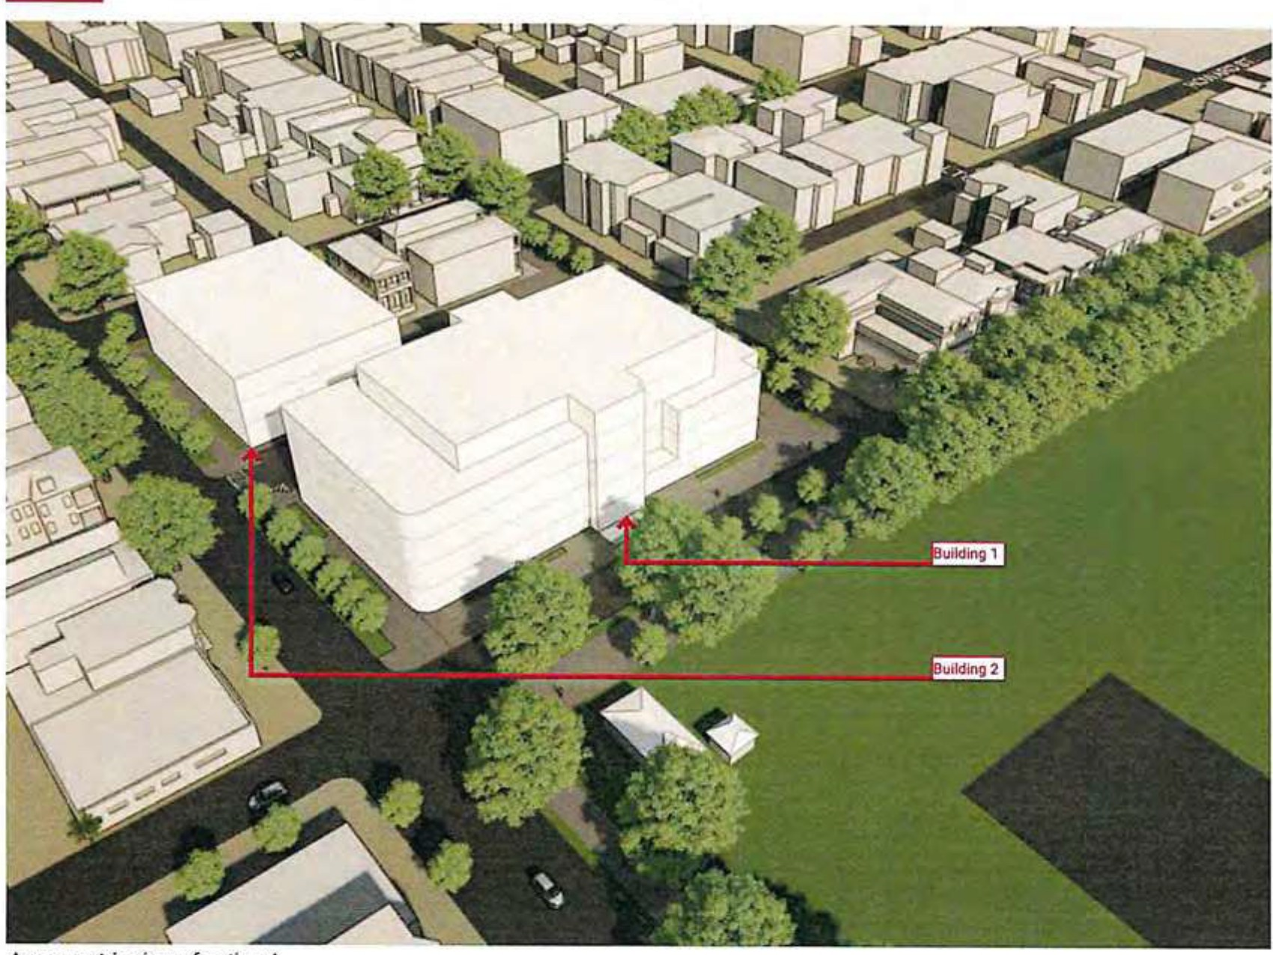
Axonometric view of option A

Proposed Square Footage

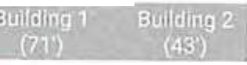

l | 17,495 sf | 10,075 sf
2 | 22,068sf | 10,075 sf
3 | 22,068 sf | 10,075 sf
4 | 17,935 sf
5 | 12,760 sf
TOTAL | 92,326 sf | 30,225 sf  ui,ss1sf

Potential Variance RequeS1s
Rezone Properties - TN-1 to TC-2 Height Variance on Building 1

Potential Special Exception Request
- Building Footprint Exception for Building 1

SAVANNAH OFFICE BUILDINGS

Original Massing

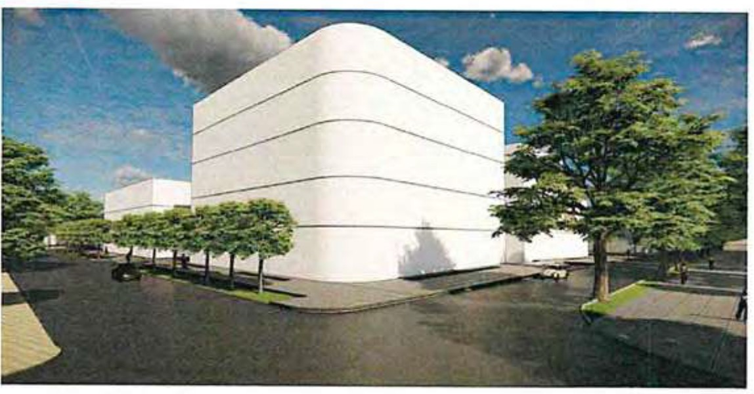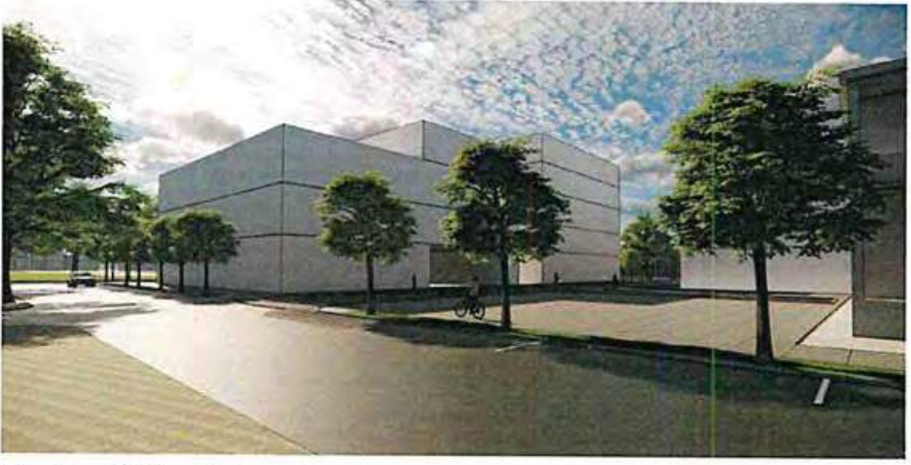

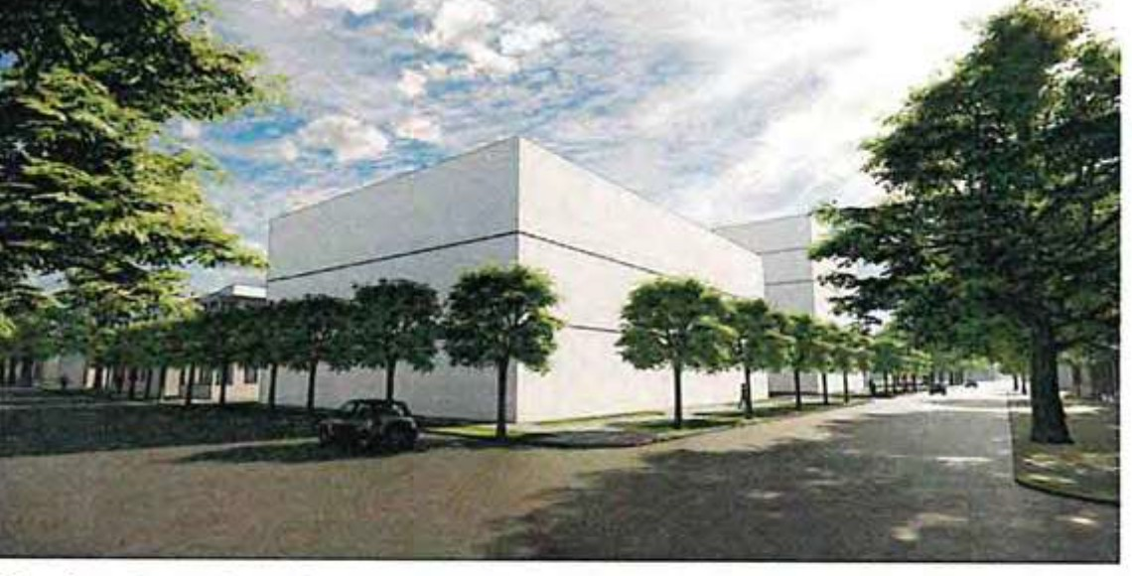
:; View from Whitaker & Park

=
,,.,
View from Waldburg & Howard

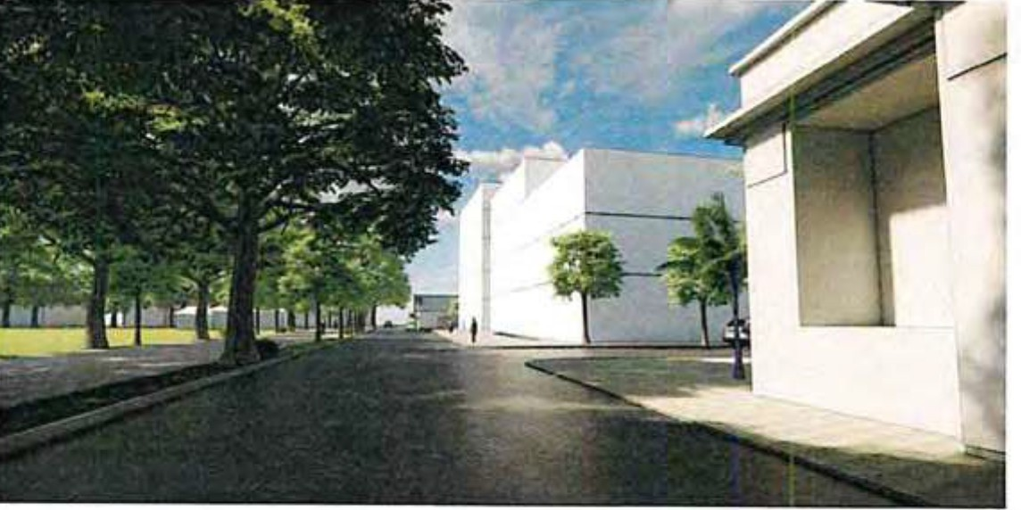
.:
_,

t.'!'j
-
-
,;;
"
0
;;
."._,
>

View from Barnard & Park View from Whitaker & Waldburg

t.'!'j
ci
1
-;;
r.
.,
0
-
-

c

.::
SAVANNAH OFFICE BUILDINGS

Revised Massing Option
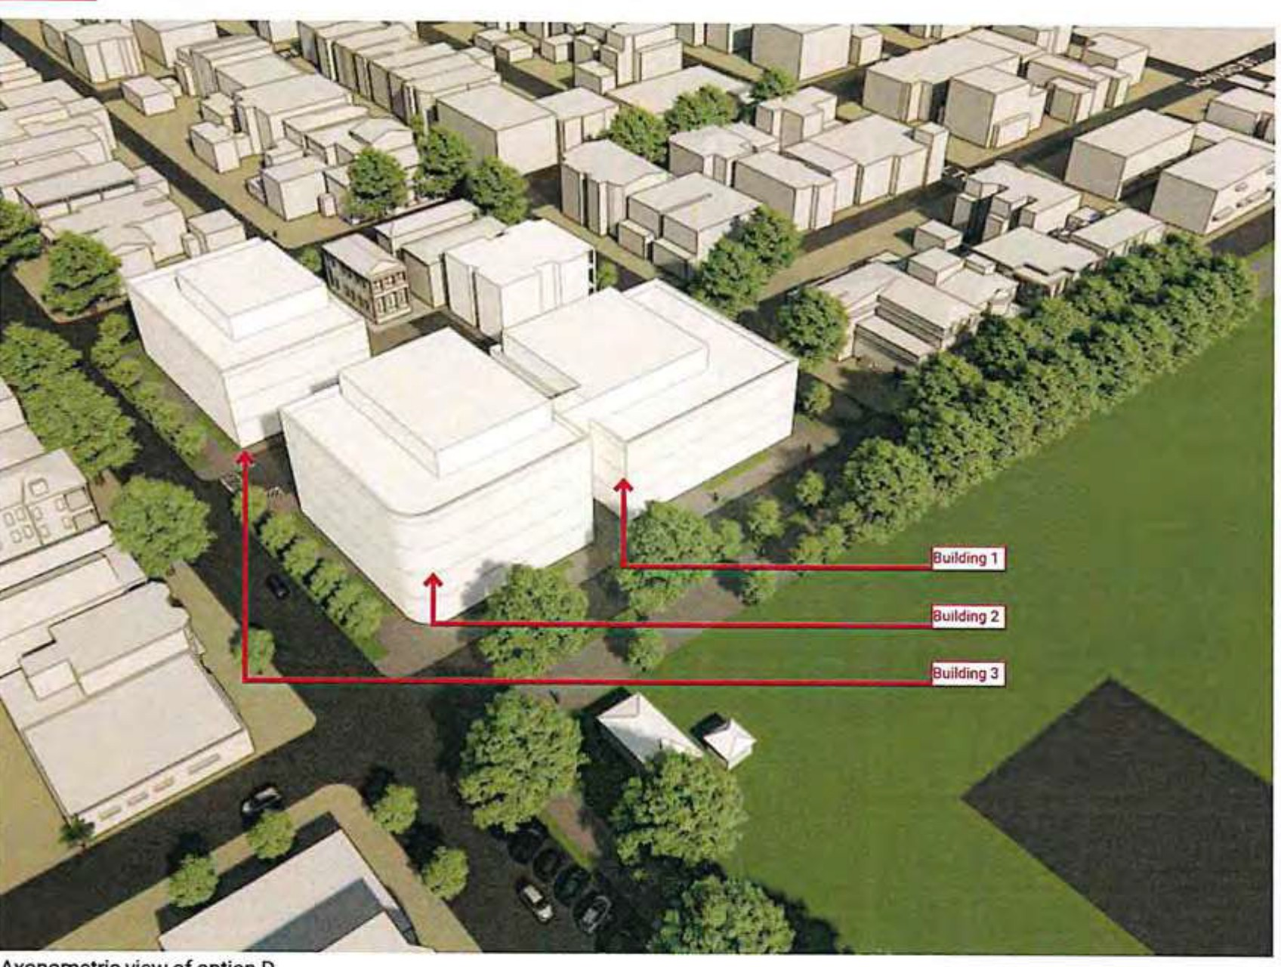
Axonometric view of option D

Proposed Square Footage

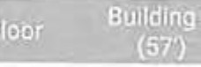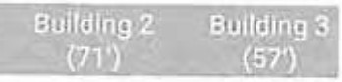

l | 12,054 sf | 10,000sl | 9,600sl
2 | 12,054 sf | 10,000sf | 9,600sf
3 | 12,054 sf | 10,000sf | 9,600sf
4 | 5,280,f | 10,000 sf | 3,600sf
s |  | 4,845 sf
TOTAL | 41,442 sf | 44,845 sf | 32,400 sf  118,687 sf

Potential Variance Requests
Height Variance on Buildings 1,2, & 3 Building Footprint for Buildings 1,2,3 Building Coverage for Buildings 1and 2

SAVANNAH OFFICE BUILDINGS

Revised Massing Option

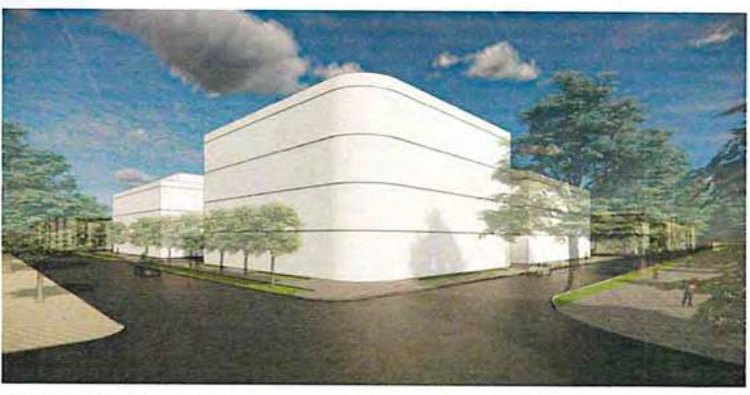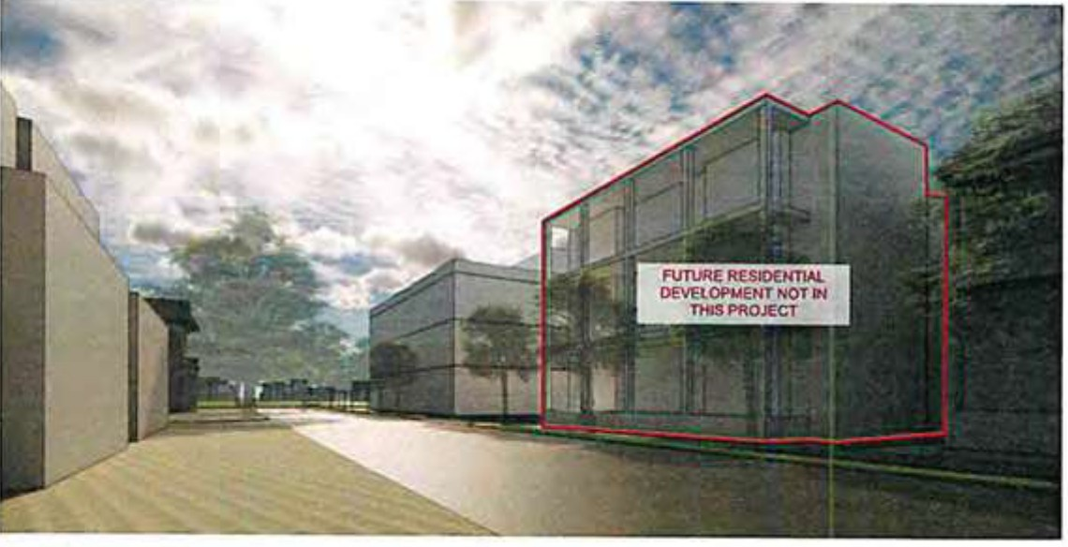

.,.
C

!

=...
,;
u
View from Whitaker & Park
View from Waldburg & Howard

t.'!'j
-
-

e,:;
""3

0
.c.
.,

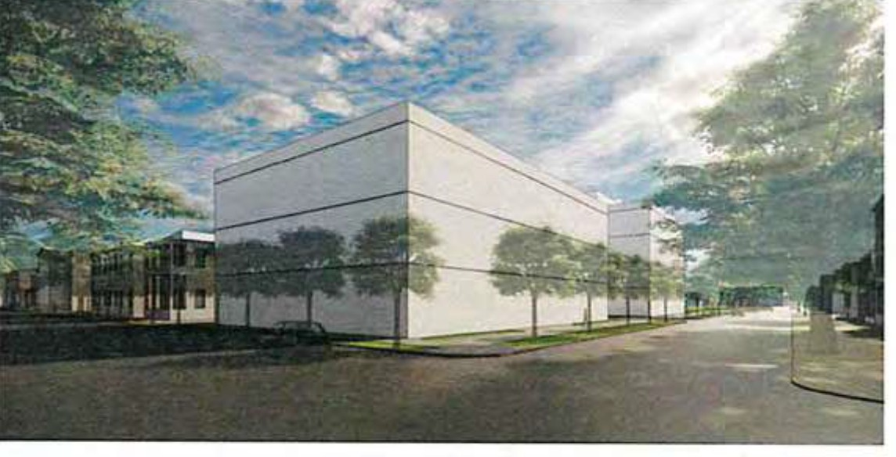
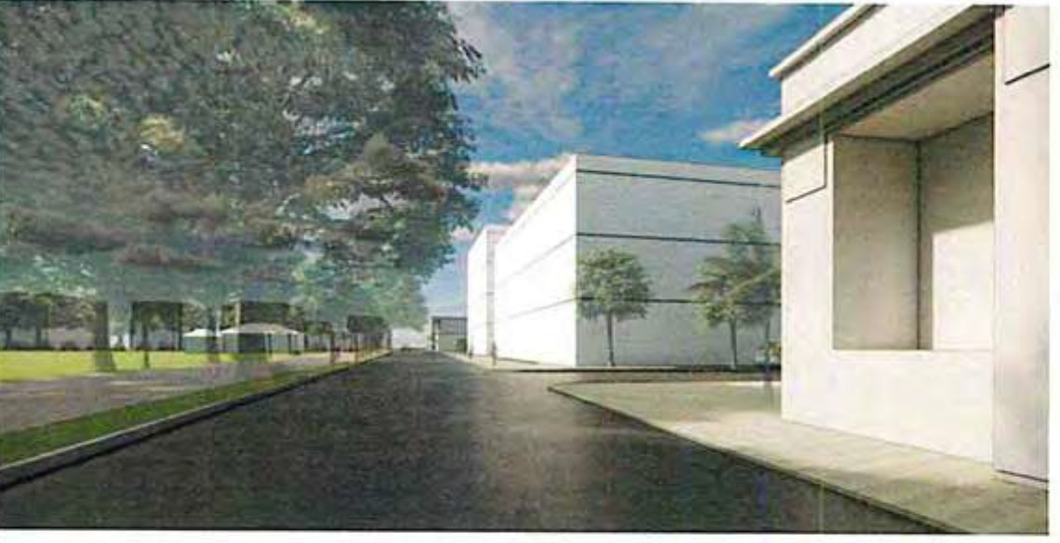
View from Barnard & Park View from Whitaker & Waldburg

SAVANNAH OFFICE BUILDINGS

Revised Massing Option
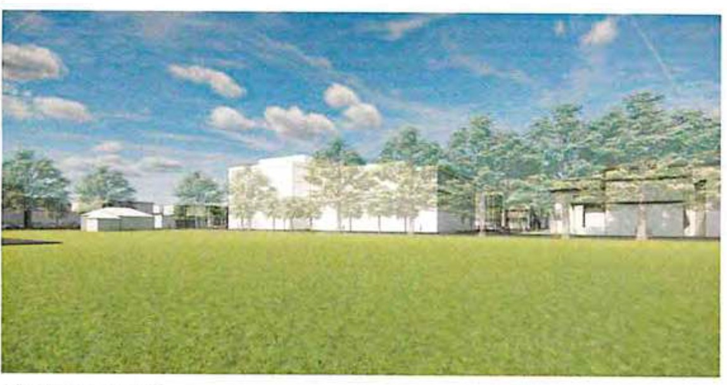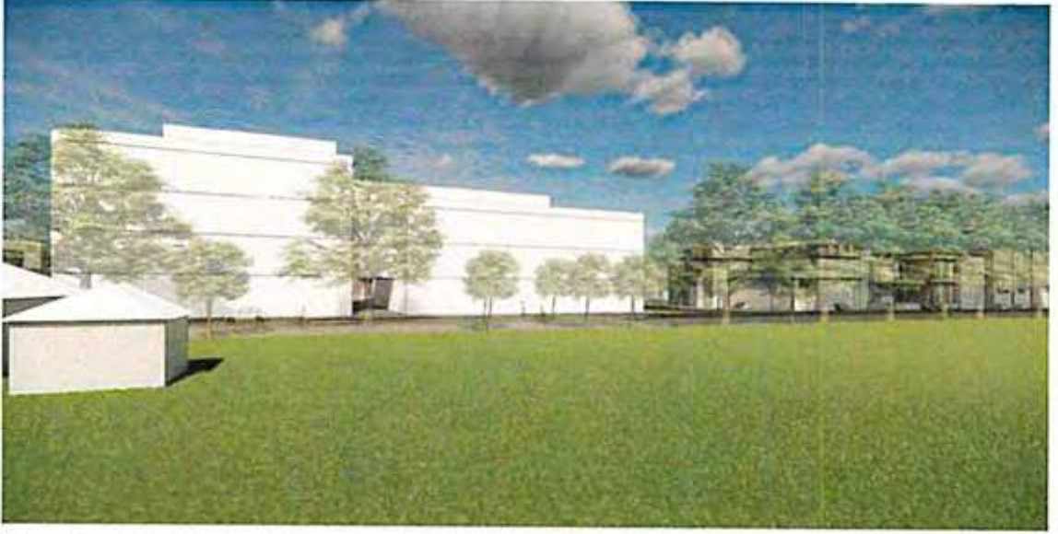

$".'

-;.

.,
g'
."'
View from Forsyth 1
View from Forsyth 2

0

t.'!'j
-
=
g
- g,

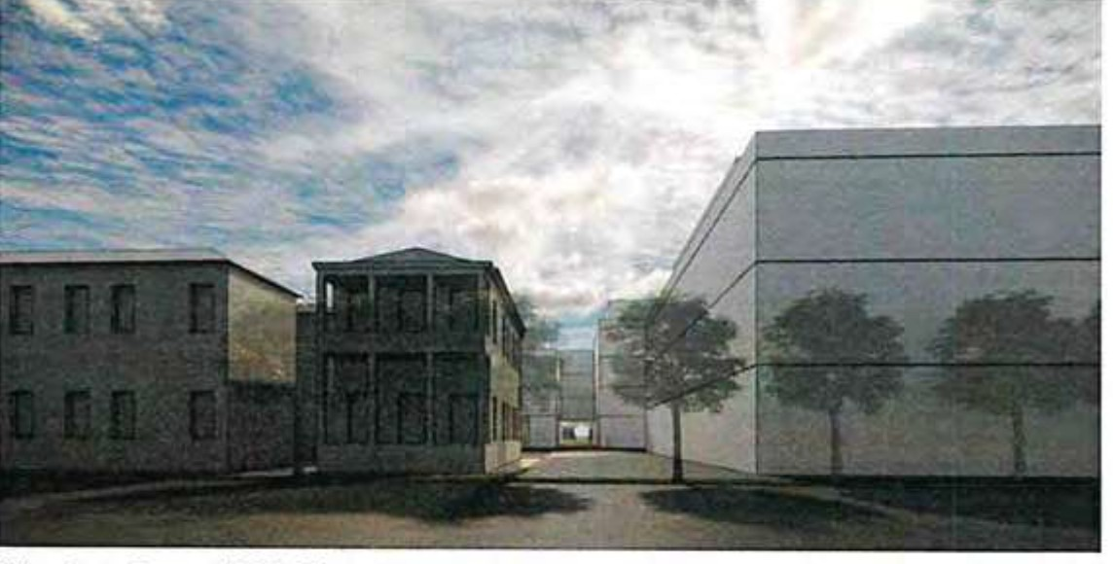
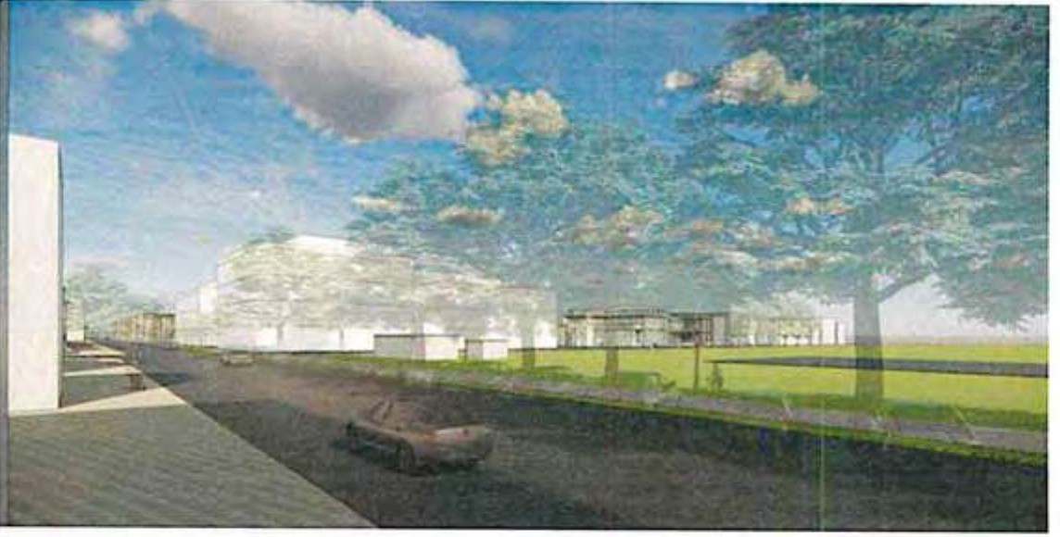
View from Barnard & Waldburg Ln View from Park & Bull

SAVANNAH OFFICE BUILDINGS

Revised Massing Option
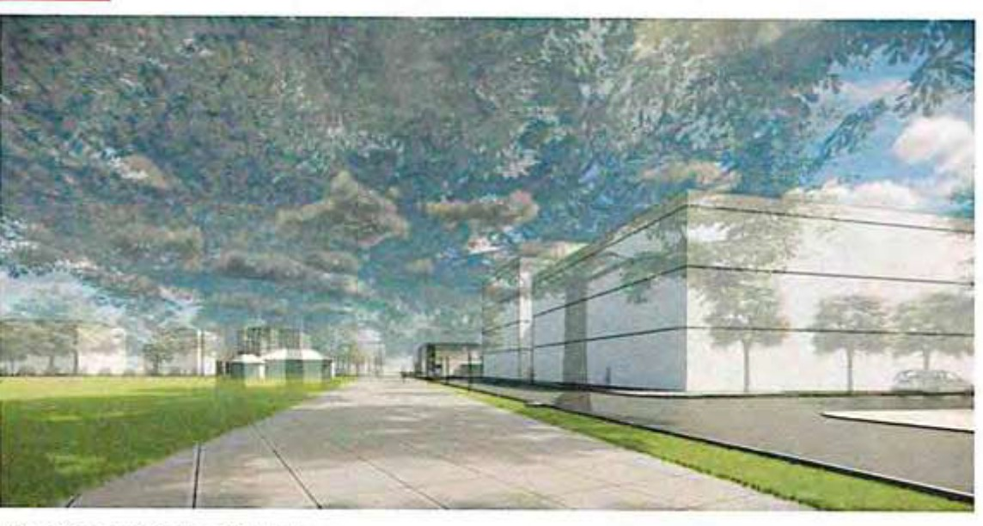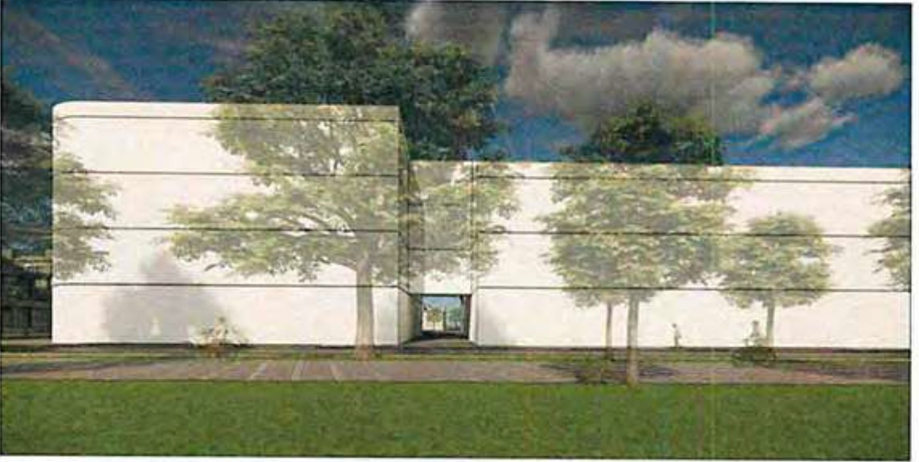

::. View from Whitaker & Waldburg
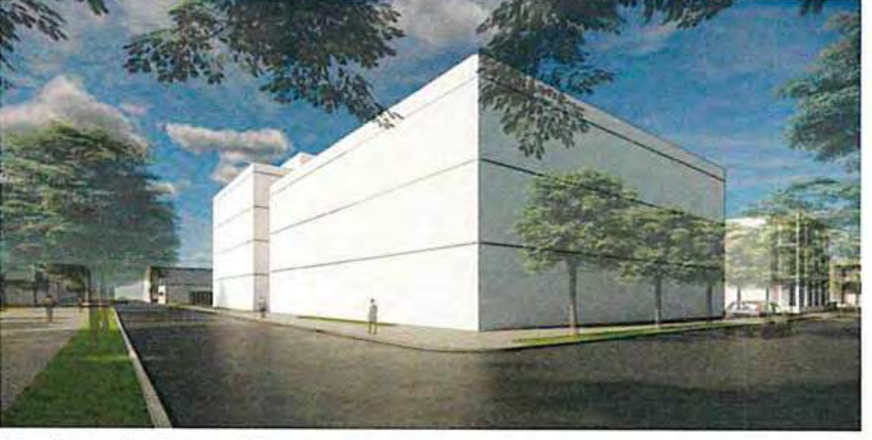
C
.;;

;
"'
View towards proposed bridge

c
.;; "V
0

>
"
-

t.'!'j
-

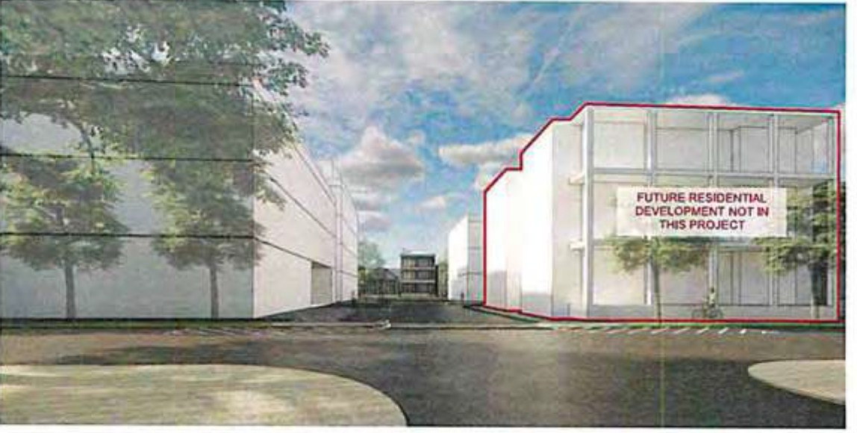
View from Whitaker & Waldburg View from Waldburg & Howard

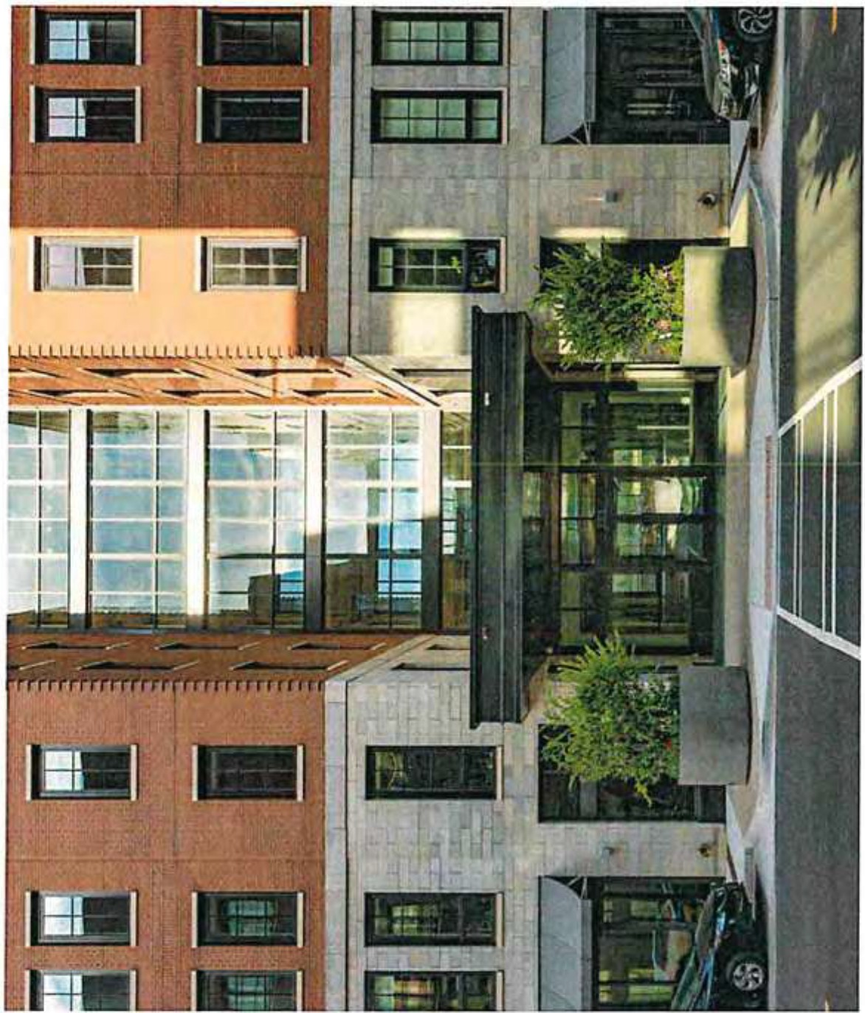

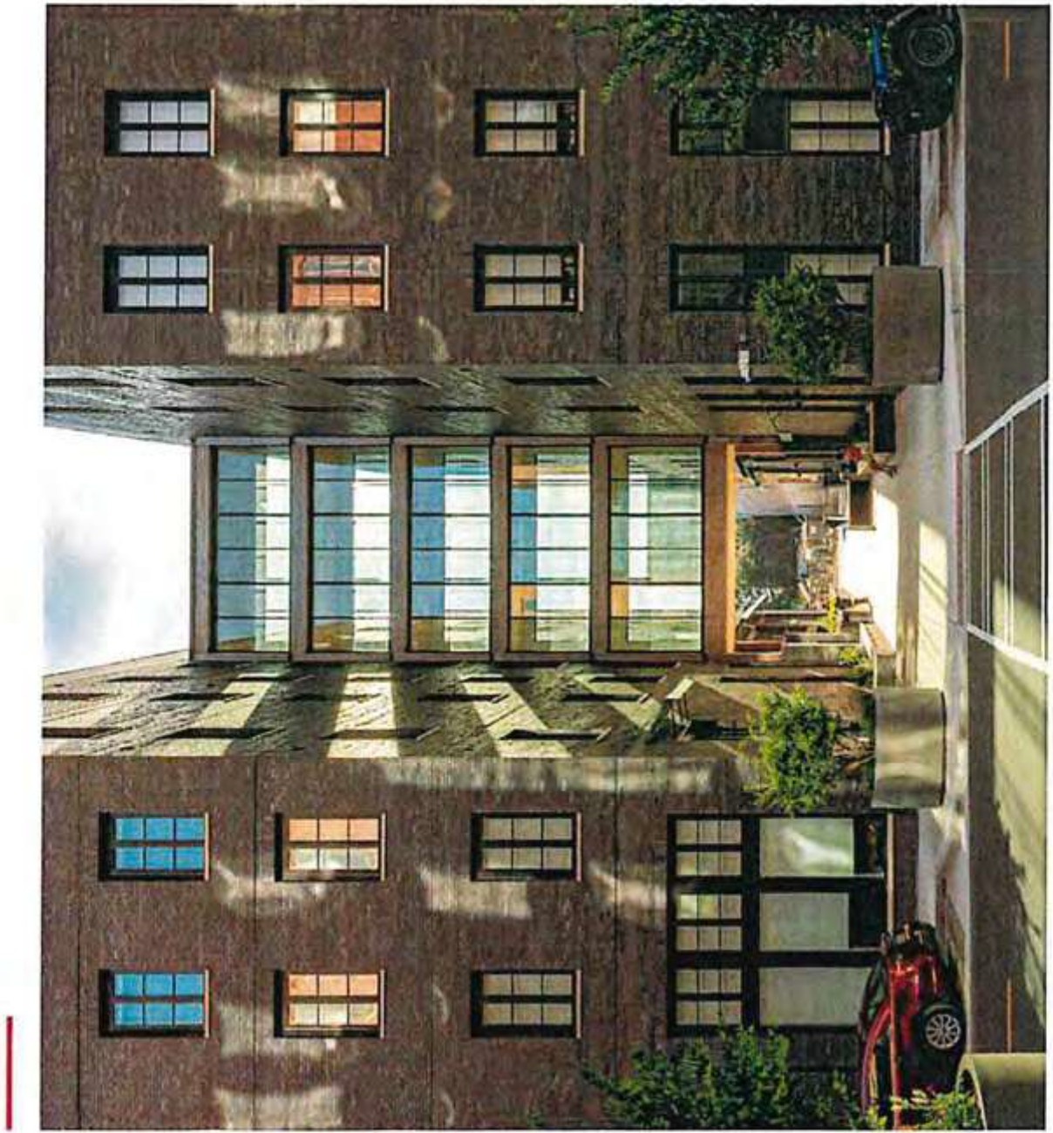
..-
C
Q)
-0
Q)
"'
<!) ()

z
-
0
..J L..
::,
-
m
w
u
;;:
u.
Q)
a..
0)
C
·-

0
:i: 0)
< ·-0-
z z
< L..
>
< a)
"'

E-t s:JU!Pl!"8 a:>!UO qeuue11es
Jll 'lJU!PI0H SU0WW0:) qtASJ0
tJZ/SZ/Ot

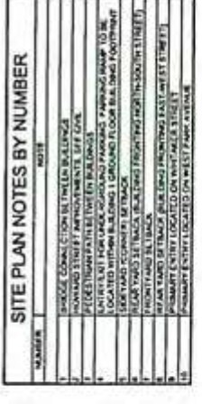
•'
!
.
!
I
I
I., s
!
•
•I
w
I
fl
5...,I 'pi
1::·
ffi I
illuli
1111
I;iI
i I

-·

.,

I I
I
-..1ft/ (
e

,,

z
::5
0.
LLI
!::
V...'.I.
::)
1u-
LI.I
!::
:uI:
0:::
<(

""'4
Ln
0


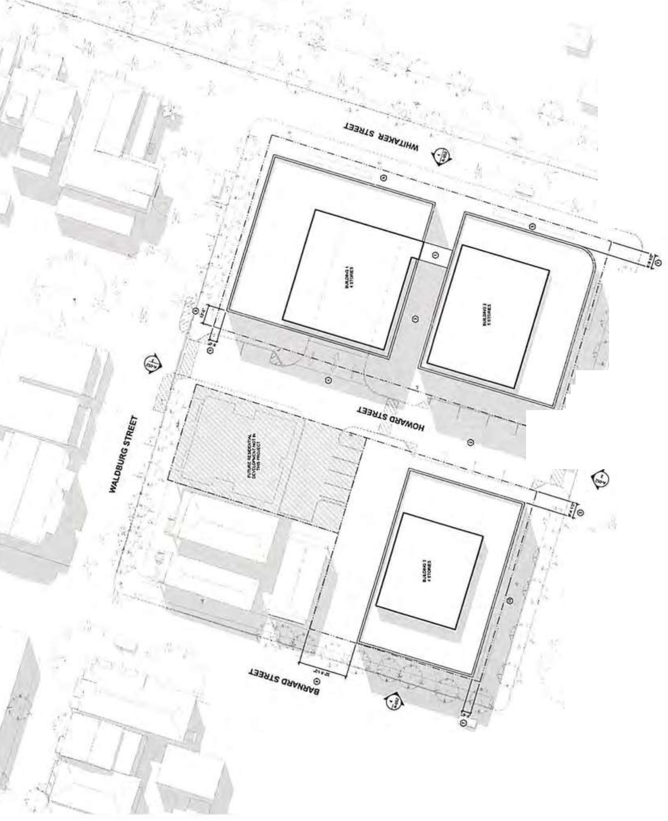



I
<(

E·t s:JU!P1!"8 a:>!JJQ 4euue11es
:n, 'au,p10H suowwo:, 4v,sJo
tiZ0Z/SZ/0t CL
VJ.
J

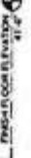
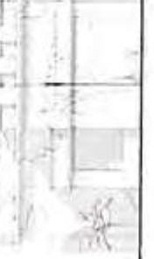
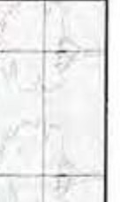
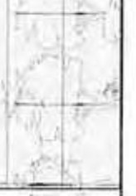

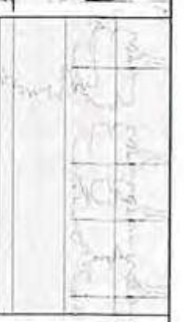
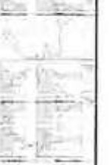
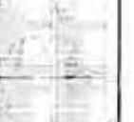



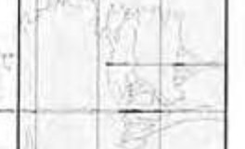


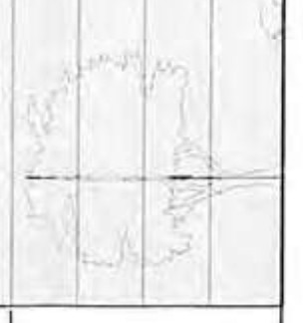
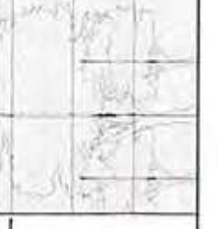

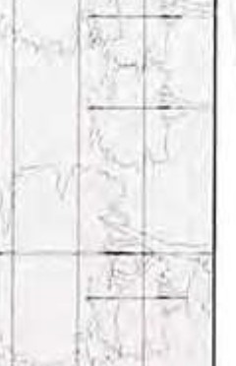
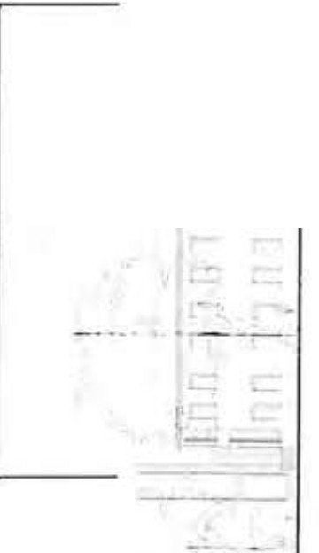
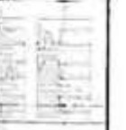

V)
I
z

0
>w
...J

w

N
i.n
0
I
ct

Page 1 of 10


CFC-CCDT\ 01/>0

Campaign Contribution Disclosure Report
Georgia Government Tran parency and Campaign Finance Commission
200 Piedmont Avenue S.E. I Suite 1416 West Tower I Atlanta, GA 30334 I 404-463-1980 I www.erhics.ga.l!ov
1. Report Type  ( cL:otOucl  Iii Original  D Amendment  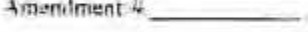 | 2. Filing is beini: made on behalf of (Select One):  Candidut or Public Official  Office Held or ought Savannah. Cho1ham County City Co\JncV Al-large Posl 1  1lnduclt' cnunty. munid{l'Jlity, di!-iHitt, (lll't ,, ]u11it.:l3l w:u)  Filer TD C2011003782  (Filer ID 1hu1hoxu,, wilh lho l<il"' "C"I  Organization or Per. on Other lhan Candid ale's Campaign Commilhie  Committ.::c Name: _c_he-'r)'i_N_e_wma_n _  Filer ID: |  |  |  | iJ c E;:irlicrof Pn t M,irkorHaml-Ddiv a'c<I Oaic    SEP2' 7 2023
3. Identifying and Contact Information
(1 )Carolyn Bell (2) 9/21/2023
Full Ncrnte uf Cw1tlidate ur Other Than Cam/it/ate Ct.1mpuig11 Cu111111ilree Name TMay'sDafe
- 210 E. Bolton Strut, Savar,nah GA 31401
Mailing AJ,lre ·s City Stace Zip Cvde
- (912) 663-7907 and/ or chbe1t21o@aot.com:
Primary t.u11tac:l P/,u11a Number E-Mail
- If o Cantli<latc or Public Official is tbcrc a campaign co1Ill1r!JCC lone or more tt·soas) to make campaign tra11sactions, keep finaacial fCl:ords oftllc campaign or file the reports? Yes o
- If yes, is 1he commiuee regislered with the Comm is ion? D Yes o
- If yes complete the t. ol.loJwuliamn Mgille:r 'Jacq1ueline -Tomlin
Name of Cnmmi1fe<' Chai111ersn11 Name n/Con,miflee Trl'asurer
4. Period for which you are Reporting
You Must Check Only One Box
My on-Election Year |  | My Election Year | Run-Offs  tRepon n:quired only if you ore: in o  RWJ-OffElectiun) | Special Election
- June 30, (year)  D December 31, (year)  1 l  Supplemental Reporting  0 June 30, (year)  D December 31, (year)  •Supplcmi:>11:\1 n:pon.s nfi.! required of c;indid.'\1  ,, ho U,lvc ti:mvc;,;C$$(ull_y " e,ncd torolUcc or h:J\'c: rc,igncd from office. Srt! 0.C 0.A. 2 l•.S. J4i |  | D Janunry 31.._(yeur) 6 days before Primary    Run-Off (ycnr)  D April 30, (year) 6 days before: General  □ June 30, (year) Run-Off (ye:ir  September J0 (ycar) 6 days before Special Primary  Run-Off (year)  t:] October 25: (year) 6 days before Special  D Dec. 31,, (ycar) Run-Off (year) |  | D 15 days before Special Primary. (year)  D 15 days before Special,  --- (year)  □ Dec. 3J, (year)
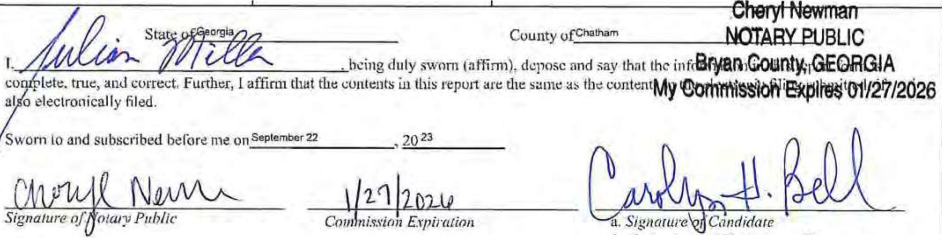
b. Orxu11izuti1111/Clwi1pcr,1·,,,1/TrlllJ.wrer

Public Ofticcr/Condidate/Othcr Thnn C'andidnte Cllmmitt<"I! Nilme

Homo Addntn Omipatlon Campany Q,ed</ Onh/ 0.lino O,ocU foul o.n...Foe Tot.ii mlnuJ"fH Owte Rl"'"wd Date DtPosU•d

l19 Albtrt.1R v./'1rrctt 1519 Chl:V'y Choii P,d., V.>nll:1111, GA ll4JS "En fO
4it Al & Fond:t lgu'-WO 70 Perett+M Cf(Ks.ng. .\:tv;,m1.\h, GA 3I4.ll reatl!d
,..,,..
Ctftd 2815 550.00 SS0.00 9/20/20l1 9/12/2023
Ci>rc.l 8393 Sl.000,00 51.000.00 l/ll/10Jl 8/ll/2023

IOG Amb•r Fwby G.11 £.a1t lB1h Street. S nlVh, GA ll Ol C>WnN'/Bt. vtar1in1 l AUrotll 8ehit'il10r SCr\iffl Onlllle. $10000 100.00 9/14/20ll 9/19/Wll
IS AnonynlOU\ Cnh $1.00 $1.00 8/9/Z0I.J 8/9/2023
11 iwley Willams l.66, S.t\li1Mlilh,GA31410 lu\lnMS n An1teyWilll1ms Online $:1.000.00 540.30 $959.70 8/5/l0ll 8/I0/202l
6.l Austtn S..IMn Jr 46 Lo,t C\'PJCU W•v, /lk1"'10<1d Hi G lll24 R,ttud Ch:cJ. 4298 $3,000.00 51,000.00 8/! l/l0'B 8/12/2023
33 6.l•bor.l&Oi.3rlnCorte.s.e 101E G.nton St, SO\IOMilh. GA 3t◄01 et'lfed rct\f'"ed Che< 1019 Sl1DJO.OO $1,000.00 J/II/J02l 8/11/2013
101 Batty & ren G.tle 700Wilminttofl lil:ind Rd !OJ, 5.lv.in,ul\, GA 31410 Retir,ed ptfi,.d Clircl 691) SUB OD SIIB.00 9/l/t0Z3 9/J.2{2023
9 kn 8..Wil!J Jt 115 8 Pfn! Mt-.adow. Pooli!r, GA JUn Presldf'n! AdtnUc WJi1e Ser Choclr lHS $1,SOO.OO si.soo.oo &/7{2023 &/7/2013 J7 Benny Jonb Jr &.Shae Jone, 1628 Walthour Rd, Savann11h, GA 31.410 £rl&inlftf1rl8 Choe• i,10 $1,000.00 St,000.00 1/9/2023 8/9/1023
,1 &e:m,ud & Em,m, Convtts. 4!14 lumlM Ave,s;w.aflnah,GA 31,:04 REflRt-D Cn.c.'C) 40SO SS00.00 $SOO.OO 8/11/2023 B/2'/1013
104 8-ernke lom.lfl 1.061\ Abettom St, Sav;ann.ah. CA3l4L9 Maft.etifl& lomm Cf\!atwe SeNkH Online 550,00 Sl.30 S41.10 9/l•/2021 9/19/2.07)
1:n. Brcncb Cok:tn3n•Hutf & " urf 111 ll l4Jldln, C•cto, s.v,....,h, GA 31405 T cl41cnu Cilo<k 416 $100.00 5100.00 9/20/2011 9/12/2013
113 Bte.rtcbM Jen ,ns J06UGr.,,,F"o Yl:tV1 S.,.,;1,m.,h,GAil-lOii RETIRED Ch•d IOl9 S2S,00 S2S.OO 9/10/1023 9/l2/20ll
31 Bt•n\ B,uemort 101 COuntl)' Club Or, S-wannah, Gil 11410 Co•tnellrlg Choe 2269 $1.000.00 $1.00000 5/11/20.l) 8/ll/2011
"'"'""
138 ISrl.an Fcmu 305" E Otatllon 5t..Sav1('flal1,G;.11t01 Retttl!.d Or,l!nt $1}0.00 SB0.00 '120/2023
711 a,l.ln Ptf'v,n 1318:arbam Rd, Stvannah, ll.t:ill l\efili Cho<k 1!14 $3,300.00 S3,300.00 ti/16hOll IJ/lG/2013 U Bud Ml•tl•dortf 6S Mynl• bf.and ltd, OJuffton1 SC19910 Miln;JglmMt M•nsi1dorft'i Inc O/\•lnt $3,300.00 S1.31.30 Sl,167.70 8/8/W23 8/10/lOll s1 au,,on L.,w Offtc.eJ lLC 2.244 E 1lhd$1,5.Jv.::iori.sh1 GA 3H04 At10fnt.'f' Che<l 1031 00.00 S500.00 1/11/102! 8/11/201!
67 Capital Oe. me,n P..\flnffl tn·c 6400 Po-Nttrt Ferry lld, St.c.-400. f.lbl"\U. GA 30139 Rti\l Elttte: OtVC!lopn1ent Capita) ee... lop(ncoot "'"' It° Chocl 1111 $3,300 00 S\300.00 Jl/11/10ll ,unou
! L ca,olyn 1, Chattes tie 2Mlksh Dr. rav.mnah. G:Al1410 Chtc:k Slill s10000 $100.00 l/lG/2023 l/l&/70U
95 CCC.Uppr:r EliUS1de, UC loper ChKt 1077 ssoo.oo $500.00 I/Z /WJ3 8/28/2D2J
ui Ch,le> & BarN, M Gotphin 7'S Southbrldco Blvd, S1innnah, GAJUQS lltttrtd Check 1007 SI00.00 $100.00 9/ZO/Z0U 9/ll/1023 JO Chi11lct Obrien Z Suw•tch Or, s,,.,n,h, lHll Rcrircd fwlir<d Online $15000 510,30 $239.70 8/B/1Jl23 8/IO/Z02l lJS Ch itn.::i 0. Thnm·JUC)r1 l.S02.Stnton 81vd, lipl 4106, S;,v;inrwt,. GA )1◄07 OOUUSUOR M!.OIAIION CliNTT'I' Chrd. 1012 $100,00 $100.00 9/20/10l l 9/'IJ,/2013
U) Oomcn,Jne, F. Wuh)Fl&lOR PO 8o• 4ftl>, Mldww'f, Ci4 31120 !ICTIA<O Chki 9974 $20000 $200.00 9/21/>0ll 9/1 )2023
49 Colond lham;a & l(:lren \IJltl!1rns 674 Wyndham Wa'i, Pooler. GA 3llll Coondirwomau City or Pooltr ChKk 1.511 SlOOOO $10000 8/11)2013 8/U/t01l
68 Commfnn To llKl Jess-P1trn 101 L , hne, S.11J.1nnih, GAiJ1.tJ1 Choe• 1333 s1s0.oo S1so.00 9/U{20H 8/ll/1013
3 Con!V JOno) 9 5'ndv Point Rood. SOY•M•h, GA 11,04 LSVR t.5VA Onttr,e, .13,300.00 SUl.10 Sl,167.70 8/2/201.J e/4/20U
6 0.,icCrillJr s Gitmb.lll Iii•"' l\d, s....,,n•t,, GA 31406 °"""ij"' Criulnc Onllnc $3,300.00 Sll2.30 Sl,167.70 8/5/2023 8/9/Z02J
II l °'9njt:I . Sr.\Olty '.5008ulf S\. Apt60t Snann:ah. G 31J01 Y.'oud CD"'r.tdor Ch«l 105 S15000 SIS0,00 9/18(2023 9/19/2023
•
CM\l,d & ttaltt G.lrfunhl .aoo MaN 80c..lev1td, Sle IA l. SWO:.ONh. GA 31406. M1r,1&Jn1 M ber- O.wld G•rfunl•I &.Co 11.C C e<l WlS $l,000.00 51,000.00 8/1/1023 !{l/2023 71i Oav.«:I T ,1,lsM s Mool\Cill un.. s,wanna . GA ,u1 l Reur!d .Cho< 408 $l,000.00 S1,ooo.00 8/16/l0L3 8/16/2013 12l Oelofls SC:reen•03t,ltli PO BalC 22111, i... Jt\fl:tht C...A 31403 Enltetkian Cho<.• 1,&s $50.00 S.S.0.00 9/20/l0!J 9/22/202.3
136 01annB&.AibtflJSton 101 l'lrttenh•m Cross1R1) Poolef1 GA lU22 Roftrtd Choe• 5116 S100.00 SI00.00 9/il/20?3 9/n/202]
67 OonWoL:rs 2.00 £S'.ltTit h.milln 51, S;Jv nn.,hj GA 31.&0l Rcrirt"O Che<I lS8l S3,:300()0 suoo.oo 8/2t/l02l 8/11/'2023
°'"""
109 Doo!t• M,10111 llAbtrt0m St. S nll.it\. GA 11401 11\e Ofdt P1<1 liCKl\e c «I 4lHO SJ.65000 Sl,65000 9/1S}102l 9/IS/2023
110 Oonr,1 MJQel llS Wen CMifU$ s1. S-AV.ll'lll,\l\..GA 31401 own,, G1r1b'likit'f 1nc Chrcl 264SO $::t.65000 St.650.oo 9/LSnoll 9/IS/2013
35 o,. E\letvn Diody 4750 Cuui.ber1ind Dr, 53t/annah, GA U4{1'j lh!&ed chkW 341 $200.00 $Ul0.00 1/11/lfill 1/11/20?3
12A Dr. Evefvn D.lodv 050 CumbM1nd Of, SiWiK'lnatt. GA dHDS Re(l,l!d Chocl Jij2 $100.00 SI00.00 9/20/10.."l /l2/Z013
3, Or. J Afphonio & Dr (\•tl n Do111d'1 •1s0 Cum""'1•nd or. s...-.nn,11, GA 3140'; Rf'tktd Chocl 1011 $10000 5200.00 e1111w21 11/11/2023
123 Or. i Alpho1uo & Qr £':clytt 0.1ndy 4750 Cu,n Ot. .ton ft, GA 3140S Rttirt'd Cho<J; 2081 SICl0,00 s,oo.oo 9/10/lOZl 9/22/2023
i:o o,. Rebecc.i Cooper !79 Btidy.vd Po.nt Rd rt. ft.e;)uh:w-t. S:C 29901 RETIRED C ,cl. 99)5 $10000 $200.00 11/11/1023 11/11(2023
70 Oul11nv h1duu,1n. Inc PO Bo•.546. 5awnrtah, GA 3140 d>om1<•I• 01.1L11 1ndw.1nlt.\. l"c Ch«, 7S1S $3)00.00 suoo.oo ll/ll{IJl1l 11/1 \/101l
97 £Jaine a rrow SOTJdf'\VJH. f W•v.!ia\liltlAlh, CiAA1'l1 Reo,-rd l\e.ttfed OnlrM. Slll0.00 $100.00 1/2'/lfl?) 9/1/2013 3:! lliM h BtaSWl-11 i,U 18 Sotttt,1'atl;wel1Avr. "ttlh. GA31411' rt .... Ch.cl: 2447 $3,300.00 Sl,l00.00 !/U/70?) 1/11/2023
Un Elslo Chhhoim 4Q.I E Brv•• s S....oM>h. GA l \401 Alto,ocy llolrlwn Falllr,,n< Ch«l •88 $SOD.OD SS00.00 9/20/2023 9/12/lllll
64 Emni;, Ptc:cr & Emily P, , \Y11!1.t11U 1614 Ele.,AQf' SI, SiM,nn.,t,, GA J li4'15 RQIJ[O Chtd 8307 °ilOOOO $100.00 8/IJ/1023 1/11/lllll
111 Eudor.t P Allen r. Ni'coJt Allf-n Ma:sle 4601Mt.1t1ow AWt. s v.1ru,at\ G 3J os RCTIACO Chee 00,6 $50.00 SS0.00 /10/202l 9/12/1023
61 ro,iv,h Man.skin P,openy owner LLC. 700 OfaVlOfl Sl, S,v;1r,n1r1, GA JlAOl 1101,1 ChK 140'76 S2,soooo Sl,WOOO atU/2023 a111n0n
24 rraocesc.. M1cthlavemi & lo n Liwn!Oce G rt.l! 2,ta ES5th51, sav.1nn1h1 GA 3JJ05 ()l lt ll49 Sl00.00 s100.00 M/'J/2023 ,1,12w
1 rrtdilSmllh o!tSOGeaMeyerAVl', Sav•nhlh1 GA3140l J.. tW.\• Akore P1oaertios llC CM<\ l/158 5J..000,00 Sl,000,00 8/7/2013 8/7/lOH
113 hcddic t• Stcvc:n1 Jr & Nr:ldt.a .SIC'tC.R1 106H Grny r.. V/o;, s..,.,,.,h, G 31406 RmP.ED c « 9179 S500.00 ssoo.co 9/10/2013 9/22/1025
'"
9? Gt'Ol"t'Wur,fW t 9 Pe,>thlft' W•v NE.AUiJtW.>, GA.90lOS 1,14"1,factmcr floe,rt Decor 6079 S2.IXl0.00 Sl,000.Dil 8/13/202l B/l4/20ll
S.O Gea,aeWood1 Ill 9 sandy pgrnI ILd. S.v,.rvi•h. Gl\.3\J0,1 Con1uh.1nt S.lcmJrS Ccruultfitg Checl 155] $3 00.00 SJ.300.00 ll/lJ{20ll 8/11(2013
l:.'!'j 94. Gleon E, w,un., Jr PO 8 SA..!Xt S'J\'•t1n.ah, GA l l4 U coo Uv.ar,nith C.0Ut1t o( ,'It& g Ch<dc 4ll $2,000.00 s1.000.00 8/B/20U 8/1C{2073
=

nz HenuenasGr PO Boc21S, f"ool,r, Gfl.3132! Rl:.OKf:D c • JS'j4
9B Henf'i Mnsi 21281V;l1hollr Rd, s... nn....GAJ.UJO Senior t,;ey A«o nu MilniC• DomlnkJ11fM()!Y Onllrtc
S50,00
ssoo.oo
S50.00 9/20/10!3 9/21/20Zl
S,00.00 9M1.fm 9/11/2021

..... 37 HUshe,P"bllcAtblri 2 ftiG>bcth c1r,,•. S•vonn,t,, GAJl<I06 lobb'(ls:\ Chc:c: l7!11 S500.00 SS00,00 B/ll/20ll 8/11/2013
.....
...,,,.,,.
0:, 54 HUr\Jt:tM1 ♦nGt!O'II PAC. lWC PO Be« 9848. Sa •nn:,h, GA 3UIL2 ChttJ,. 24Sl ssoooo ssoo00 8/U/101'i 8/U/10H
,..,
7S ira l!.cHn111& H11 t\ 81mcllo 10 llff ny Pl S no h. GA ll•06 iflctcmcy (l,oc> 1895 $3,300.00 53.300.DO 8/lG/2023 &/1&/lJJ7!
n Jl,yOCoollCqTrrE 411 SotJttibtt Bk.'ti, Uf!lt lOCi. Sl\'.trt h.GAll•OS HI\ Admk1lill11ar Cho<l 7S $2,500.00 si,soo.oo 8/16/20:!.l 8/16(2013
=

..I..
0 tacqvcllnf' Tomtln lll H1dtorv Gto'w'e ln, S;t nn.:tl\, GA 3l&C» ""lrw Chkk 5071 Sl,<Xl0,00 $1,000.00 M/11/20!3 ll/lJ./20ll
134 tic:quetyn o JenklnJ-Smhh s.... , Pl,Sn•nn"'1. GA 31J19 Check Z90S s100.00 $100.00 9/10/lOll 'JJ21./1!Jll
108 J:xttii, Cotdc W,lwn Ill 7370 Hodsson Mc-rnori.ll o,, Su,tc 10, 5.J"t.anri. . GA 31Bu dcr Bcuecn Homu Cli<:<l 1224 Sl,000,00 $1,000.00 9/15/lOlJ 9/lS/202l
23 llfnt.cC JoJtph Colli'" 111 A. O E M:t«:in St. Sltv-,,,,1'1.th, GA 3UOl ifl11nl! r- Ch,c, 1.lRSi S149 OD SlO,oo R/9/lOU R/9/IOU Gl binei UndJey it & Steph¥111! U1kll 17YJts\ aluffOt S.W•n.uh, G4 l140G a..o Byrd Coo\JI! Co Chocl: lil/; $3.)00,00 Sl.30000 8/11/1013 l/11/Wl3


tr fl

DocuSign Envelope ID: 79EA923B-B0BE-4724-8951-50051BA25996
PLEASE SEE ADDENDUM ATTACHED

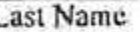
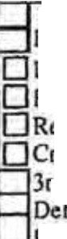

n( .((IJ!l lU I
State of Georgia
Campaign Contribution Disclosure Report

Itemized Expenditures
Musi list expenditures made lo a single recipient for which lhe aggrel!ate folal more than $100.00.

Page 7 oflO

List Name and Mailing Address of Recipient |  | Exp. Date Exp. Type* | Occupation & Employer | Expenditure Purpose | Amount  Paid
First N n•c | Dule |  | 0cCUflllliun
Lust Name

Address Addrcss2
City

Stale Zip
Firsl N.an1c

Address Address?
City
ExJ)Cnditore In-Kind
Loan Repayment efund eimburscmenl redit Card
rd Party
Deferred Payment
ymcnl on Deferred Expense
ovcstment
Date

ExJ>enditure In-Kind
Lonn Repayment Refund eimburscmcnl redil Card
rd Party
ferrcd Payment

Employer

Occupntion

Employer

1--------- 1Poymcnt on Deforrcd Expense

Slate Zip
Investment
Dale

Occup.i1ion

- ast Nome

Address
Expenditure
Orn-Kind

0 Loan Repayment
□
1--A....,.dd..,.r-es-s2,,..-----------------1 Reflll1d
0 Rcimbur.;cmcnt
0 Credit Card
1-,-C-ity t'=.3rdPllrty
Deferred Pa)·mcnt
1 1Paymcn1on Deferred Expense

Employer

Slate
Zip
Investment

Page Total$ _
- Expenditure Type (Expenditure, In-Kind, Lonn Repayment, Rtfund, Reimbursement, Credit Card, 3rd Pony, Deferred Payment on Deferred Expense. Investment)
l'ubl,c (.lf'lic: •r/Camlii.lale/0th,·r·11,an Candidotc Cummiucc Name

Public0llktr/C.111J11la1..-1011tcr lltun Ca11J1Ja1c ('n111n11llcc Nt1111c
--^{D}-^{etr}-^{ic}-^{C}-^{ar}-^{lto}-^{n} ^{Leg}-^{g}-^{ett}---------...- ;r.>H.i ..-IB⁷ IT^{of}l¹J⁰:r

CCORCO"OUIU1IONSIUPOlrrfORSO'l10»11
......
. ....

lankl.,.._Cbtc.kl mon.m "'°'71,lf(hNJd 5 t.,t..n•
'""1023 trH.adu.,C«ot&f.,IPAi:._lnc. 10!o•IMI
,'.."....".." ,'
.S.t.n.n-n,h
JU11(bbnkl lt.500.oct-
JUll(bla'l•I S .00

,,.,...,
ftobtf1H.Hf1'\MI 7 H•fJJI H,wn Lan• , ,
........
GA JUf1( '1 SSOO,oo

ThePolOttC:0,,0,tl.lCMI 12.7 Abl'fco..n lbte\ (blNI SrtanMh 0,\ ,1 (lllfn I $1,000.00 S/111:tOU c,rcor, HP 1t 1 17WtkDo.niN&hSUHJ '"""'I S.vanlllh GA 2140'1 {bwi I U.000,00
D•l'\llfo.nD,te IUmo Ad4fet>!Jaoi•l A,ddrtnLlnt2 Ci $h,- 111 Ou11eiron ToUI
f.ftio,r!psori Z11C1\.I.UriaDt ,.......1 l)ibe.41.tnd GA 2'221 111'1 1 $1.000,00
....
1hl..U -t.t• 1'6GrfY1,CrulCt>dn !b4onll S.V•l'lr\ah GA 2100 (bbnltl $t50.00 1 Jz,m frw ,,j POl• 10S01 !"""I .s:.;lan,uh 1Ml2 (W.wlij 11, .0Q S.Gfifn POle,t101aJ 1=•1 S...1rvuh GA JUU(OIMI\:) Jl,500.00
""
..

7,'J,112.W DHCI\Ful<o,, POlu.lUS 11:W\t
Hll"ICClNGlou;i HC.W.m,JCAIP\Kt $111cC

11f'lllnl
.H..a.,l.e.t.1.1,.
_
....
....
........
G,\ !IHK n,aoo.tJQ
AO!l«t,f.J.ame., 47'11',ttuOrtw i""''I S-tvtrut,ah
..
--* t7tfobtlaf, ot 1-1 Say.1M,lfl "" , •.u,f
»otl (b!Ml\j .b,300,00

:11•0,1 1.M1ij

.,.,,.,,
- d<W..-t 1J29WIWlll\rttnl$'-"•M, 1...... s.w.,.,...,,
juryC.W 2101Wh.IUey.\ft • S\il\t&-1
SlfOflenft..H..tl 17 ta now P♦IMOt, ttll.. 'J
lho 1E.!hoole 12.Ea(te,,GlnlDr ("""" ,..,.,.,n,ah
,,.,ofbt.aet) 11.S®.-OO
('lank) (111.11161 11,,00.00
..
.f,'I,S.0..0.0.
.. ,lU,.N(b!Ml) 1.1,.5.00...00..
SSOD.00

eu-;idlnr,le(W ComnlUniUn ,AC '"'" J
"'"'"
..'"....'"..."..'....
''""") l""''I 1,u,,.1

k.Cl.11kOrmci :JO, lu1Ch1\ 11Sl1NI (btMIIIJ
Wt\00.Ulli!Stqi.K, 17W,tlciffOllw. ("""'-I
.>.H..0.1.(t,LIM.I .S.* 0.0..

k,,nlft.1C,-Sli1wd htWhluhfSllH.t (bl.w,'J Sav•nn11ti GI> J1-to11b
.Sl,500,00
....
flft!U.:,.sl.2W01k-.PC 1tot AlllC.OlttSllUI -•I Sl¥1IWIM! G.\ Jt.Ot iS!l.ll'IJ
&MbM•L 1HW.Cb1rtle111t. 1"""'1 s.n.11Mh •• ,,.o-i (1:,11_., $250.00
1/10/202.l Ndtl .LU: 1tt E.YktofY Otl"N ,1,1.w,11 St'f,iN\,l!t a, '1&05( ...
li1rttinl.NOtlk&1.W: 22.&,lf.U,,,d ,•d (b'ri) St-n.nnllil
..........

O.Wt\!NsF.HliU' mn U11t:tMll'II\GnDt , , ..
DNd Rr,natW, SIMm ,01oaz..m:
.....,..._.....

3HCM(M11M.) 1250.00
21i&oJ (W.r'-1 1500.00
illl*(b\tn.lJ SSOO,DO
·..
..
.......

£tlc.l¥1T'ffl1i.r 1LUJ4lt
--
1l,b,l...r..i,J
c;c,0411,,0obo U.C t.llHlthSllHI Sulla.21
,.,...
f: tndso!V.nhwi.111111 l'OlodUl {'blMlkJ SfVatcl'llfl GI> ,u,2.tiNMJ .S:.50100
,_,,
{bunkt
&U!M.s t1tt.t1kl
.....
14Ytr,Mf'I
..
......
.JJl<lltM.lnkl
,
..
,....
>CofdeWA.loolll 1:J1oHO'df\onH•fflAfUlDt..,_ SUit D-lO s..nnn,h
tl,000,00
i,aos lb\J $150,00
,
Cl>IM\I
!tillnlt) .sno,oo

JOCWr.arlcAn 1b!aotl 5.wlnMh Cl,\ "'°' (Man•1 S,,S00,00
.. .......
t10rol:ltN!lewtl POISH'10t06 !blJflkl lfOl::IWll1 HA OJ1A7 (ol,/,tl "'"'°·"'

.. ........ ..
ffMh.infti5;fldn lE.t!lhSUH\ 111'¥tiJ S:HlnNlt
J\,01 (blankj tl,001.00
.....

P-.trktO.$.Mf 10H.l1U.$I
l\ol1fkrASavlM11hlnc ,Olel1''7M
,(b.lN..ti,j 5.MlhNb
..
-
S:MwrtMtCIUM1n _.,,,TaltMIISUtd (WW.I .......... "" :)l401f
Sd'teft1 1CVrMN,6c.ll,P.C- I tutUktt'tSUut (bl..,I S.W.niu.h-
Subtln&Ptocmtll!•llC u, ll.wn Thuo1.1.1tA,d low«i ,.u1Mah
""
lUO:Z.(buf\l) $2$0,00
Jlll-l(bLain\1 ,,so.oo
,ttyQfl!Qlt UQl..,.,tOriore (bl.o,tJ ...... MA 02111 t•""'I Sl.S00.00
,3,1&_01 (b(Mlij
.,_

SOl1Qt"Mwi.t1l1:1 ,0ScAA11Ro-c.tw1ijA... ftlHI '"""" ........
."." J1'llltrl J 11.IOO.OO

wmnClltltl\,.ofl'l:ltln,llc 11ltt.w.HDftwt '°""'I Thlaldt1kI1I
........
1117/lUJ C..ut AA.nocbtn U.C .SM¥ Dbcowit COmti'ti DOIH .!11,,1 S. 1r,n.a.h
....

lU1Cl{illlM,) n.000.0>
:11•0:StltU I U.OOIJJO

Hudson C- tk Cllpli" U.C 1tA01AptdltA'ff l"""I
.....

JUl!lt,llillll)
...

Hu&hd ,ut,dc IJf,/1:1 2 .a.balilCl!tlt l._"..".".,'l ......... CA ''.".". .......
,,

1m10u S,Monstt:I .&lf11;1hlfYll-.rtfOt. I°""'! Swa!V\Ah
,
..
lwaMah CA l1401(bl4M)
..
Sr,oo.oo
.......

>ohftk.Col 1NCo,,mtodoreDl'Nf
...,,i,,, ltf llk:11\1 PDhit:1HCM {bllo'I !ifflooih
Mllti;Y.SmihA lMI ,010-,11:.1
Srt.t!WIMI
21410 ICl!dl t1!10,00
lUll(Clt I $!,00.00

.....RN<IU.C U01 't'ln•\.tnlll lluCI fUO tett.111,J Or\MdO fl 2D11 (011IQ1 11,000.00
31411 tr111t1 sa,o.oo
hM:£1inC1Mc-k r.w _...,SCll.00
w • POl••1'71 !!!!!!!!I Slof6MIIII

EXHIBIT H-2

CfC-CCOR 01/lO

Campaign Contribution Disclosure Report
Georgia Government Transparency and Campaign Finance Commission
200 Piedmont Avenue S.E. I Suite 1416 West Tower I Atlanta GA 30334 I 404-463-1980 I www.ethics.ga.l!.ov

- Report Type
- Filing is being made on behalf of (Select One):
Use l.iarlicrMl'ost

(S<1,r1 Ooc)

[!] Original
D Amendn,ent
Candidnte or Public Official Mark MI land-Ddiv recl-
Office Uelcl or Soughl City of Savannah· Dislrlcl 4 Alderman
(Include cnu1Hy, mu11ic1µ.,li1v1 disrnct, l'IC1J;I orJudlci:ll .(Ur)
Filer ID C2019000507
(Filar ID th1t b"!!ins with the lcitcr"C") APR2 4 2023
Organization or Person Other than Candidate's Cam1)aign Commitfrc
Committee Name:
I-

Filer ID:
(Filer10 thnt b"!!ins wilh the!<Iler .. NC")
- Identifying and Contact Information

( I) Nick Palumbo
Full Name of Candida,e or Other Than Candidate. Campaign Commillet! Name
(2) 2/24/2023
Today's Date

(3 216 E-51st Street
Mailing Address

City

Savannah

Stare
GA
Zip Code

(4) 912-220-8439
Pri111mJ1 011tt1cf !'!tone Number
and/ or nickforsavannah@gmail.com

£-Mail

- If a Candidate or Public Official is there a campaign comir ee (one or more wsons) to make campaign transactions, keep financial records of' the campaign or file the reports? Yes • No
- If yes, is the committee registered with the Commission? D Yes □ No
- 1r yes. complete the following:-----------------li-----------------
Name of Committee Clwirper:mn Name ofCommilfee Treasurer
- Period for which you are Reporting

My Non-Election Year
You Must Check Only One Box
My Election Year Run-Offs
(Report required only if you arc in a
Run-Off Elec!ion)

Special Election

- June 30, (year)
- December 31, (year)
D January 31, (year)
[!] April 30 2023 (year)
D June 30, (year)
t i□
6 days before- Primary Run-Off (year)
6 days before General
Run-Off (year)
D 15 days before Special Primary, (year)
D 15 days before Special,

Supplemental Reporting

September 30, (year)
6 days before Special Primary
---
(year)

D June 30, (year)
D December 31, (year)
•supple.mental rc1>0ns arc rcquirl!dor,andidalcs who hll\'Cunsuccessfully ca,npa.igocd f0< office Of
hiWO rcsi ncd from office. St!i: 0.C.G.A § 21-S­
J4i

D October 25, (year)
- Dec. 3 I , (year)
Run-Off (year) 6 days before Special Run-Off (year)
- Dec. 31, (year)


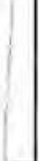

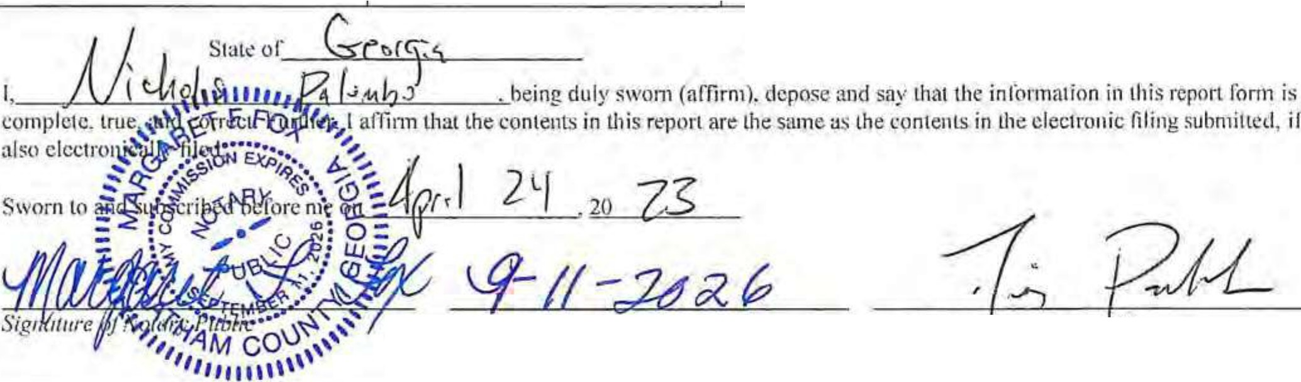
County 01· e-"- -"'-ll r-\.c._

Commission Expira1io11 a. Sig1w111 't> <J/Ca11di ale
b. Orga11i::otio11/Cl111lJX'Hl·Bl'lf'H.C3

Public Officer/Canditlatc/Ollu.:r Thun Candiume Com111illN Name Pag,:_1 of

- .
State of Georgia
Campaign Contribution Disclosure Report Itemized Contributions
Must Iist contributions received by a single contributor for which the aggregate total more than $100.00.
Note: Loans are no longer repotted in 'ltemized Contributions" section. See Loan Reporting section below.

Full Name of Contributor Mailing Address
(Affiliation of Committee if any)

Received Date
Contributor

Occupation &
Election Cycle**
Cash Amount
In-Kind Contributions Estimated Value

First Name or Business Name
Hunter Maclean
Last Name Georgia PAC Address
PO BOX 9848
Address2

City Savannah
I
Stale Zip
GA 31412
Aff. Comm.

First Name or Business Name
Seabring Properties, LLC
Contribution Type* Date
4-6-23

l!J Monetary
U In-Kind
n Common Source
D Credit Received on Loan

Date
4-5-23
Employer Occupation
Political Action Committee

Employer
HunterMaclean GeorgiaPAC

Occupation
Property
□

D Primary [!l General D Special
D Special Primary
D Run-Off Primary
D Run-Off General
-, t<un-urr ;:)pcc1a1
D Run-Off Special Primary

C;ul1Am1.

500

Cash Ami.

250
Description Est Value

Description

Esl Value

Lasl Name

Address
209 Brown Thrush Road
Manager 0 Primary [!l General Special
D Special Primary D Run-Off Primary D Run-Off General
-, 1<un-uir ;:)pee1ar

Address2

City
Savannah
Stale Zip
GA I31419
Aff. Comm.
[!l Monetary
0 In-Kind
D Common Source
D Credit Received on Loan
Employer
Seabring Properties, LLC
D Run-Off Special Primary
Description

First Name or Business Name
John
Last Name Coleman Address
104 Commodore Drive
Address2
Date
4-3-23

[!l Monetary
Occupation
Contractor

Employer
Bonitz of

0 Primary [!l General D Special
D Special Primary D Run-Off Primary D Run-Off General D Run-Off Special D Run-Off Special
Primary
C;uh Ami,

500
Est Value

DcseripLion

City 0 In-Kind
Georgia

Savannah Stale
GA
Aff_Comm.

Zip
31410
I
D Common Source
D Credit Received on Loan

Itemized Contributions Page Total $ 1250 EXH ITH-3
Public Olricer/Can<lidatc/0lher Thun Cand1duk Commillet Name P.1J?..:_2s or

- 05c., u1 .a.v

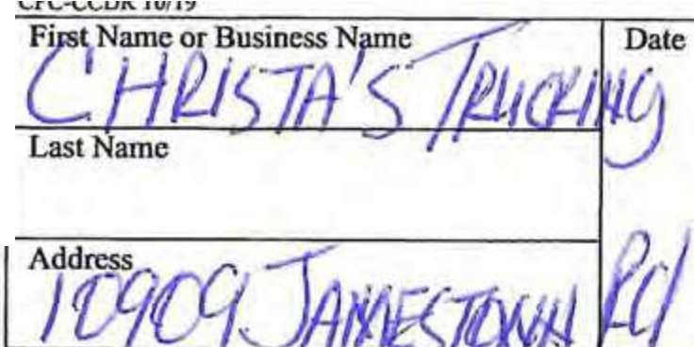
Occupation
q /Cif-23 #I)

f.ll, □Special
0 Special Primary
0 Run-Off Primacy
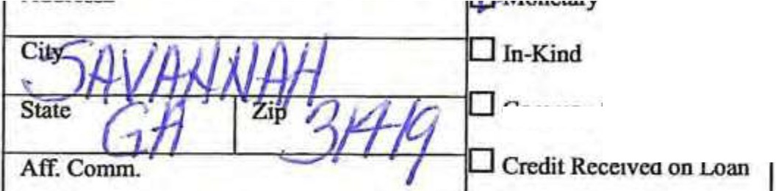
0 Run-Off General f-:'-:--:'-"'=-'==--+_,,._Lt....8-JJ'-J!o_.,_,, ,L..f.A"7'":7"'=---------lf-=E,--m-p-=-to_y_cr--------f Run-OffSpccial

Common Source
□
0 Run-Off Special Primary

Date Occupation
□Primary
era! special
□
0 Special Primary
0 Run-Off Primary D Run-Off General
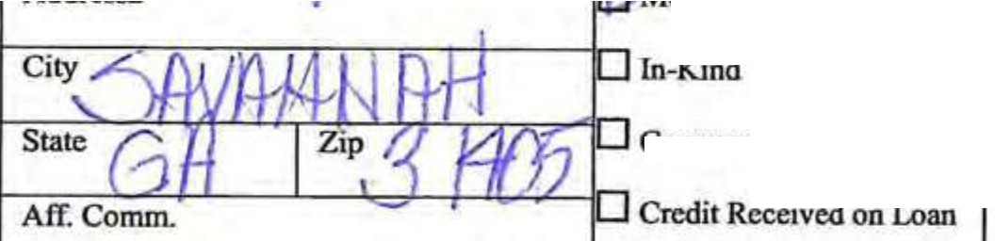
f-:7.--'--::---=-----t-==...:...!....:..:......cc..-::;........,;::1;;::; o"'n:::.c_tary +E=-m-p-=-10_y_er lO Run-Off Special

Common Source
0 Run-Off Special Primary

Date Occupation
r.} maiy
h1/ftl./F0 8!2:Primary
7., DRun-OffPrimary
0 Run-Off General
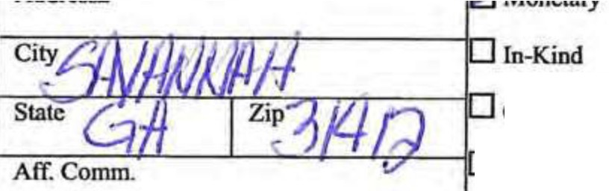
1-f:--:-:::....;,'7-'--'---" ::; .::.:.. ,_r l-E=-m-p:-lo-y-er lORun-OffSpecial
0 Run-Off Special Primary

Common Source
0 Credit Received on Lonn

CashAml

()
Description

0
Esl Value
6
Description
0
Esl Value
D
Description


Date
Occupation C:isbAmt. EsL Value
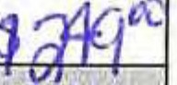 D

DP. ary
ral special
□
0 Special Primary
D Run-Off Primary
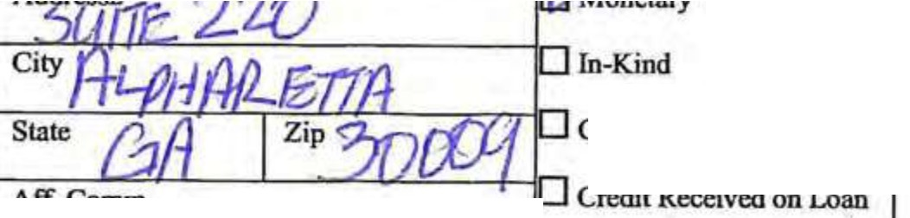
0 Run-Off General l-:--:-:'==-- "--...!..": r:.i...::.t...:.--=::cp--c=---1,;::;-::;,, -------t-:Em:--p-:-Jo_y_c_r ----, Run-Off Special
Common Source
Aff.Comm.
□
DRun-Off Special Primary

Descciption

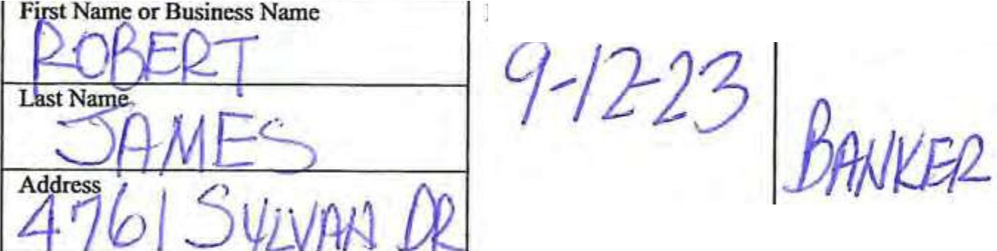
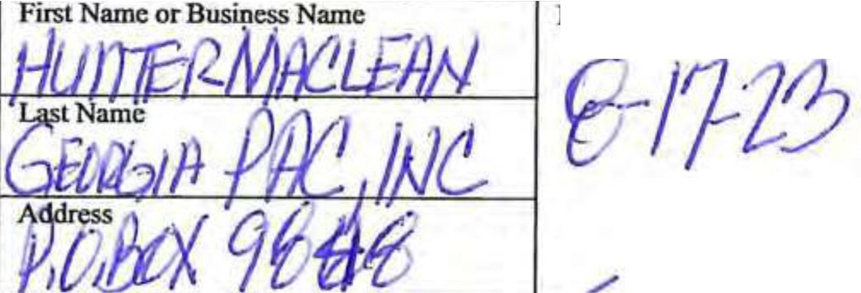
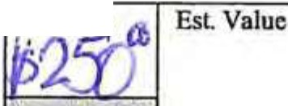
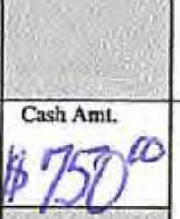
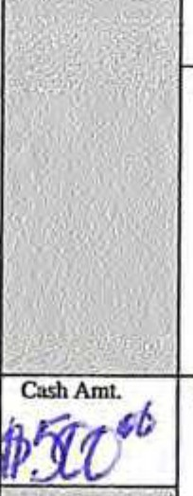
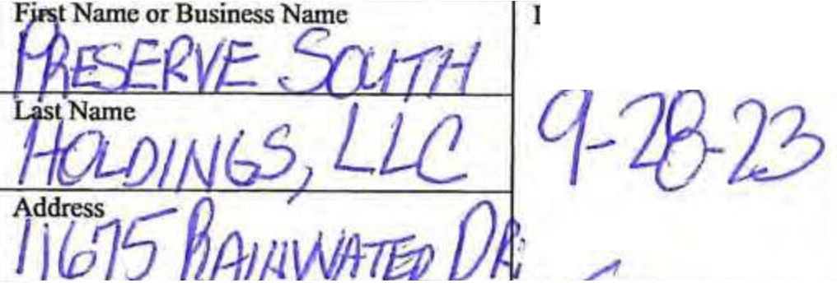
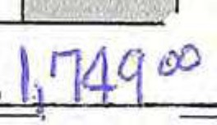

Itemized Contributions Page Total $ 0
- Contribution Type (Monetary, In-Kind, Common Source, Credit Received on Loan)
•• Election Cycle (Primary, General, Special, Special Primary, Run-Off Primary, Run-Off General, Run-Off Special, Run-OffSpecial Primary)
••• 1f any such person(s) shall have a fiduciary relationship to the lending institution or party making lhe advance or extension of credilEXHIBJT H-
4


PmS- of

- 11--.rlH/IY
j
Public Officer/Candidate/Other Than Candidate Committee Name
r1

I '

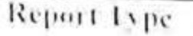
( :1mp:11 11 ( ·, 11111 ihutil111 I )1,L'ill--,111\· I L'I'' 11l
(;l'orgia Cmt-rnmt•nt Tra11span·11c and c·a111p:1ig11Fi11a11n· Co111111i

-'1111'1,dn,•11: \1,·1111,·\I "uli.--11(,\\,,11.,,,,.. \•l.111'.1.C,\ i1 U .J,1: :,,. 11'11

- I·tlt1t!.: 1, h, 111!.: 111.1111' 1111 h1·hall nl t'rl,·, I t )111

·ion
_I

CJ
/ ' ••, 1• j
0
c .,nd,d.11, "' l'1t11lo,· t 1111,1.tl

I ' '·,I s:.. ... 11,,_,, A1d<r'(..d.---n'"' I
I
RECEIVED 1
clcRK OF cnu CIL OFFICE
I I

JUL O 3 2023

' I I l

I'
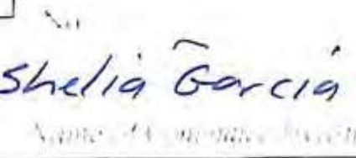
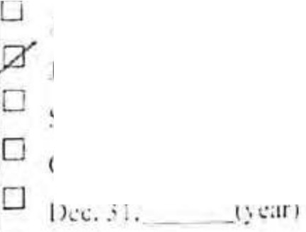
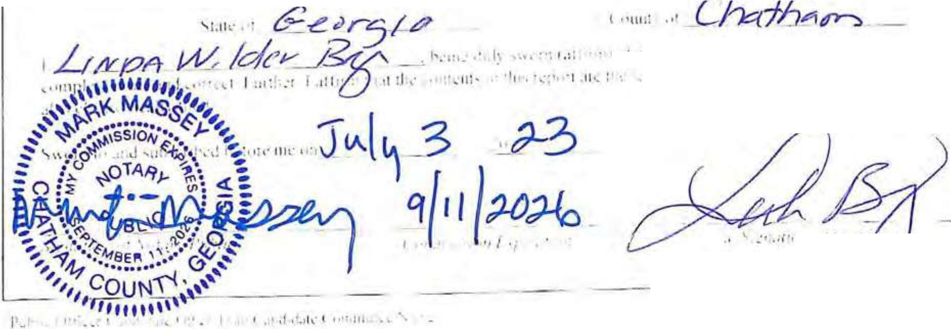

r. :--:-:-:-:------!_ • _· _._,_· _'
;_ ld.:111il\ ill!.::111d ( ,,111.1<·1 l11l11rt11:t1i1111
I ' L ,-11 J"' iv·.I Ju - B l'v -/\

• ' •,, '

/-1-!,. I

---,,
I I

I... .
-
I; fl
I' I _j ){ /5 E ¼" I' \..- /"-1'1"-M C // :,/ tfov[
,, I {,

' ' ^{I} '
, I ,, ·,,

,' ,.. I

'.,
I' ., ' ' I
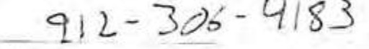
' .I • •5uS /3.L7-JIGs Y-{/1 /)',) J t?,.,,,..
/

11 .. I \, \.t :\ • ... I'.i.. ..., l : ,• ., •,... •·. :.: •. • 1 • , ,., p' r;·\' • ,. '''-'Id 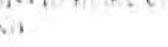 I ,, ! ._ • I

I• .I
• l\:, 1 : .• " , .. f'" : 1• I . ti ...•: ..;,, ', '



\ "I• ,.•j,._ 0 "- ti I I
Joltn£.. Bj.J"l::H}.J

\ ,I' I/ • I

-L Pl1rioci for\\ hid1 you arc Reporting

- h nn-Elel'lion Year
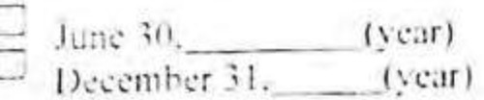

\ h [b:tion '\ l':tr

I.. • ...1. ,J. I: l',lf I
\pr I ;o 1:-l·:1 1
1t.11c "- "l.,o1-.J. ryc.:rJ
Run-Offs
lh·r •fl r•: lltll,,.°J'Ii,'• 1·: ··· ,,!\.' 1:: .,
l\1..0-U:1 I k.••11; I
,,J.? s hdi11,· I', 111.,ry
IU11-( l?'I I'• l'.!f
fJ h ,i,I\ bd .. rc .( ,1:11.:1al
p
I{1111-hn ( w.1r)
f, d.:. h.:!1111: S1 1-.:1.d l'rinur
pcrial Elrc1io11

::J : 5 J.1 , b('ti,rl· "!'..:·1. I
I l'nm:1r:,. (_l':lf I
O I: ,l.1 , b;:!,,r,· '-p..:,·,al.
j ( l'.lr)

. '11ppll'llll'1tl:1I RC'por1i11
S..:p1,·1ni··:r11._ ( l·:111 □ Ru11-11:r ,-.i.)
le lkr ; I.

0 J 'Ill' ,1(1. () t.':.r)
D I l.:1.'l'll1C'll'f JI. -- ()

l';trl
< 1,:1,,J,,:r 25. t:-..:.1r1
I r, tl.1 , hdi)r..: pl·,::tl
llu11-I )J f I y,:.ir \

•• -.·• J•,:"".-. ,f\"'• t,J,,t .. ¹,·.
"' ..... - _ ••, ..... I • \,.i.-;- ,·. 11. , \.,.
...
t ,. • :Jtr.,..·• ,r \.r • I 1 \ : • •
J

•, di..,· . ,Iii.I ,1\ ti .1' 11n• 1:',, Ill.Iii 111 •: .. 1'.,• 1' 1,1;1· ,
1111\.. rlw •. • ...111 'rlH .. h.'\,.l'\'l',t,11•11:-' •·.·11111: ti

.. , ,•:,,,,. --
[, iJ1,, ' •'I •111,,

ll,tlc
I",r,1 \!.t11h.' l1r l\11,111c,, N:\111\,.·
J'l:ct<e\J
I ,1,1 \1,1111,: /
.,11,1...1..1..C:c)

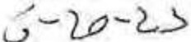

'h"·u1,t111111

/Lf1T·

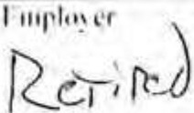

01•11111,11,
0f.c11cr.il
Q,p,•,1,11
O-.pn1.tl1'111tt.ll) D 1(11111111 l'lltll,IJ') 0 1(1111,I Ill C ,,•11.:r,11
-□
R1111,CIii ',p.:, tJI
0 l<111H )If 're,,.,I
Pr1111.11:
I I ''"' 11., \,,111,

1._su I

I
--- --
''"''""'''"'::
I I I
I
I

l"ir-1 's,1m.: or l\u,in.:" NJm.:
ti(/ .Ji[(5' )1...J ,._,.,

1),11,·

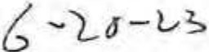
\ kcup,1111111

0 Prtnhlr\
,l1 \',1-111,:
- ---
I
I

I :i t N:uni:
GA- -pA-CL C.'
,\JJrc ,
l D b.1i I y '3

U ln-KinJ
c:k,.:11.:,,;,
·0 ..,.,,1,,I
D Sp,·,1.,tl.,1111;11:
D lt1111-( Ill 11rtllt:I"
0 Run-( IIT(i,:11,•1,;l
□
-,,...,,-11-pl,-n-)1.:-·r ltun,()11"11.:,:1al
-
D llun-!l11' 'i p.:n.1I
l'nm,10

-- -

llJIC
I ,1 \'alt•c

,
p,•ncl.lr:
. ·,1....S:- -LJ □ln-KrnJ
1
□
g!'.J:llllJI"\
!Al,.:ncr.11
D Special
D Spccwl Prnn.tf")
0 R1111-0ff l'nm.ll"\
D Run-UffGrn r;I
0 Run-OffSp ciJI
D Run-<lff':ipcci.11
l'rimJt:

IJ,:,crtpltllll

s,-.••6
A /7'f''J/lf "/
l"111"'''""''"'''
1

r\11 (',,mm D< rctl11 J(,:,:,:11.:d ,111 LoJ11

firsl Name or 13usinc,s Name

3cff
(k.:ura1i11n
l:-1 \'nluc

Cit)SA' I/
0 ln-K,nd

1-S-,a-',c=:: ;
6
Aff. Comm.
,,f---.-:-/l,..,.ip-'3_/_l{_ 1□l'ommon Sourc.:
LJ Credi, lkcd1cd on I oan

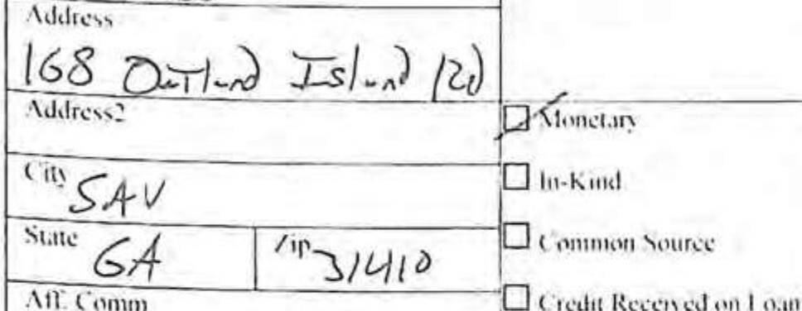
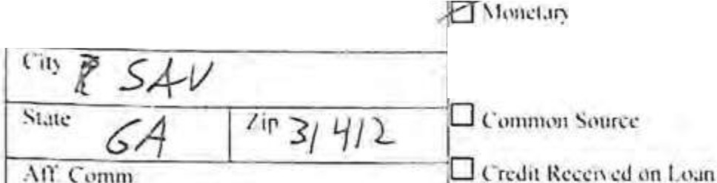
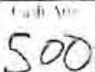
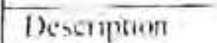
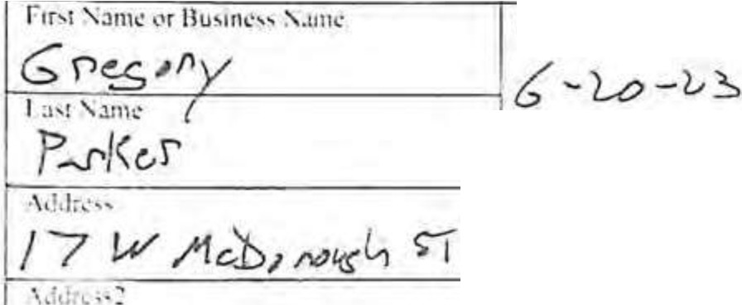
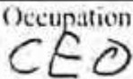
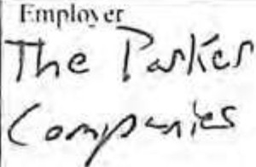
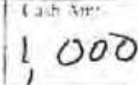
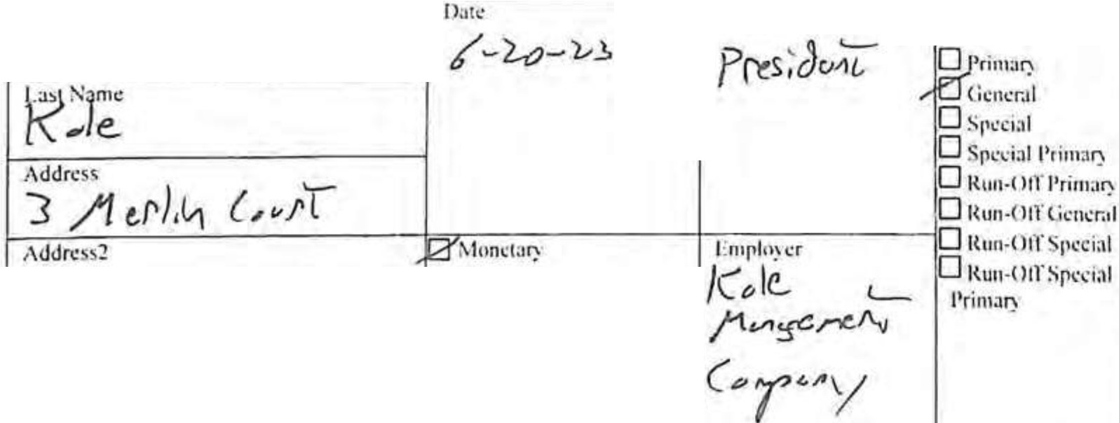
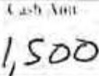
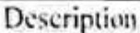
Itemized Contributions Page Total S ); ""2..S Z) s
- Comnbu11on r)p (f\1one1Jry. ln•K1nd, Commun Source. (rc:J11 R cca,ct.1 on I uan)
•• Election C)'clc (Prinrn1:. Gener.ii, !:irecial, Speci I Primal'). Run-Off l'rinwry, l{un-Off ( icn<ml. R1111-0tl'Srcc1al, Run-Off Spcd;1l l'ri111af'))
•• • If any uch per on(s) hall h ca riducia') r.:b1ionship to the lending 111,tituli\1111•r party mal.ing the ;uh a11cc ('r c\lcn ion ,1rcrcdil


CFC-CCDR 10/19

State of Georgia
Campaign Contribution Disclosure Report

Itemized Contributions

Must list contributions received by a single contributor for which the aggregate total more than $100.00. Note: Loans are no longer reported in "Itemized Contributions" section. See Loan Reporting section below.

Full Name of Contributor Mailing Address (Affiliation of Committee if

Received Date
Contributor
Occupation &
Election Cycle*'
Cash Amount
In-Kind Contributions Estimated Value

any)
First Name I Business Name Donna M

Last Name Jepson
Address
143 Puttenham Xing Address2
City Pooler
Contribution Type" Date
04/11/2023

(2]Monetary Olnklnd Ocommon Source
credlt Received on
Employer
Occupation Other

Employer Jepson Holdings

QPrimary
:zjGeneral
=ispecial
0 Special Primary
0 Runoff Primary
0 Runoff General
0 Runoff Special
□
Runoff Special Primary
QRecall

Cash Amt.
$2,500.00
Description Est. Value
$0.00

Description

Stale
Zip
O Loan
□Refund
□

GA 31122
Aff. Comm.

'
First Name / Business Name JelTrey F.

Last Name Jepson
Address
143 Puttenbam Xing Address2
City

Otnterest Date
04/11/2023

[2]Monetary O1nkind

Occupation Other

Employer

Assooated with a regulated entity

QPrimary (2]General QSpecial Qspecial Primary
0 Runoff Primary
0 Runoff General
0 Runoff Special
□
Runoff Speclal Primary

Cash Amt.
$2,500.00

I

Est. Value

Description

$0.00

Pooler

State

Zip
I
Ocommon Source
O Credit Received on Loan
QRefund
NoI1h Point Real Estate, QRecall
Inc.

GA 31322
Aff. Comm.

First Name / Business Name JK Homes,Inc.

Last Name

Address
22 Commerce Pl Address2
City Savannah
Qlnterest Date
04/11/2023

(2]Monetary Qlnkind
0 Common Source
O Credit Received on

Occupation

Employer
□Associated with a regulated entity

QPrimary (2]General
QSpecial
DSpecial Primary
0 Runoff Primary
0 Runoff General
0 Runoff Special
0 Runoff Special Primary
QRecall

Cash Amt.
$2,000.00

Est. Value

Description

$0.00

State
GA
Aff. Comm.
Zip
I 31406
Loan Refund
Qlnterest
□

□Associated with a regulated entity
Itemized Contributions Page Total "7,000.00 $0.00

Public 0ffioer/Candidate/Other Than Candidate Committee Name Friends of Van Johnson EX'HIBllll,. J>f §_

DocuSign Envelope ID:79EA923B-B0BE-4724-8951-50051BA25996

r►('-C('l)R 10.19 PLEASE SEE ADDENDUM ATTACHED
State of Georgia
Campaign Contribution Disclosure Report Itemized Contributions
Must list contributions received by a single contributor for which the aggregate total more than $I 00.00.

Page4 of 10

Note: Loans are no longer reported in "Itemized Contributions" section. See Loan Reporting section below.

Full Name of Contributor Mailing Address
(Affiliation of Committee if any}

Received Date
Contributor

Occupation &
Election Cycle**
Cash Amounl
In-Kind ContriblI\ions Estimated Value

Firsl Name or Business Nllllle

Last Name

Address
Contribution Type*
Employer
Occup1uion

□Primary
□General
Special
Special Primlll)'
0 Run-Off Primary
0 Run-Off General

Co.sbAmt
Description
Est. Value

t-:-'7":"--=-------------t::::;-:-:---------1---:::----,; t-'Kun-un ::,pecm.1

Address2 Monc!Bry
Employer O Rua-Off Special
Primary
Description

1-::-------r-c::: J..J Common Sourcie
St.ate Zip
1-------...L r-Crcdit Received on Loan
Alf. Comm.

First N1llllc or Business Name

LnslNnmc

Address
Date
Occupation

□Primary
0Gcncral
0 Special
D Special Primary
0 Run-Off Primary 0.Run-OffGcncral
Est Value

1--: ---=------------+.:=--:--:----------11-=:---: 1--'Kun-vn ::,pec1a1

Addrcss2 Monclllry
1 1L1In-Kind
City
Employer □Run-Off Special
Primruy
Description

Sl:itc Zip

Aff. Comm.

fir.;i Name or Business Name

LostNamc

Address

Credit Received on Loan

Dale

Occupation

□Primary
0 General
0 Special
0 Special Primnry
0 Run-Off Primnry
D Run-Orf General
Run-Off Spcciol

Est. Volu

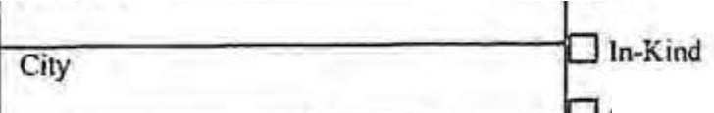

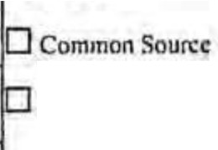
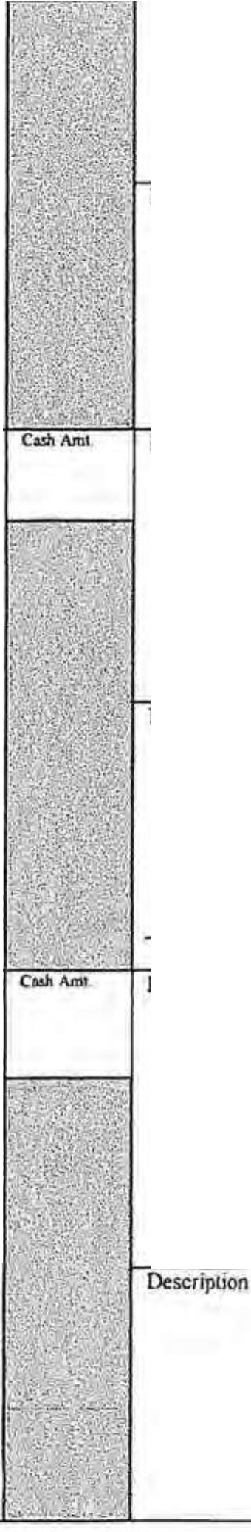
I-A-:dc:-dr-es_s2.,,...-----------=::-:-M".'"o_n_cta-ry-------l Em-pl:-o-yc-r lf7 Run-Off Special
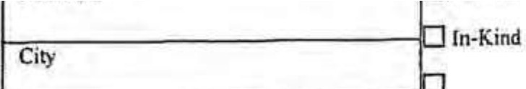
Prima.ry

1------- -------1 -Common Source
State Zip
Credit Received on Loan
Alf.Comm.

Itemized Contributions Page Total $ .$

7/11120U ......""" 41 DBMll.aft wn•• ._...,
,t,ntdot(1nYntl 7110/20:tj tMlfH ,oa..,l'lOz. 1>,1""1 ........,, .. 2HUCcl!Ul,ilof\t S,,00

liwn\\'llf!Ol'I ff< JO$SO 1etltt4 ,1.000,vo

EddY 2' H1lln¥0f111 S\INI
H•ftln•bl.ltt .V..N 2540,iriltd SfC0,00

.. ........ .... .....
..
7'1V201l 1tnrty1,:ison 1.u,11nent,wn)0111 """"'1 rooL£1'
711112.tz:I ""1,.,_Yw.'JJMnS 1" DaU.ind hi.and HI s..,.,.....
:nm CewlMIQMIO Jl,500.00
11'10 h.sDIWC>wfttl 1750.00

711t/2:0ll ................ ,.o..hr545
111s'Land0ftte
-
...
,'."."..''.I,
...
1121m, Qriono.,h..,.,. l? •nylJ11tffDftt,II -.i , -Sav• !I

s-.,ftMh
....

'500.00
J1'fl ttsl.d-1 Sl,000.00
Sw•MM G,\ 3144.JH't'IIC1•1'1 .,..,

Sl,500,oa
7/HmZJ Jo"11hS\\lblnli ,.N&ll02I
7/Ul>OU AnwdeoCOftllnl 17D1 Kawiam• RdN.W
--
c.,.,,.... tS1nl,r"'"1ANd
Dndr.tdfion UDW•lutowrM
,.....
"'""..",,,.. .W..H..M.".ll.On DC

,1,000, fC4.NU MIPrlf\d!tll n,ooo.oa
H.-lc llWHtttl.. U.-SIIHI 1.-J ........ .... 11.q.1 rdJrri smoo

»""'6'•n-,'41lftDf i-'l
JlCN(ctu,aJ mooo
11410IUJ.aA(ttll 11,SOO.OO
.,,,..,,
.
....

1Yct-dlUDflw - .S..VMMPJ .G.,\ ..... .......
.,,
.......... ....
n•M
..
.......

1'•1rickw.lwr nuf,11114'" lo,,, .S.v.tMah G,\ JICIM ll,u&Enalelm;ei $1,HO.OD
-·
..
J112AFwn4tlaindCh.lkm.tn .......
UHSSurtc• 11,S,O.OO
11"'°2:J W.edt.HttN!f -IJ
IN>oJ:1 Mictut [doy lS..,,..d,hw.r\ttSU"1
,(."..'".'I f'IINrrtbWr1 WY 15'0tlrtlr'N $100.00
lhllJOU 9/1.9/Zn:J
,H.,D_a,M,-l
4iatlJKtHal.vl.n1d
Cf'lmtftdHJU.OA.l1JlA

.1mmu AoD«tPetritnr.wl 11:J0[11tKc!!1$l/Hl -1 S.,enM
1,,o,aHCA nso.oo

AMOelOftlllleTtUI Sii 7'1,00
......

Gf•Mht.t '81.UJ..OO
Le1s:tlOOiwlan ,
llffl,!t-'CW1ltbildoft, k.t.001.00

EXHIBIT 1-2

CfC-CCOR 01/lO

Campaign Contribution Disclosure Report
Georgia Government Transparency and Campaign Finance Commission
200 Piedmont Avenue S.E. I Suite 1416 West Tower I Atlanta GA 30334 I 404-463-1980 I www.ethics.ga.l!.ov

- Report Type
- Filing is being made on behalf of (Select One):
Use l.iarlicrMl'ost

(S<1,r1 Ooc)

[!] Original
D Amendn,ent
Candidnte or Public Official Mark MI land-Ddiv recl-
Office Uelcl or Soughl City of Savannah· Dislrlcl 4 Alderman
(Include cnu1Hy, mu11ic1µ.,li1v1 disrnct, l'IC1J;I orJudlci:ll .(Ur)
Filer ID C2019000507
(Filar ID th1t b"!!ins with the lcitcr"C") APR2 4 2023
Organization or Person Other than Candidate's Cam1)aign Commitfrc
Committee Name:
I-

Filer ID:
(Filer10 thnt b"!!ins wilh the!<Iler .. NC")
- Identifying and Contact Information

( I) Nick Palumbo
Full Name of Candida,e or Other Than Candidate. Campaign Commillet! Name
(2) 2/24/2023
Today's Date

(3 216 E-51st Street
Mailing Address

City

Savannah

Stare
GA
Zip Code

(4) 912-220-8439
Pri111mJ1 011tt1cf !'!tone Number
and/ or nickforsavannah@gmail.com

£-Mail

- If a Candidate or Public Official is there a campaign comir ee (one or more wsons) to make campaign transactions, keep financial records of' the campaign or file the reports? Yes • No
- If yes, is the committee registered with the Commission? D Yes □ No
- 1r yes. complete the following:-----------------li-----------------
Name of Committee Clwirper:mn Name ofCommilfee Treasurer
- Period for which you are Reporting

My Non-Election Year
You Must Check Only One Box
My Election Year Run-Offs
(Report required only if you arc in a
Run-Off Elec!ion)

Special Election

- June 30, (year)
- December 31, (year)
D January 31, (year)
[!] April 30 2023 (year)
D June 30, (year)
t i□
6 days before- Primary Run-Off (year)
6 days before General
Run-Off (year)
D 15 days before Special Primary, (year)
D 15 days before Special,

Supplemental Reporting

September 30, (year)
6 days before Special Primary
---
(year)

D June 30, (year)
D December 31, (year)
•supple.mental rc1>0ns arc rcquirl!dor,andidalcs who hll\'Cunsuccessfully ca,npa.igocd f0< office Of
hiWO rcsi ncd from office. St!i: 0.C.G.A § 21-S­
J4i

D October 25, (year)
- Dec. 3 I , (year)
Run-Off (year) 6 days before Special Run-Off (year)
- Dec. 31, (year)

County 01· e-"- -"'-ll r-\.c._

Commission Expira1io11 a. Sig1w111 't> <J/Ca11di ale
b. Orgm11:-otio11/C/111i1 fffflY.JUI.C3

Public Officer/Canditlatc/Ollu.:r Thun Candiume Com111illN Name Pag,:_1 of

C'ff.CCIJR IOM
State of Georgia
Campaign Contribution Disclosure Report Itemized Contributions
Must list contributions received by a single contributor for which the aggregate total more than $100.00.
Note: Loans are no longer reported in "Itemized Contributions" section. See Loan Reporting section below.

Full Name of Contributor Mailing Address
(Affiliation of Committee if any)

Received Date
Contributor

Occupation &
Election Cycle**
Cash Amount
In-Kind Contributions Estimated Value

l'irsl Name or Business Name
Jeffrey Last Name Jepson Address
143 Puttenham Xing
Contribution Type*
Date
4-6-23
Employer Occupation Construction

D Primary General
□
Special
D Special Primary
0 Run-Off Primary
0 Run-Off General
7 Kun-urr ::,pecia1

Cash AniL

1000
Description
Est Value

Address2
Monetary
Employer 0 Run-Off Special
Dcscriplion

City
Pooler
Stale
GA
Aff. Comm.

ls i 22
0 In-Kind
D Common Source
0 Credit Received on Loan
Evans General Primary
Contractors

I

f-irsl Name or Business Name
Waters BP Inc.
Last Name

Address
Date
4-5-23
Occupation
Convenience Store

D Primary General Special
□
D Special Primary
0 Run-Oil' Primary
0 Run-Off General
-, l{Ull·UIT .::.pecia,
Cash Ami

500
Est Value

Address2
Monetary
Employer 0 Run-Off Special
Description

City
0 In-Kind
Waters BP Inc.
Primary

Savannah 0 Common Source
State I Zip 0 Credit Received on Loan Aff. Comm.
GA 31404

First Name or Business Name
West Construction Company
Last Name

Address
PO BOX 61388
Date
3-22-23
Occupation
Construction
Company 0 Primary General
□
Special
0 Special Primary
0 Run-OIT Primary
0 Run-Off General
0 Rtm-OffSpecial
Cash Amt.

250
Esl. Value

Address2
Monetary
Employer
West
0 Run-Off Special Primary
Descriplion

City 0 In-Kind
Construction

Savannah
Stale
GA
Aff. Comm.

Zip
31406
I
0 Common Source
D Credit Received on Loan
Company '
I
I
I

Jtemized Contributions Page Total $1750 EXJ!IBIT 1-3
Public Ol'liccr/Can<liclatc/Olher Than Cautlidnle Committee Nome Pu)leE of

Page 5 of 10

CFCCCORI0/19
First Name or Business Name  Building Better Communities PAC |  | Date  07/24/23 | Occupation  Engineering |  | □Primary  □[jJ General Special  D Special Primary D Run-Off Primary D Run-Off General D Run-Off Special  0 Run-Off Special Primruy | CashAml. | EsL Value
Last Name |  |  |  |  |  | 250
Address
27 Chatham Center South Drive
Addrcss2 SuileA |  | [iMonellU)'  0 In-Kind  D Common Source  D Credit Received on Loan | Employer  EMC  Engineering Services, Inc. |  |  |  | Description  Check
City
Savannah
State GA | I Zip 31405
AIT.Comm.
First Name or Business Nnme  James Corde |  | Date  08/04/23 | Occupatio | .n | □Primary  □[iacneral  special  D Special Primary  D Run-Off Primary  0 R11n-OIT General  D Run-Off Special  D.Run-Off Special Primary | CashA!nL | Est. Value
 |  |  | Construction
Last Name  Wilson Ill |  |  |  |  |  | 1,000  ll  p
Address
7370 Hodgson Memorial
Addrcss2 Suite D-10 |  | Monelary  D In-Kind  D Common Source  D Credit Received on Loan | Employer  Beacon Builders Inc. |  |  |  | Description  Check
City
Savannah
Staie  GA | I Zip 31406
Aff. Comm.
First Name or Business Name  Wade |  | Date  08/17/23 | Occupation  Lawyer |  | □Primary  [j]Geaeral  D Special  D Special Primary  D Run-Off Primary  D Run-Off General  0 Run-Off Special D Run-Off Special Primary | c..hAmL | EsL Value
Last Name  Herring |  |  |  |  |  | 250
Address
1 Verdell Drive
Address2 |  | Monetary  0 In-Kind  D Common Source  D Credit Received on Loan | Employer  Hunter Maclean |  |  |  | Description  Check
City
Savannah
Stale  GA | I Zip  31406
Aff. Comm.
First Name or Business Name  Jeffrey |  | Date  08/28/23 | Occupalion  Construction |  | □Primary  □[jJ General special  □D Special Primary Run-Off Primary  DRim-Off General  D Run-Off Special  D Run-Off Special Primary | Cuh/\mL | Est Value
Last Name  Jepson |  |  |  |  |  | 1,800
Address
143 Puttenham Xing
Address2 |  | [jJ Monetary  D In-Kind  U Common Souroe  D Credit Received on Loan | Employer  Evans General Contractors |  |  |  | Description  Check
City Pooler
State  GA | I Zip 31322
Aff. Comm.
 |  |  | Itemized Contributions Page Total $3,300 |  |  |  | $
- Coolnbullon Type (Monetary, In-Kind, Common Source, Credit Received on Loan)
•• Election Cyclc(Primwy, Geoeral, Special, Special Primary, Run-Off Primary, Run-Off General, Run-OU-Special, Run-Off Special Primary)
,. • lf any such pcrson(s) shall have a fiduciary relationship to the lending institution or party making the advance or extension of credit
Public Officer/Candidate/Other Than Candidate Committee Name _K_u_rti_s_P_u_rt_e e P'-"T 1p

CFC-CCDR 10/19
F pP(iag\(
Last: ePxn'

Date

MHJ,0)23

Occupation
6ttJ[f/1(_·mary
l C(Jli2/l(Jok□_General
Special

Calih Amt. ,'l Est. Value
Ii
J Jcco
0

Ai4?JVtrm3lJ-¥lMf1

iJlLJ
(1
..01CSlBc()C'11
0 Special Primary
0 Run-OfTPrimary
ORun-OffGeneral

Addrcs.s.2.
City l_)CQLE 0 ln-Kiod
Stale GA IZip. 1·-w. 0 Common Source Comm.

AIT.

Mrr(ietary

0 Credit Received on Loan
Employer 0 Run-OffSpeeial
0 Run-Off Special
Primary

Description
0

First Nome or Business Name

LastName

Address
Date
Occupation

□Primary
□General
□special
D Special Primary
D Run-Off Primary
0 Run-OfTGeneral
Cash Ami..
Est. Value

Address2 0 Monetary
Employer
0 Run-Off Special
DRun-Off Special
Description

City
State I
Alf.Comm.

Zip
0 In-Kind
D Common Source
U Credit Received on Loan
Primary
I

First Name or Business Name

Last Name

Address

Address2
Date

U Monetary
Occupation

Employer

0 Primary General
D Special
□
D Special Primary
D Run-Off Primary
0 Ruo-OffGencral
0 Run-Off Special
0 Run-Off Special
C:ishAnu.
Est. Value

Description

City 0 In-Kind
Primary

State IZip
AIT. Comm.
U Common Source
D Credit Received on Loan

First Name or Business Name

Last Name

Address

Address2
Date

0 Monetary
Occupation

Employer

□Primary
□General
□special
D Special Primary
D Run-Off Primary
0 Run-Off General
0 Run-Off Special
D Run-Off Special
CoshAml.
Est. Value

Description

City 0 In-Kind
Primary

State IZip
0 Common Source

A.ff.Comm. 0 Credit Received on Loan

Itemized Contributions Page Totalq$ rml $ n

- Contribution Type (Monetary, In-Kind, Common Source, Credit Received on Loan)
s7.:;1_
•• Election Cycle (Primary, General, Special, Special Primary, Run-Off Primary, Run-Off General, Run-OtTSpccial, Run-Off Special Primary)
••• If aoy s.ch pe=•(•) shall b>vo, fid,da,y rela<;oo,b;p "' , '""'; , m_•} :/);: •d,:•rqe,,, ;;redUEXHIBPall!eT 2-Sof
Public Officer/Candidate/Other Tiian Candidate Committee Name Iii1/i(,f}!/(//1->n!!.,,' /?f/Jtt,,frr ./ :.J Il

Page lofl

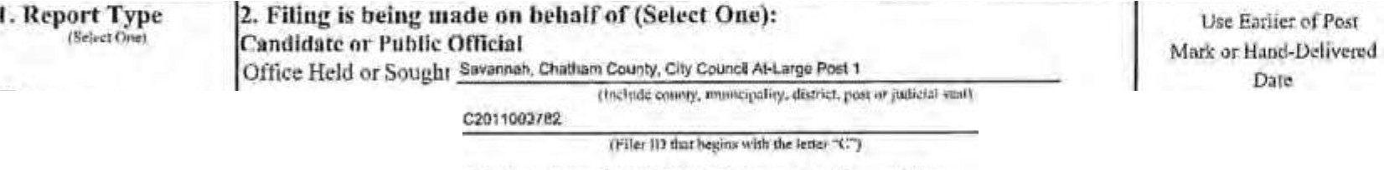
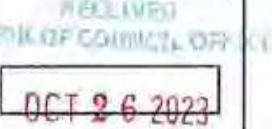


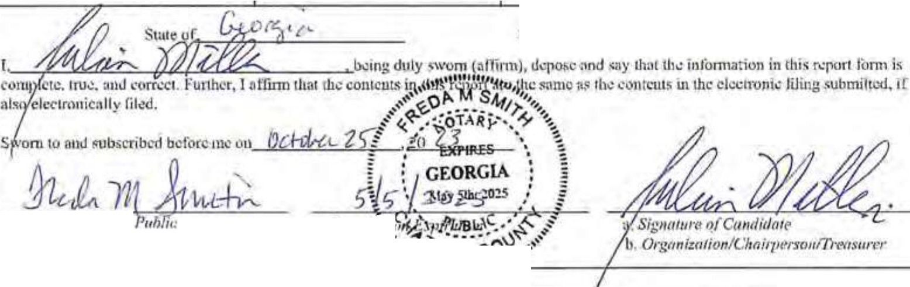
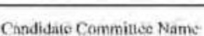
Campaign Contlibution Di closure Report
Georgia Government Transparency and Campaign Finance Commission
200 Piedmont Avenue S.E, I Sulte 1416 West Tower I Atlanta, GA 303341404-463·1980 I ww, ,cthi :s.cn.gov

Originul
D Amendment
Filer ID
O uni1.01ion or Person 0th r lh n nipuijln Commit! c r
Commillcc Name:
_cha<>IN_owman

Filer ID:

3. Jdentif •ini,:and onrnct !oformntion

( ( ) CAROi.YN BEU.
Full Nome nfC011dlrft1II! or Otlt r Thu11 Cumlidnt,• Cumpalg11 Co111m/11rv N11111e

l2) I0/2$123
Todays Dm11

(3} ZIO E. ecc.,, SI.
Alai/i11g 4JJ,.ess
- m.1113.1001
P,-i111<lf)' Co111ur.1 Pho11 .V11ml!f!1•

Swann
Cit

ond/ or o:I\DIU10Q>Ol.com

!!1401
Zip C<..!e

- If n Cauditlnlo ur Public Oflioinl is lh rtl csn1pa1gu conu • (llnc or rn11re rf <ms} to 1rr.tk.: cumpalgn trnnsaCLions. keep
fi11ancinl records of the ·umpnit,tn or fil,Hh( reports'/ Yc'l- No
- If yes, is the c..1mmit1 e registered with the CQJrunissiou? D Yes D No
(TI If yr. complctr ,ti.:following:-J_u_li_a_n_M_ll_le_r ,J_a_c_Q u_e_l_in_e_T_o_m_l_in
Nome of Co111mi11ee Choftpet 011 1ra111e o[Commitlee Treasurer
4. Period for which you are Reporting

You Must Check Only One Rox
My on-Election Year My Election Year Run-Offs
tRcron required only ,r yoo on: on a
Run.Off El,..:llun)

pecial Election

D June 30 (year)
D December 31,.. (yeer)
D Janunry 3I.._.(year) April 30, (yenr)
6 dnys before Primary Run-Off (yell!)
6 days before General
I 5 days before Spec.ial
Primary, Jyear)
15 days before Special,

l---::---,----:-::: l41nrJune30,_(ycor)
Snpplcrnentul Reporting September JO, (year)
0 Junc."30 (year) Oc1obcr25,..:laJ..jcvc:1r)
0 DccumbcrJI (ycar) D Dec.31, (yeor)
- u,..r.."..u'llli1,1l .._
...,._a. LJJycauip,p.'dMollirr_oc
hns.rc:t,tflk'J (AAtt, ►c.,"i•-.,I') C<'1..\.f .!I+ J.i
Run-Off (ye.,r)
6 days before Special P11maiy
Run-Off (ycru) 6 days before Special Run-Off (year)
(year)
'Dec. 31, (yenr

Cu11111y uf._-=t!,_,l_.'l.,,.ti_--'fi-'-t-=1'-=l{ t1/._1'-----

Sigmuure ,ifSuMrv Cmnmi.\'£
,,,,,,, AM ,\,,,,\;
l'ul\11 Olllccr/ronJld•10/C11hcr t h•III c.rct •Bell ------'---------- Vuuc_1 ,1I --1.!._

EXHIBIT J-1

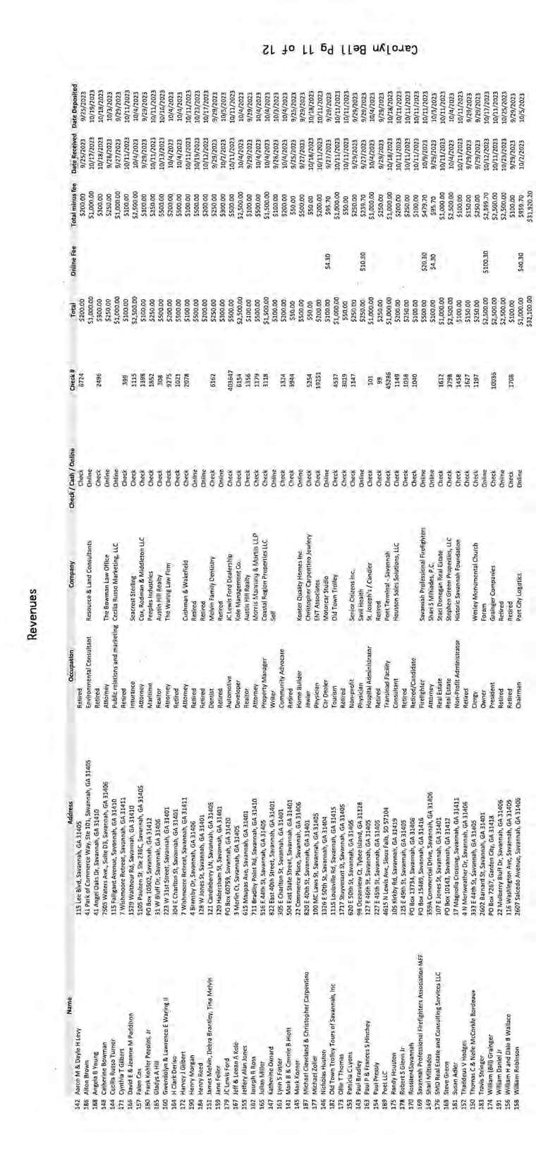

DocuSign Envelope ID:79EA923B-B0BE-4724-8951-50051BA25996

r►('-C('l)R 10.19 PLEASE SEE ADDENDUM ATTACHED
State of Georgia
Campaign Contribution Disclosure Report Itemized Contributions
Must list contributions received by a single contributor for which the aggregate total more than $I 00.00.

Page4 of 10

Note: Loans are no longer reported in "Itemized Contributions" section. See Loan Reporting section below.

Full Name of Contributor Mailing Address
(Affiliation of Committee if any}

Received Date
Contributor

Occupation &
Election Cycle**
Cash Amounl
In-Kind ContriblI\ions Estimated Value

Firsl Name or Business Nllllle

Last Name

Address
Contribution Type*
Employer
Occup1uion

□Primary
□General
Special
Special Primlll)'
0 Run-Off Primary
0 Run-Off General

Co.sbAmt
Description
Est. Value

t-:-'7":"--=-------------t::::;-:-:---------1---:::----,; t-'Kun-un ::,pecm.1

Address2 Monc!Bry
Employer O Rua-Off Special
Primary
Description

1-::-------r-c::: J..J Common Sourcie
St.ate Zip
1-------...L r-Crcdit Received on Loan
Alf. Comm.

First N1llllc or Business Name

LnslNnmc

Address
Date
Occupation

□Primary
0Gcncral
0 Special
D Special Primary
0 Run-Off Primary 0.Run-OffGcncral
Est Value

1--: ---=------------+.:=--:--:----------11-=:---: 1--'Kun-vn ::,pec1a1

Addrcss2 Monclllry
1 1L1In-Kind
City
Employer □Run-Off Special
Primruy
Description

Sl:itc Zip

Aff. Comm.

fir.;i Name or Business Name

LostNamc

Address

Credit Received on Loan

Dale

Occupation

□Primary
0 General
0 Special
0 Special Primnry
0 Run-Off Primnry
D Run-Orf General
Run-Off Spcciol

Est. Volu

I-A-:dc:-dr-es_s2.,,...-----------=::-:-M".'"o_n_cta-ry-------l Em-pl:-o-yc-r lf7 Run-Off Special
Prima.ry

1------- -------1 -Common Source
State Zip
Credit Received on Loan
Alf.Comm.

Itemized Contributions Page Total $ .$

7/11120U ......""" 41 DBMll.aft wn•• ._...,
,t,ntdot(1nYntl 7110/20:tj tMlfH ,oa..,l'lOz. 1>,1""1 ........,, .. 2HUCcl!Ul,ilof\t S,,00

liwn\\'llf!Ol'I ff< JO$SO 1etltt4 ,1.000,vo

EddY 2' H1lln¥0f111 S\INI
H•ftln•bl.ltt .V..N 2540,iriltd SfC0,00

.. ........ .... .....
..
7'1V201l 1tnrty1,:ison 1.u,11nent,wn)0111 """"'1 rooL£1'
711112.tz:I ""1,,Y.w_.'JJMnS 1" DaU.ind hi.and HI s..,.,.....
:nm CewlMIQMIO Jl,500.00
11'10 h.sDIWC>wfttl 1750.00

711t/2:0ll ................ ,.o..hr545
111s'Land0ftte
-
..,,,..
,'."."..''.I,
...

s-.,ftMh
........
....

'500.00
J1'fl ttsl.d-1 Sl,000.00
Sw•MM G,\ 3144.JH't'IIC1•1'1 .,..,

Sl,500,oa
7/HmZJ Jo"11hS\\lblnli ,.N&ll02I
7/Ul>OU AnwdeoCOftllnl 17D1 Kawiam• RdN.W
--
"'"""
,
1121m, Qriono.,h..,.,. l? •nylJ11tffDftt,II -.i -Sav• !I

WHM"llOn DC
,1,0.0.0., fC4.NU MIPrlf\d!tll n,ooo.oa

c.,.,,.... tS1nl,r"'"1ANd
Dndr.tdfion UDW•lutowrM
,.....
.,,
.......... ....
....
JlCN(ctu,aJ mooo
11410IUJ.aA(ttll 11,SOO.OO
.......

.,,,..,,
H.-lc llWHtttl.. U.-SIIHI 1.-J ........ .... 11.q.1 rdJrri smoo

»""'6'•n-,'41lftDf i-'l

1Yct-dlUDflw - .S..VMMPJ .G.,\ ..... .......
.
n•M
..

1'•1rickw.lwr nuf,11114'" lo,,, .S.v.tMah G,\ JICIM ll,u&Enalelm;ei $1,HO.OD
-·
..
J112AFwn4tlaindCh.lkm.tn .......
UHSSurtc• 11,S,O.OO
11"'°2:J W.edt.HttN!f -IJ
IN>oJ:1 Mictut [doy lS..,,..d,hw.r\ttSU"1
,(."..'".'I f'IINrrtbWr1 WY 15'0tlrtlr'N $100.00
lhllJOU 9/1.9/Zn:J
,H.,D_a,M,-l
4iatlJKtHal.vl.n1d
Cf'lmtftdHJU.OA.l1JlA

.1mmu AoD«tPetritnr.wl 11:J0[11tKc!!1$l/Hl -1 S.,enM
1,,o,aHCA nso.oo

AMOelOftlllleTtUI Sii 7'1,00
...

Gf•Mht.t '81.UJ..OO

Le1s:tlOOiwlan
,...

llffl,!t-'CW1ltbildoft, k.t.001.00

EXHIBIT J-2

CfC-CCOR 01/lO

Campaign Contribution Disclosure Report
Georgia Government Transparency and Campaign Finance Commission
200 Piedmont Avenue S.E. I Suite 1416 West Tower I Atlanta GA 30334 I 404-463-1980 I www.ethics.ga.l!.ov

- Report Type
- Filing is being made on behalf of (Select One):
Use l.iarlicrMl'ost

(S<1,r1 Ooc)

[!] Original
D Amendn,ent
Candidnte or Public Official Mark MI land-Ddiv recl-
Office Uelcl or Soughl City of Savannah· Dislrlcl 4 Alderman
(Include cnu1Hy, mu11ic1µ.,li1v1 disrnct, l'IC1J;I orJudlci:ll .(Ur)
Filer ID C2019000507
(Filar ID th1t b"!!ins with the lcitcr"C") APR2 4 2023
Organization or Person Other than Candidate's Cam1)aign Commitfrc
Committee Name:
I-

Filer ID:
(Filer10 thnt b"!!ins wilh the!<Iler .. NC")
- Identifying and Contact Information

( I) Nick Palumbo
Full Name of Candida,e or Other Than Candidate. Campaign Commillet! Name
(2) 2/24/2023
Today's Date

(3 216 E-51st Street
Mailing Address

City

Savannah

Stare
GA
Zip Code

(4) 912-220-8439
Pri111mJ1 011tt1cf !'!tone Number
and/ or nickforsavannah@gmail.com

£-Mail

- If a Candidate or Public Official is there a campaign comir ee (one or more wsons) to make campaign transactions, keep financial records of' the campaign or file the reports? Yes • No
- If yes, is the committee registered with the Commission? D Yes □ No
- 1r yes. complete the following:-----------------li-----------------
Name of Committee Clwirper:mn Name ofCommilfee Treasurer
- Period for which you are Reporting

My Non-Election Year
You Must Check Only One Box
My Election Year Run-Offs
(Report required only if you arc in a
Run-Off Elec!ion)

Special Election

- June 30, (year)
- December 31, (year)
D January 31, (year)
[!] April 30 2023 (year)
D June 30, (year)
t i□
6 days before- Primary Run-Off (year)
6 days before General
Run-Off (year)
D 15 days before Special Primary, (year)
D 15 days before Special,

Supplemental Reporting

September 30, (year)
6 days before Special Primary
---
(year)

D June 30, (year)
D December 31, (year)
•supple.mental rc1>0ns arc rcquirl!dor,andidalcs who hll\'Cunsuccessfully ca,npa.igocd f0< office Of
hiWO rcsi ncd from office. St!i: 0.C.G.A § 21-S­
J4i

D October 25, (year)
- Dec. 3 I , (year)
Run-Off (year) 6 days before Special Run-Off (year)
- Dec. 31, (year)

County 01· e-"- -"'-ll r-\.c._

Commission Expira1io11 a. Sig1w111 't> <J/Ca11di ale
b. Orga11i::otio11/C/111i'E H1lffl'IIITJ.C3

Public Officer/Canditlatc/Ollu.:r Thun Candiume Com111illN Name Pag,:_1 of

cr-r-CCOR I0/ I?
State of Georgia
Campaign Contribution Disclosure Report Itemized Contributions
Must list contributions received by a single contributor for which the aggregate total more than $100.00.
Note: Loans are no longer reported in "Itemized Contributions" section. See Loan Reporting section below.

Full Name of Contributor Mailing Address
(Affiliation of Committee if any)

Received Date
Contributor

Occupation &
Election Cycle**
Cash Amount
In-Kind Contributions Estimated Value

First Name or Business Name Conrad and Dorothy Last Name
Kearns
Address
4 Sapphire Road
Contribution Type*
Dale
4-5-23
Employer Occupation CEO

0 Primary [!)General D Special
D Special Primary
D Run-Off Primary
0 Run-Off General
7 Kun-vrr pec1a1

Ca,h Ami.

250
Description
Est. Value

Address2
[!) Monetary
Employer 0 Run-Off Special
Description

City
Savannah
Stale

Zip
0 In-Kind
D Common Source
Southside Fire Primary
and EMS

GA
Aff. Comm.
I31410 0 Credit Received on Loan

First Name or Business Name
Jeff
Last Name Kole Address
3 Merlin Court
Addrcss2

City
Savannah
State Zip
I
GA 31405
AIT.Comm.

First Name or Business Name
David
Last Name Paddison Address
1528 Walthour Road
Address2

City
Savannah
Date
4-1-23

[!]Monetary
n In-Kind
D Common Source
0 Credit Received on Loan

Date
4-4-23

[!) Monetary
0 In-Kind
D Common Source
I
Occupation
President

Employer Kole Management
Company

Occupation
President

Employer
Sterling Seacrest Pritchard

0 Primary [!)General Special
0 Special Primary
□
0 Run-Off Primary
0 Run-Off General
7 Kun-vrr ;>pcc1a1
0 Run-Off Special Primary

0 Primary [!) General Special
□
0 pccial Pmnary
0 Run-Off Primary
0 Run-Off General
0 Run-Off Special
0 Run-Off Special
Primary
Ca h Ami.

1000

Clllih Amt

1000
Est Value

Description

Est. Value

Description

State
GA
Aff. Comm.
Zip
31410 0 Credit Received on Loan

Itemized Contributions Page Total $ 2250 EX&IBIT J-3
Pub( ic Oflicer/C,mdidatc/Olher Than Ca11did.ih! Committee Nnme Pa l! Of

Page 5 oflO

CFC-CCDR 10/19
First Name or Business Name  Ansley |  | Date  06/18/23 | Occupation  Owner | □Primary  □General  Special  D Special Primary D Run-OfTPrimary D Run-OfTGeneral D Run-OfTSpecial D Run-OfTSpecial Primary | C:.SJ, Amt, |  | Est Value  500
Last Name
Williams
Address
322 East Factors Walk
Address2 |  | Monetary  U ln-Klnd  D Common Source  D Credit Received on Loan | Employer  Live Oak Restaurant Group |  |  |  | Description  Online Contribution
City Savannah
State  GA | I31401  Zip
AIT. Comm.
First Name or Business Name  David |  | Date  06/30/23 | Occupation  Insurance Agent | □Primary  □Iii General special  D Special Primary D Run-Off Primary D Run-Off General D Run-Off Special D Run-Off Special Primary | Ca,h /\mt. |  | Esl Value  1000
LastName  Paddison |  |  |  |  | '
Address
1529 Walthour Road
Address2 |  | Monetary  0 In-Kind  D Common Source  D Credir Received on Loan | Employer  Sterling Seacrest Partners |  |  |  | Description  Online Contribution
City Savannah
State  GA | I Zip  31410
Afr.Comm.
First Name or Business Name  Micheal |  | Date  6/30/23 | Occupation  Vintage Home Restoration | D Primary  □General  special  D Special Primary D Run-Off Primary D Run-Off General D Run-Off Special D Run-Off Special Primary | C.,h i\m |  | Est. Value  750
LastName  Condon |  |  |  |  | I
Address
28 Cherry Drive
Address2 |  | Monetary  iLJ ln-Kind  D Common Sourc  tJ Credit Received on Loan | Employer  Self |  |  |  | Description  Check
City Milton
Stale  MA | Zip  I 02186
Aff. Comm | .
First Name or Business Name |  | Date | Occupation | □D Primary General  D Special  D Special Primary D Run-Off Primary D Run-Off General D Run-Off Special D Run-Off Special Primary | Clllh Ami. |  | Est. Value
Last Name
Address
Address2 |  | D Monemry  0 In-Kind  D Common Source  D Credit Received on Loan | Employer |  |  |  | Description
City
State | I Zip
Aff. Comm.
 |  |  | Itemized Contributions Page Total $ |  |  |  | $2,250
- Contnbuuon Type (Monetary. ln-Kmd, Common Source, Credit Received on Loan)
•• Election Cycle (Primary. General, Special. Special Primary, Run-Off Primary, Run-Off General, Rlln-OffSpecial, Run-Off Special Primary)
H• If any such pcrsoo(s) shall have a fiduciary relationship to the lending institution or pan:y making the advance or extension of credit

Public Officer/Candidate/Other Than Candidate Committee Nrune
Kurtis Purtee

PageJl.of lg

-------------=EXHIBIT J-4

CFC-CCDR 10/19
State of Georgia
Campaign Contribution Disclosure Report
Itemized Contributions
Must list contributions received by a single contributor for which the aggregate total more than $100.00.
Note: Loans are no longer reported in "Itemized Contributions" sect |  |  |  |  | .ion. See Loan Reporting section below.
Full Name of Contributor Mailing Address (Affiliation of Committee if any) |  | Contributor |  | Election Cycle* |  | Cash Amount | In-Kind Contributions
 |  | Received Date  Contribution Type• | Occupation &  Employer |  |  |  | Estimated Value
 |  |  |  |  |  |  | Description
First Name / Business Name Olympia Cafe |  | Date  03/03/2023 | Occupation | 0Prtmary  □0General  special  D Special Primary  D Runoff Primary  0 Runoff General  0 Runoff Special Runoff Special  Primary  0Recall  ::]Associated with a regulated entity |  | Cash Amt.  $3,000.00 | Est. Value | $0.00
Last Name
Address  5 E River St |  |  |  |  |  |  | Description
IZ] Monetary Olnkind
DCommon Source
D Credit Received on Loan
□Refund
Olnterest
Address2
 |  |  | Employer
City Savannah
State GA | Zi  I31 01
Alf. Comm.
First Name / Business Name Jeanne M. |  | Date  04/11/2023 | Occupation Other | □Primary  □IZ]General  special  D Special Primary  0 Runoff Primary D Runoff General D Runoff Special D Runoff Special  Primary  0Recall  ::]Associated Wflh a regulated entity |  | Cash Amt.  $2,500.00 | Est. Value | $0,00
Last Name Paddison
Address  1529 Walthour Rd |  |  |  |  |  |  | Description
IZ] Monetary
Olnklnd Ocommon Source
D Credit Received on Loan
□Refund
Olnterest
Address2
Employer
Savannagh Wildlife Rescue
City Savannah
State GA | Zlp  I31410
Aff. Comm.
First Name / Business Name  JamesL |  | Date  04/J 1/2023 | Occupation Other | □Primary  IZ]General 0Specfal  0 Special Primary  D Runoff Primary  0 Runoff General  0 Runoff Special  D Runoff Special Primary  0Recall  ::]Associated with a  regulated entity |  | Cash Amt.  $250.00 | Est. Value | $0.00
Last Name Pannell
 |  |  |  |  |  | I
Address Post |  |  |  |  |  |  | Description
IZ] Monetary Olnkind
DCommon Source
0credit Received on Loan
□Refund
□Interest
Address2 Ofc 8050
Employer
James L. Pannell, Attorney At Law
City Savannah
State  GA | Zip  I31412
Alf. Comm.
 |  | Itemized Contributions Page Total |  |  |  | $5,750,00 |  | $0.00

Public Officer/Candidate/Other Than Candidate Committee Name Friends of Yan Johnson

From: To: Subject: Date:
Clara Greig
Edward Morrow: Sally Helm
Opposition to 24-005816 ZA & 24-005815-ZA Monday, November 18, 2024 9:54:30 PM

Mr. Morrow-

Please add my comments to the public record in Opposition of 24-005816 ZA & 24-005815-ZA.

I am compelled to express my outrage regarding the proposed changes to the FLUM and the zoning adjustment from residential to commercial use for properties located at 1001, 1015 Whitaker, 120, 124 W Park Ave within the Victorian District.
As a deeply concerned citizen, I find these proposals not only misguided, but also potentially devastating for our community, heritage, and quality of life.
The Victorian District is far more than just a collection of buildings; it embodies our community's history, culture, and identity. To even consider altering zoning to commercial use is to risk irrevocably changing the neighborhood's character. Such actions would inevitably lead to the degradation of community cohesion, and heightened levels of traffic and noise - none of which are conducive to the peaceful, residential environment that we all cherish.
We must critically evaluate the long-term consequences of prioritizing economic gain over community well-being. This committee exists to compel responsible community planning. Allowing the heart of a neighborhood to be converted to a massive commercial complex betrays everything this committee stands for and directly contradicts the concept of community planning.
I implore you to heed the voices of the community who value the uniqueness and integrity of the Victorian District. The proposed zoning changes would set a dangerous precedent, undermining the historic and residential fabric of our cherished historic neighborhoods.
Thank you for your attention to the urgent matter, and for considering the strong sentiments of the residents of the Victorian District and citizens of Savannah. I respectfully insist that, as community representatives, you must reject the proposal for the zoning change from residential to commercial use and the modifications to the FLUM.

Regards, Clara Greig

From: To: Subject:
Date:
Tana Fi eccia-Flagg
Edward Morrow: Sally H m
FLUM Amendment request, Zoning Request to change from TC-1 to TC-2- opposition to these changes for the record
Tuesday, November 19, 2024 9:52:07 AM

I am reaching out to you to express my opposition to a vote by the MPC regarding the zoning and use changes for the following properties: 1001, 1015 Whitaker, 120, 124 W Park Ave.
This includes a zoning change from TC-1 (Residential) to TC-2 (Commercial) as well as a change to FLUM from Traditional Neighborhood to Traditional Commercial.
My husband and I reside at 115 W Park Ave, Savannah, GA 31401, directly across from actions that these changes will impact since these change requests are a precursor to a two story underground parking garage and 3 office buildings ranging from 3 to 5 stories tall to loom over the Victorian Neighborhood and Forsyth Park.
Changing the zoning to commercial use risks altering the character of the neighborhood, leading to the loss of historic properties and community cohesion, increased traffic, and noise pollution, which are not conducive to a residential environment.
It is important to consider the long-term implications of prioritizing business over community.
I believe that the proposed zoning changes would set a dangerous precedent and negatively affect the historic and residential nature of our beloved neighborhoods.
We implore you to consider those ofus who live in this community. Thank you for considering our concerns.
Tana Fileccia-Flagg Ronald Flagg

SEPTEMBER 14, 2023, 2:00 p.m. - CITY COUNCIL REGULAR MEETING

CITY GOVERNMENT OFFICIAL PROCEEDINGS
OF THE MAYOR AND ALDERMEN
SAVANNAH, GEORGIA

The regular meeting of the City Council was held at 2:03 p.m. Mayor Johnson recognized Alderman Nick Palumbo who introduced Adam Solender, Chief Executive Officer of Jewish Educational Alliance and Savannah Jewish Federation to offer the invocation. The Pledge of Allegiance was recited in unison.

PRESENT:
Mayor Van R. Johnson, II, Presiding
Alderwoman Kesha Gibson-Carter, At-Large, Post 1 Alderwoman Alicia Miller Blakely, At-Large, Post 2 Alderwoman Bernetta B. Lanier, District 1
Alderman Detric Leggett, District 2 Alderwoman Linda Wilder-Bryan, District 3
Alderman Nick Palumbo, District 4, Vice-Chairman
Alderwoman Dr. Estella Edwards Shabazz, District 5, Mayor Pro-Tern Alderman Kurtis Purtee, District 6
ALSO, PRESENT:
City Manager Joseph A. Melder Chief of Staff Daphanie Williams City Attorney Bates Lovett
Clerk of Council Mark Massey EXHIBITM

Exhibit 4: Measurement Report - Sey Hey.pdf Exhibit 5: Security an - Sey Hey.pdf
Exhibit 6: Security an - Transition Permit.pdf

Mayor Johnson declared the alcohol hearing open for Items #8, #9 and #10. No speaker{s}.
- Mayor Pro-Tern Dr. Shabazz moved to close the alcohol hearings for Items #8, #9 and #10, seconded by Alderman Leggett and Alderwoman Wilder-Bryan. The motion passed unanimously, 9-0-0.
- Alderman Leggett moved to approve Item #9, seconded by Alderwoman Miller Blakely and Alderman Palumbo. The motion passed unanimously, 9-0-0.

- Approv of a Class E (Beer, Wine) (By the Package) Alcoh License to ShivKumar Pat for 7-11 Mini! Store, a Convenience Store Located at 3700 Waters Avenue. The establishment is ocated between East 53rd and East 54th Streets in Aldermanic District 3.
Exhibit 1: Checklist-7-11 MinitStore.pdf Exhibit 2: Density Map- 7-11 Mini! Store.pdf Exhibit 3: Alcoh Reports - 7-11 Mini! Store.pdf
Exhibit 4: Measurement Report - 7-11 Minit Store.pdf Exhibit 5: Security an - 7-11 Mini! Store.pdf
Mayor Johnson declared the alcohol hearing open for Items #8, #9 and #10. No speaker{s}.
- Mayor Pro-Tern Dr. Shabazz moved to close the alcohol hearings for Items #8, #9 and #10, seconded by Alderman Leggett and Alderwoman Wilder-Bryan. The motion passed unanimously, 9-0-0.
- Alderwoman Wilder-Bryan moved to approve Item #10, seconded by Alderman Palumbo. The motion passed unanimously, 9-0-0.

ZONING HEARINGS
- Recommendations by the Historic Preservation Commission for a Text Amendment to the City of Savannah Zoning Ordinance Section 7.9, Victorian District Contributing Resources Map for 1001 Whitaker Street (20044 25001), 124 West Park Avenue (20044 24003), and 1015 Whitaker Street (20044 25002) which Are All Zoned TN-1 (Traditiona Neighborhood-1). Aldermanic District 2 (File No. 23-003955-ZA). Recommend Deni I.
Exhibit 1: Historic Preservation Commission Recommendation (File No. 23-003955-ZA) .pdf Exhibit 2: Map of Subject Properties.pdf
Exhibit 3: Photos of Subject Properties.pdf

Mayor Johnson declared the zoning hearing open for Item #11. Speaker{s}:
. Melanie Wilson, MPC representative
. Leah Michalak, MPC representative
. Andrew Jones - IN SUPPORT
. Nancy Maia - OPPOSED
. Ronald Motyka - OPPOSED
. Gary Guthrie - OPPOSED
. Robin Williams - IN SUPPORT
. Kathy Ledvina - IN SUPPORT
. Michael Brown - OPPOSED
. Rebecca Fenwick - OPPOSED IN SUPPORT
. Harold Yellin - representing the applicant EXHIBITM

Mayor Johnson asked for the dates of each property. Ms. Michalak answered: 1001 Whitaker Street was built in 1961, 1015 Whitaker Street was built in 1957, and 124 West Park Avenue was originally constructed prior to 1888, but was modified in the 1960's.
Alderwoman Wilder-Bryan asked for the specific renovations for 124 West Park Avenue building. Ms. Michalak indicated in the 1960's the two individual buildings were joined and fully skinned (covered) in brick.
Alderman Palumbo expressed concern why the structures were not added in 2018 as contributing structures. City Manager Melder indicated the structures were viewed as not being contributing in 2018, and Ms. Michalak stated it was not until the Council adopted the new zoning ordinance in 2019 that allowed the ability to add structures of exceptional importance. Alderman Palumbo, Ms. Wilson and Ms. Michalak discussed MPC's ability and timing to list structures as historic, contributing or Victorian.
Alderman Leggett asked Attorney Yellin if Campbell & Son's Funeral Home Director was in favor of making the structure non contributing (yes, he favored the decision of the City Manager to not add the three structures to the contributing map). Alderman Leggett asked if there was anything in the deed paperwork to eliminate these buildings from any historic registry (there is nothing to that effect). After Alderman Leggett inquired about the alternatives, if Item #19 is not approved, Attorney Yellin indicated the one-story buildings would be the norm in the community. When those building were constructed there were no zoning requirements/restrictions. Now that NewZo is in effect, the community would have restrictions on size and style of any new buildings.
Alderwoman Miller Blakely asked Attorney Yellin when the building was purchased by the new owners: 1001 Whitaker Street in 2010; 1015 Whitaker Street approximately 2016; and 124 West Park Avenue approximately 2008. Alderwoman Miller Blakely asked if MPG is recommending the three buildings be added as contributing structures. Ms. Wilson answered the Historic Preservation Commission (HPC) is recommending the buildings be added as contributing structures. Alderwoman Miller Blakely asked what would be the impact on the infrastructure if the buildings were demolished. Ms. Wilson stated, if the buildings are demolished, new buildings according to NewZo would be constructed. The infrastructure would not be effected.
Alderwoman Gibson-Carter asked if there were any other factors contributing to the designation of a contributing structure such as history, use and people associated with the building. Ms. Wilson indicated the criteria is not limited to the physical structure. Alderwoman Gibson-Carter and Attorney Yellin discussed possible purposes of the buildings (office space and underground parking). Alderwoman Gibson-Carter identified the petitioner as a contributor to candidates campaigns.
Alderman Palumbo and Alderwoman Wilder-Bryan raised a point of order. Mayor Johnson acknowledged the point of order.
Mayor Johnson indicated contributions to all City Council Members campaigns can be found at www.savannahga.gov under Clerk of Council for viewing by the public. Alderwoman Gibson-Carter stated the information is not available to citizens without access to the internet, and the information is hard to locate on the site. Mayor Johnson indicated the information is readily available to the public and thanked Clerk of Council for making the information prominent to citizens.
Mayor Johnson expressed concern for the Campbell & Son's Funeral Home Letter stating the building needs extensive repairs and making the structure a contributing structure would make it more difficult to maintain operations. Ms. Wilson stated Mr. Campbell would need to submit any improvements/repairs for approval to HPC.
After extensive due diligence, Alderwoman Lanier stated her concern for how the community will benefit or how it would impact the community. There is nothing in writing. Alderwoman Lanier has recommended establishing a community benefits ordinance for developers and:itfff:YH i groups.

In this particular case, the area residents and developers need to meet (and they might have already done so) to establish some type of community benefits for the residents.
Alderwoman Wilder-Bryan stated there needs to be an economic driver and what Mr. Campbell has requested is an economic driver. Alderwoman Wilder-Bryan expressed campaign contribution information is available to citizens. Candidates live in Savannah, contributions come from residents of Georgia, not Florida or South Carolina. Constituents are satisfied with her performance and she is committed to the residents of Savannah.
Alderwoman Gibson-Carter raised a point of order. Mayor Johnson acknowledged.
Alderman Palumbo moved to close the zoning hearing for Item #11, seconded by Alderman Leggett and Alderwoman Miller Blakely. The motion passed unanimously, 9-0-0. See related Agenda Item #19.

- Petition of Joshua Yellin on Behalf of Micha Condon, Vintage Home Restoration, LLC, for a Zoning Map Amendment of the 0.04-Acre Property Located at 222 West Duffy Street ( N 20052 16013) from TN-1 (Tradition Neighborhood-1) to TC-1 (Tradition Commercial-1 ). Aldermanic District 2 (File No. 23-003454-ZA). [Continued from the August 24, 2023 Council Meeting at the Petitioner's Request]
Exhibit 1: MPG Recommendation Packet (File No. 23-003454-ZA).pdf Exhibit 2: Maps for 222 West Duffy Street (File No. 23-003454-ZA).pdf Exhibit 3: Site Visit for 222 West Duffy Street (File No. 23-003454-ZA}.pdf
Mayor Johnson declared the zoning hearings open for Items #12 and #13.
Speaker(s):
- Edward Morrow, MPC representative
. Ms. Pearl Reddick - OPPOSED
- Ms. Doris Fogle - OPPOSED
. Josh Yellin, representing applicant
Mayor Johnson asked Ms. Reddick if she was an authorized speaker/representative of the Church (yes). Alderman Leggett indicated notification of the restaurant serving alcohol was received two days ago and there was no opportunity for meetings.
Attorney Yellin indicated there was a meeting with the neighborhood association and a good neighbor agreement was signed. The petitioner met with the Church last evening and discussed hours of operation.
Mayor Johnson, Mayor Pro-Tern Dr. Shabazz, Attorney Yellin and Ms. Fogle discussed the parking, prior restaurants, restaurants next to churches serving alcohol, and meetings with members of the Church.
Alderwoman Wilder-Bryan requested a listing of all establishments requesting special use permits since January 2020. City Manager Melder will provide Council with the list.
Alderman Leggett moved to close the zoning hearing for Items #12 and #13, seconded by Alderwoman Wilder-Bryan. The motion passed unanimously, 9-0-0. See related Agenda Items #13 and #20.

- Petition of Joshua Yellin on Behalf of Micha Condon, Vintage Home Restoration, LLC, for a Speci Use Permit with Conditions to Allow on Premises Consumption of Alcoh in Association with a Restaurant Located at 222 West Duffy Street ( N 20052 16013). Aldermanic District 2 (File No. 23-003455-ZA). [Continued from the August 24, 2023 Council Meeting at the Petitioner's Request]
Exhibit 1: MPG Recommendation Packet (File No. 23-003455-ZA}.pdf Exhibit 2: Maps for 222 West Duffy Street (File No. 23-003454-ZA) .pdf Exhibit 3: Site Visit for 222 West Duffy Street (File No. 23-003454-ZA) .pdf
Mayor Johnson declared the zoning hearings open for Items #12 and #13.
EXHIBITM

